**SMARTANGLER:**

**AUTOMATED FISHING TOURNAMENT SYSTEM**

**ALVINA ALPHONSUS**

**FACULTY OF COMPUTING AND INFORMATICS**

**UNIVERSITY MALAYSIA SABAH**

**2025**

**SMARTANGLER:**

**AUTOMATED FISHING TOURNAMENT SYSTEM**

**ALVINA ALPHONSUS**

**THESIS SUBMITTED IN PARTIAL FULFILLMENT FOR THE DEGREE OF BACHELOR OF COMPUTER SCIENCE WITH HONOURS**

**(SOFTWARE ENGINEERING)**

**FACULTY OF COMPUTING AND INFORMATICS**

**UNIVERSITY MALAYSIA SABAH**

**2025**

**NAME :** ALVINA ALPHONSUS

**MATRIC NUMBER :** BI22110003

**TITLE :** SMARTANGLER: AUTOMATED FISHING TOURNAMENT

SYSTEM

**DEGREE :** BACHELOR OF COMPUTER SCIENCE WITH HONOURS

(SOFTWARE ENGINEERING)

**VIVA’S DATE :**

**CERTIFIED BY;**

1. **SUPERVISOR**  Signature

Professor Madya Dr. Azali Bin Saudi

# 

# **DECLARATION**

I hereby declare that the material in this thesis is my own except for quotations, equations, summaries and references, which have been duly acknowledged.



24 APRIL 2025 ALVINA ALPHONSUS

BI22110003

# **ACKNOWLEDGEMENT**

I would like to express my sincere gratitude to my supervisor, Professor Madya Dr. Azali Bin Saudi, for the continuous guidance, valuable advice and encouragement provided throughout the completion of this Final Year Project. His constructive feedback and support have been instrumental in helping me improve and complete this project successfully.

I would also like to extend my appreciation to my examiners Ts. Dr Chin Pei Yee and Dr Zaidatol Haslinda Abdullah Sani for their helpful comments, suggestions and constructive feedback during the evaluation process. Their insights have greatly contributed to improving the quality and outcome of this project.

In addition, I am truly grateful to my family and friends for their unwavering support, understanding and encouragement throughout this journey. Their motivation has been a constant source of strength and inspiration.

Without the kind assistance and support of all these individuals, the successful completion of this project would not have been possible. Their guidance, encouragement and contributions are deeply appreciated. Through this project, I have gained invaluable experiences and opportunities for personal and professional growth, for which I am truly grateful.

ALVINA ALPHONSUS

24 APRIL 2025

# **ABSTRACT**

I would like to express my sincere gratitude to my supervisor, Professor Madya Dr. Azali Bin Saudi, for the continuous guidance, valuable advice and encouragement provided throughout the completion of this Final Year Project. Their constructive feedback and support have been instrumental in helping me improve and complete this project successfully.

**Keywords:**

# ***ABSTRAK***

***SMARTANGLER: SISTEM AUTOMASI PERTANDINGAN MEMANCING***

*I would like to express my sincere gratitude to my supervisor, Professor Madya Dr. Azali Bin Saudi, for the continuous guidance, valuable advice and encouragement provided throughout the completion of this Final Year Project. Their constructive feedback and support have been instrumental in helping me improve and complete this project successfully.*

***Kata Kunci:***

**TABLE OF CONTENTS**

TITLE Page

DECLARATIONi

TABLE OF CONTENTSii

LIST OF TABLESiv

LIST OF FIGURESv

CHAPTER 1: INTRODUCTION1

1.1 Introduction1

1.2 Problem Background2

1.3 Problem Statement5

1.4 Project Objectives 7

1.5 Project Scope8

1.6 Organizational Report10

1.7 Conclusion11

CHAPTER 2: LITERATURE REVIEW12

2.1 Introduction12

2.2 An Overview of SmartAngler Automated Fishing Tournament System 12

2.3 The Growth and Evolution of Fishing Tournaments.13

2.3.1 Evolution of Fishing Tournament14

2.3.3 The Impact on The Growth and Popularity of Fishing Tournament15

2.4 The Impact of Digital Solutions on Fishing Tournament Efficiency 16

2.4.1 Automation of Fishing Tournament Operations17

2.5 Review of Existing Fishing Tournament System18

2.5.1 iAngler18

2.5.2 FishAngler23

2.5.3 FishPal27

2.5.4 KeepNet30

2.5.5 Reel LiveWell32

2.6 Comparison of Existing Fishing Tournament System34

2.7 Summary of Literature Review35

CHAPTER 3: METHODOLOGY36

3.1 Introduction36

3.2 Project Methodology for SmartAngler36

3.2.1 Planning37

3.2.2 Analysis38

3.2.3 Design38

3.2.4 Implementation39

3.2.5 Testing39

3.2.6 Project Closure40

3.3 Conclusion40

CHAPTER 4: SYSTEM DESIGN41

4.1 Introduction41

4.2 Interview Findings41

4.3 Survey Questionnaire Analysis44

4.4 System Design52

4.4.1 System Architecture52

4.4.2 Data Flow Diagram (DFD) Level 054

4.4.3 Data Flow Diagram (DFD) Level 155

4.4.4 Entity Relationship Diagram (ERD)59

4.4.5 Data Dictionary60

4.5 User Interface65

4.6 Prototype74

4.7 Conclusion75

REFERENCES76

APPENDICES78

# **LIST OF TABLES**

Table 1.1: Modules for SmartAngler System 4

Table 2.1: Comparison Between SmartAngler system with The Existing System 5

Table 4.1: USER Table5

Table 4.2: TOURNAMENT Table 28

Table 4.3: TOURNAMENT_REGISTRATION Table36

Table 4.4: FISHING_SPOT Table 36

Table 4.5: SPOT_BOOKING Table 36

Table 4.6: FISH_CATCH Table 36

Table 4.7: RESULT Table36

Table 4.8: REVIEW Table 36

Table 4.9: CALENDAR Table36

Table 4.10: SAVED Table36

# **LIST OF FIGURES**

Figure 1.1: An angler won cash prize in Fishing tournament in Sipitang2

Figure 1.2: Fishing Tournament Advertisement Through WhatsApp Chat3

Figure 1.3: Angler Inquiring About Advertisement Flyers 4

Figure 1.4: Manual Result Generation Using Microsoft Excel Spreadsheet4

Figure 1.5: Official Competition Results Posted via WhatsApp5

Figure 2.1: iAngler Tournament Dashboard Screen 19

Figure 2.2: iAngler Tournament Available Listings Screen 19

Figure 2.3: iAngler Tournament Details Screen 20

Figure 2.4: iAngler Add Catch Screen 21

Figure 2.5: Weather Information in iAngler Tournament 22

Figure 2.6: Dashboard Screen 23

Figure 2.7: Weather Forecast 23

Figure 2.8: Snap Captured Fish 24

Figure 2.9: Select Catch Location24

Figure 2.10: Select Fish Species 25

Figure 2.11: Add Catch Details 25

Figure 2.12: FishAngler Features Available26

Figure 2.13: Main Interface of FishPal27

Figure 2.14: List of Available Book Fishing28

Figure 2.14: Detailed Information of the Fishing Activities28

Figure 2.16: Fish Catch Analysis29

Figure 2.17: Anglers’ Reviews 29

Figure 2.18: Competition List Dashboard 30

Figure 2.19: Fishing Tournament Details 31

Figure 2.20: Live Results Leaderboard31

Figure 2.21: Real-Time Leaderboard of Fishing Competition Results32

Figure 2.22: List of Available Fishing Competitions33

Figure 3.1: Waterfall Model Phases for SmartAngler System Development37

Figure 4.1: Booking and Registration Record on Paper42

Figure 4.2: Paper Based Fish Catch Logging Record43

Figure 4.3: Percentage of Angler Age Group 44

Figure 4.4: Angler Participation in Fishing Tournament45

Figure 4.5: Percentage of Digital Platform Usage for Fishing Tournaments 45

Figure 4.6: Participants Who Missed Tournaments Due Poor Advertisement46

Figure 4.7: Issues Faced When Booking a Fishing Spot47

Figure 4.8: Percentage of Angler Facing Issue in Tracking Tournament Dates 47

Figure 4.9: Number of Angler Able to Track Performance via Live Updates 48

Figure 4.10: Overall Satisfaction with Current Fishing Competition Experience 49

Figure 4.11: SmartAngler Features Preferences50

Figure 4.12: Aspects Rated by Anglers for an Ideal Fishing Tournament Website50

Figure 4.13: Anglers’ Preference on Current Methods or SmartAngler51

Figure 4.14: System Architecture of SmartAngler 52

Figure 4.15: Data Flow Diagram (DFD) Level 054

Figure 4.16: DFD Level 1 for Account Management 55

Figure 4.17: DFD Level 1 for Tournament Advertisement Management 55

Figure 4.18: DFD Level 1 for Fishing Spot Management56

Figure 4.19: DFD Level 1 for Participant Registration 56

Figure 4.20: DFD Level 1 for Fish Catch Record 57

Figure 4.21: DFD Level 1 for Result Management 57

Figure 4.22: DFD Level 1 for Review Management 58

Figure 4.23: Entity Relationship Diagram (ERD) of SmartAngler 59

Figure 4.24: User Login Page 65

Figure 4.25: Homepage66

Figure 4.26: Calendar 66

Figure 4.27: Tournament Advertisement Page 67

Figure 4.28: Tournament Details Page 68

Figure 4.29: Participant Registration to Join Tournament Page 68

Figure 4.30: Fishing Spot Booking Page 69

Figure 4.31: Live Leaderboard Page 70

Figure 4.32: Review Page for Tournament 71

Figure 4.33: Admin Dashboard 72

Figure 4.34: Admin Create Tournament Advertisement Page 72

Figure 4.35: Tournament Participant List Page 73

Figure 4.36: Create Fishing Spot Page 73

Figure 4.37: Fish Catch Log Page 74

Figure 4.38: Prototype User Flow for SmartAngler 75

**CHAPTER 1**

**INTRODUCTION**

* 1. **Introduction**

The evolution of digital technologies has transformed the way events are planned and organized across many fields including recreational activity. According to Hamid, the integration of automated and digitalized systems in event management have improved these sectors by enhancing operational tasks and reducing error while creating better user experiences (Hamid, 2023). However, in some cases for recreational activities such as fishing competitions, especially those that been held on private ponds are still remain unaffected by such advanced technologies to automate the fishing tournament system.

In recent years, fishing competitions in Malaysia has experienced growing popularity since its now attracting hundreds or even thousands of anglers from both local and international anglers. This rise in popularity reflects a growing interest in recreational fishing tournaments, not only as a casual leisure activity but also as an organised and competitive sport with a varied range of participants.

Although fishing tournaments are growing in popularity, most of the task during the fishing tournament are still managed manually including registration, spot booking, fish logging and result recording. The increasing number of angler participants makes these manual management process slower, prone to error and creating confusion to both organizer and participants.

To address these challenges, the SmartAngler system has been developed as a user-friendly web-based solution that automates important task involved in managing fishing competition. The system is specifically developed for the use in fishing tournament and aims to enhance the overall visibility and efficiency in fishing competition management. At the same time, it offers more organized and fairer tournament experience for both participants and organizers.

* 1. **Problem Background**

Fishing tournaments are popular events that are usually organized in public lakes, coastal waters and privately owned fishing ponds. These fishing tournaments provide opportunities for anglers to compete and showcase their skills.

Over the years, Malaysia has become a main destination for hosting fishing tournaments due to its numerous fishing sites. For example, the Royal Pahang Billfish International Challenge 2025 which is hosted in Kuala Rompin has once again positioned Malaysia as a global hotspot for sport fishing. The tournament attracted 64 participants from six countries including Italy, Japan, China, Singapore, Australia and the United Kingdom highlighting Kuala Rompin’s reputation as one of the most preferred destinations for fishing in Asia. (Zainuddin, 2025). This shows that Malaysia is appeal in the fishing tournament sector.

Fishing tournament often features multiple fishing categories and offers attractive prizes which including cash prizes, trophies and fishing equipment or vouchers. For example, in Figure 1.1, the 2025 edition of one fishing tournament in Sipitang, Sabah awarded up to RM50,000 in cash and trophies (Sabah News, 2025).

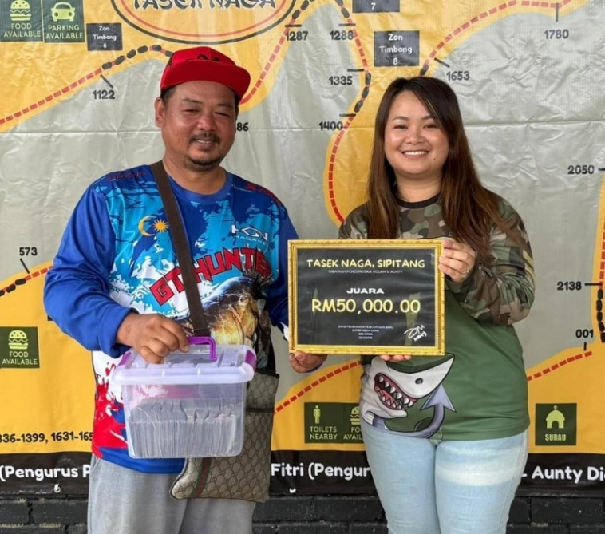

**Figure 1.1: An angler won cash prize in Fishing tournament in Sipitang**

Source: Sabah News, 2025.

Despite the popularity and rising number of angler competitors in fishing tournament, many of these events still rely on manual process. The main task for this tournament including participant registration, fishing spot booking, fish logging and result generation are still managed manually using paper-based method. This manual process might work well for small-scale fishing tournament, however, when it comes to larger events with larger participants, it becomes challenging and confusing to manage. These manual processes are not only time-consuming and error-prone but they also reduce the overall experience for both organizers and participants.

Moreover, advertisement of fishing tournaments is often done through social media platforms such as WhatsApp and Facebook. For instance, as illustrated in Figure 1.2, promotional ads for the Super Mega Game were shared via WhatsApp. Meanwhile, in Figure 1.3, it highlights a problem faced by an angler who is seen inquiring about the availability of fishing tournament advertisement which highlighting the lack of easy access to event information. Hence, this indicates a lack of centralized digital platforms for advertisement sharing and notification announcement for any changes of information in fishing tournaments. The dependence on word-of-mouth and messaging apps can result in missed information, confusion and limited reach for anglers especially for large-scale tournament.

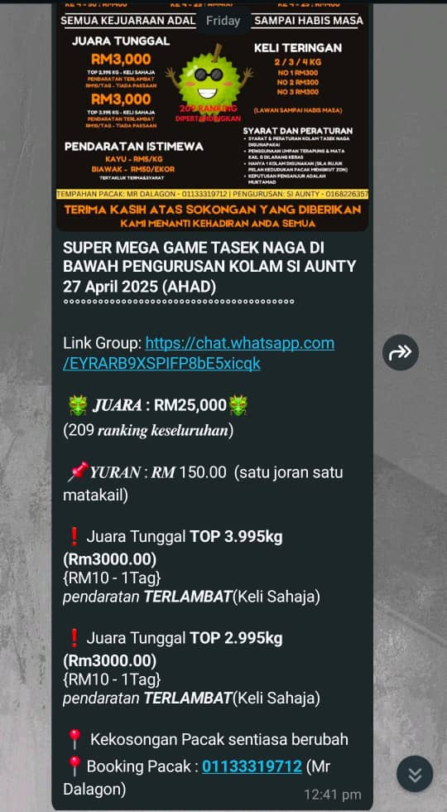

**Figure 1.2: Fishing Tournament Advertisement Through WhatsApp Chat**

Source: Kolam Rekreasi Pupuluton Valley WhatsApp Group.



**Figure 1.3: Angler Inquiring About Advertisement Flyers**

Source: Kolam Rekreasi Pupuluton Valley WhatsApp Group.

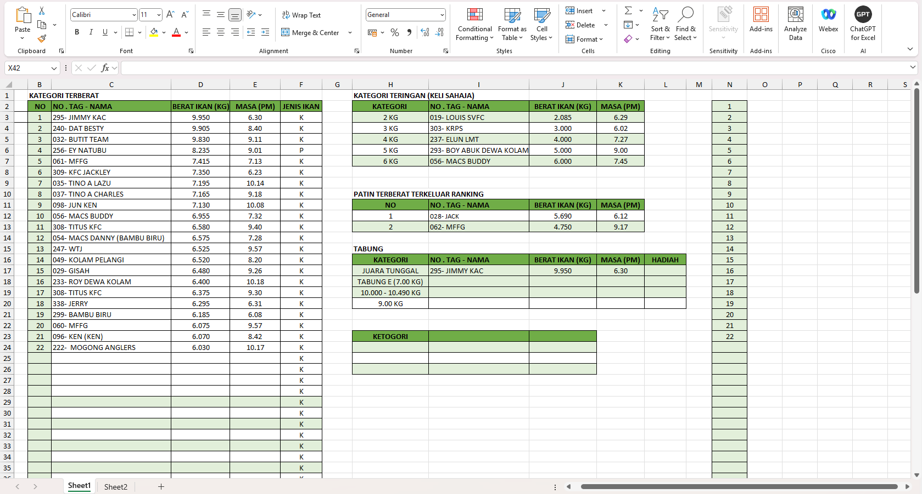In addition, the generation and management of tournament results is also one of a key concern in fishing tournament since most of the event organizers still rely on Microsoft Excel spreadsheets to manually insert fish catch data, participant details and final scores. Without automation in this process, it often led to delays in announcing winners, inconsistent rankings and disagreement over final results which can make participant to lose trust and question the fairness of the event.

**Figure 1.4: Manual fishing tournament result generation using Microsoft Excel spreadsheet**Source*:* Alphonsus Ongkudon, personal interview, April 2025.

After the tournament has ended, the final official results are usually shared through WhatsApp and Facebook after the tournament ends. However, as shown in Figure 1.5, the organizer often posts the results few hours or a day after the tournament ends. This delay not only reduces participant engagement but also reflects a lack of professionalism in tournament management. Additionally, anglers are unable to access real-time rankings or the final results which can lead to frustration and confusion.

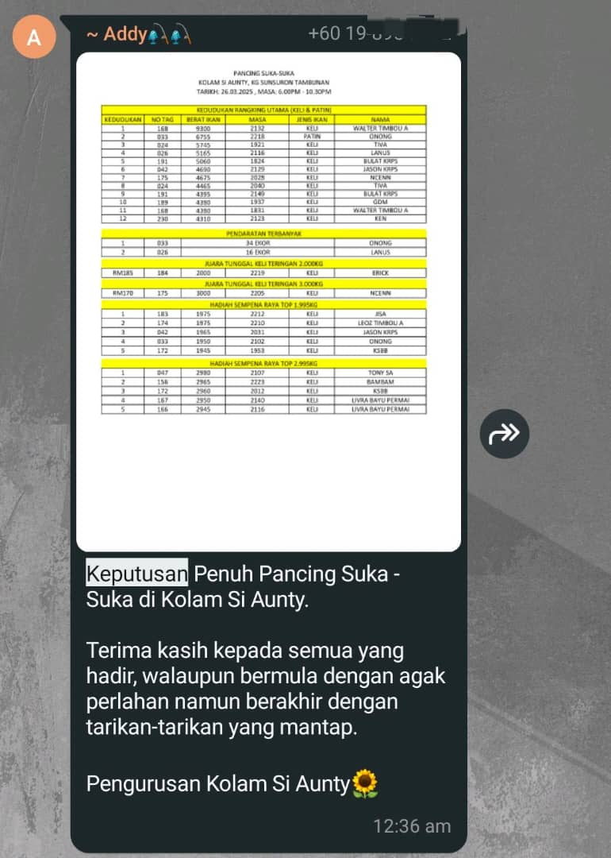

**Figure 1.5: Official Competition Results Posted via WhatsApp**

Source: Kolam Rekreasi Pupuluton Valley WhatsApp Group.

As technology has become increasingly important in event management across all industries, it is evident that fishing competitions must be modernised. By developing the SmartAngler web-based system, these tournaments will operate more efficiently and provide a better experience for both organisers and participants.

* 1. **Problem Statements**

Fishing tournaments in Malaysia are growing in popularity and is now attracting a large number of participants. However, many of these tournaments still rely on outdated and manual processes for main tasks. This causes several problems that affect the overall experience for both organizers and participants.

One major issue in fishing tournament event is the way competitions are advertised. The primary platform for advertising fishing tournament is using social media like Facebook and WhatsApp. These platforms have a wide reach of audiences, however it limits the reach and accessibility of event information. As a result, potential angler participants may miss out on tournament announcements and also struggle to access complete and up-to-date information about upcoming tournaments.

Additionally, the current method of booking fishing spots remains a problem during tournament management. Most tournaments still rely on manual methods where participants book their preferred spots via text messages, phone calls or self-booking and the organizers will record the details on paper. This process often leads to double bookings, confusion about spot availability and a lack of real-time spots availability updates.

Registration for tournament is also inefficient. To register for the tournament anglers must wait in line at registration counter where they are required to manually fill out forms with their personal information. This not only creates long waiting times but also increases the risk of entering wrong personal data. These mistakes can cause delays and confusion later in the competition, especially during results verification and prize distribution.

Furthermore, fish catch data logging continues to be done manually, with the organizers using paper logs to record and track catches. This method is not only time-consuming but also prone to human error which resulting in inaccurate records. As the number of participants and catches increases, managing and verifying the data becomes more complex and often leading to error in result generation and delays in announcing results.

Apart from that, the generation of competition results is done using spreadsheets, which require manual data entry by event staff. The manual result generation may is prone to human error and this will directly affect the accuracy of the tournament result. The delay in processing the results may lead to complaints or distrust among participants, especially in cases where errors are discovered after winners are announced.

In addition, the lack of a live leaderboard is a major disadvantage in current fishing tournaments. Absence of real-time tracking of participant rankings causing confusion and prevents participants from adapting their strategies effectively during the event. Organizers are often overwhelmed by repeated inquiries about rankings and must perform last-minute checks to confirm final scores, which slows down the award process and adds additional stress to everyone involved.

Lastly, sponsorship and prize management are still a challenge in most of the fishing tournaments. Majority of the organizers still use manual methods like spreadsheets or written notes to manage sponsor information and prize distribution. This complicates the process of monitoring sponsor commitments, prizes and updates. Poor management of sponsors can cause mistakes in prize distribution or sponsors not getting proper recognition. Thus, it is difficult for organizers to keep transparency and provide sponsors with the visibility they deserve during and after the tournament without a proper system.

* 1. **Project Objectives**

The main purpose of this project is to create SmartAngler, an Automated Fishing Competition System which is an innovative solution designed to address the challenges faced by organizers and participants in fishing tournaments. The following objectives outline the specific objectives to achieve in this project:

1. To gather requirements for the SmartAngler system through interviews and surveys with fishing tournament organizers and participants, ensuring the system is designed to meet user needs.
2. To develop the SmartAngler system using Waterfall methodology, ensuring that each phase is completed within a defined timeline and meets functional and non-functional requirements.
3. To evaluate the performance and usability of the developed SmartAngler system by conducting System Usability Scale (SUS).
   1. **Project Scope**

The project scope outlines what the system will cover and what it aims to achieve. It specifies the modules, functions and the users involved the development of SmartAngler system.

In this project, there are two main users in the SmartAngler System which is Admin (Organizer) and User (Anglers).

**Table 1.1: Modules for SmartAngler System**

|  |  |  |  |
| --- | --- | --- | --- |
| **No.** | **Module** | **User** | **Description** |
| **1** | User Authentication | Admin | Can log in securely, manage user accounts, reset passwords and assign roles. |
| User | Users can register for the system and securely log in to have access to the system. Users can update their personal details as needed. |
| **2** | Tournament Advertisement | Admin | Admins can create, manage and update tournament advertisements. Admins can delete or achieve outdated or cancelled event advertisement. |
| User | Anglers can view tournament advertisements to stay updated on upcoming events. They can access important information such as event dates, registration information and prize details directly through the advertisements. Additionally, they can save the tournament advertisements for easy reference later. |
| **3** | Participant Registration | Admin | Admins can manage participant registrations, approve or reject them and update or delete registration details. They ensure the registration process runs smoothly and handle any cancellations. |
| User | Users can register for tournaments by providing necessary details. They can also update their registration details if necessary, allowing for easy management of their participation. |
| **4** | Fishing Spot Booking | Admin | Admins can manage the availability of fishing spots, update the list of available spots and delete bookings. |
| User | Anglers can browse available fishing spots, book their preferred spots and view booking details. Users can also cancel or modify their bookings if required. |
| **5** | Notification and Announcement | Admin | Admins send notifications such as updates, reminders and urgent alerts. |
| User | Users will receive email notifications regarding tournaments, bookings and results. |
| **6** | Catch Fish Log | Admin | Admins can log fish catches details during the tournament. Admin can edit, update or delete the data if necessary to ensure accuracy. |
| User | User can view the fish caught and their corresponding data. |
| **7** | Sponsorship and Prize Management | Admin | Admins will manage sponsor information, prize allocations and updates. |
| User | User can view sponsor details and prize breakdowns for tournaments. |
| **8** | Result Management | Admin | Admins manage the overall result process, including selecting categories and ensuring accurate data entry. They handle the verification of results, make adjustments if necessary, and update tournament rankings. |
| **9** | Review | Admin | Admins can view and manage participant feedback and reviews. |
| User | Angler can submit and delete their own feedback and reviews. |

* 1. **Organizational Report**

This section provides an overview of each chapter in the report to give a clear outline of its structure. The Final Year Project report is divided into seven chapters where each chapter is focusing on a different type of aspect in the SmartAngler system. Each of the chapter are builds upon the previous one which expanding on the project’s development and key findings.

1. Chapter 1: Introduction

Chapter 1 provides a general overview of the SmartAngler system which including the problem background and the problem statement of the proposed system. It outlines the objectives that need to be achieved by the end of the project and defines the project scope. Additionally, this chapter introduces the main modules of the system and explaining each of their functions and how they contribute to solving the identified problems.

1. Chapter 2: Literature Review

The Literature Review chapter reviews existing research and systems related to fishing tournament management and the role of technology in improving such events. This chapter also reviews relevant theories, methodologies and technologies that are used in similar projects. Additionally, this chapter compares five systems that are almost similar to SmartAngler and providing insights into how they address similar challenges and what can be learned from their design and implementation.

1. Chapter 3: Methodology

The Methodology chapter describes the method used to develop the SmartAngler system. This chapter outlines the Waterfall methodology chosen for the project and explain the details for each stage of the system development. Additionally, this chapter explains the data collection methods used to gather requirements from users and the tools and technologies used for system development.

1. Chapter 4: System Design

The System Design chapter covers both the system analysis and design of the SmartAngler system. The system analysis involves gathering insights from users, whereas the system design focuses on creating detailed analytical representations. This chapter includes the architectural and technical design of the system which featuring diagrams such as Data Flow Diagrams (DFD), Entity Relationship Diagrams (ERD) and user interface designs which are presented through high-fidelity prototypes using Figma.

1. Chapter 5: Implementation

The Implementation chapter focuses on the actual development process of the SmartAngler system. This includes the coding and programming modules of the system such as creating the backend logic, implementing the front-end user interface and integrating the database to the real system of SmartAngler.

1. Chapter 6: Testing and Evaluation

Chapter 6 focuses on the testing and evaluation of the SmartAngler system. It explains how different testing methods, such as unit testing, integration testing and the System Usability Scale (SUS) were used to assess the system’s performance and usability. The chapter provides an overview of the results from these tests showing how the system functions and how user-friendly it is. The goal of this chapter is to ensure the system meets users’ requirements and provides a smooth experience for users.

1. Chapter 7: Conclusion

The Conclusion chapter provides a summary of the overall outcomes for SmartAngler project, reflecting on the objectives outlined in the introduction and evaluating how effectively they were achieved. It provides a final evaluation of the system’s effectiveness in solving the problems identified in the earlier stage. The chapter also discusses the limitations of the project and provides suggestions for potential improvements and future developments.

* 1. **Conclusion**

In summary, the SmartAngler system aims to address the challenges of managing fishing tournaments by automating main tasks that are typically handled manually. The system includes features like tournament advertisement, participant registration, fishing spot booking, fish logging, result management and live leaderboards. The system is designed to improve efficiency, reduce errors and enhance the experience for both organizers and participants.

**CHAPTER 2**

**LITERATURE REVIEW**

* 1. **Introduction**

This chapter provides an overview of topics and technology related to the automation of fishing tournament management systems, with the purpose of providing important background knowledge and highlighting the importance of this project. The goal of these studies is to help with the development of the SmartAngler system by reviewing existing systems and technologies used in similar areas. The following sections will analyse the existing systems, compare their functionality, and highlight their weaknesses, thus providing the foundations for supporting the development and implementation of the SmartAngler automated fishing tournament system.

* 1. **An Overview of SmartAngler Automated Fishing Tournament System**

SmartAngler is a web-based platform that was designed to modernize the way fishing tournaments are managed. It was developed to solve the common issues faced by organizers and participants in the current fishing tournament process, in which most of the tasks are still managed manually. Main task such as spot booking, registration and result management is typically managed manually. Hence, as the tournaments become larger, these processes can become time-consuming, error-prone and inefficient. Hence, SmartAngler has offers a solution by automating these tasks and making the tournament more efficient for both organizers and participants.

One of the main features of SmartAngler is its automated registration and fishing spot booking system. Participants will no longer need to wait in long lines to register because they can sign up and book their fishing spots directly through the SmartAngler platform. This not only speeds up the process but also reduces errors that often happen during manual data entry. Besides, the platform offers a real-time update on fish catches and current participant rankings throughout the tournament. This makes participants more aware during the tournament process and enabling them to monitor their performance.

SmartAngler also replaces the outdated manual method of recording fish catches with a digital logging system. This is to ensures that records are accurate and it avoids delays in processing results. The system will automatically generate results ranking based on the catch logging data and updates the leaderboard. This process is much faster and more accurate. This helps build confidence and trust in the accuracy and fairness of the tournament outcomes.

In summary, SmartAngler is developed to simplify and improved the process of tournament management, enhance its efficiency and the overall experience of organizers and participants.

* 1. **The Growth and Evolution of Fishing Tournaments**

The popular recreational activity of fishing tournaments allows professional anglers and hobbyists to compete by demonstrating their skills while building friendships with others who share their fishing passion. Over the past few decades, the fishing tournament event has experienced significant growth in popularity and evolution of the tournament system. The rising popularity of the sport has led to tournaments becoming more standardized and professional while adopting innovative technology solutions which broadening participation base and financial impact. This section explores the current trends that are shaping the future of fishing tournament management. As the industry continues to grow, it is important to understand these trends in order to adapt and improve the experience for participants and organizers.

* + 1. **Evolution of Fishing Tournament**

The origins of recreational fishing as a sport can be traced back to ancient civilizations where was not only a method of survival but also a kind of leisure sport. In ancient China, sport fishing was called *zhuo* which means involved catching fish and then releasing them back into the water (SportFishing, 2024a). This is similar to today’s catch-and-release method. Greek and Roman civilizations also recognized the recreational value of fishing using methods such as angling, trapping and spearfishing for sport. They even held fishing tournament to determine who could catch the largest or most fish. This highlights the early competitive nature of fishing (SportFishing, 2024a).

In the late of 19th century, the first formalized fishing tournaments began to develop in United States (Aftco Social, 2024). An official fishing competition system started to develop during this period although its format remained basic and lacked formal rules. In the early 20th century associations like Game Fish Association (IGFA) began to establish official rules for these tournaments. These guidelines included catch limits, fishing techniques and species identification (IGFA, n.d.). These rules were introduced in response to several factors, such as the growing popularity of fishing as a recreational activity, the rise of fishing clubs and associations and the introduction of prizes and sponsorships. The aim of this guideline was to promote ethical angling practices, form a standard rules and guidelines for fishing tournaments.

As the world moved towards technological advancements, fishing tournaments experienced a major transformation. With the rise of technologies, commercial sponsorships and the growing interest in recreational activities, fishing tournaments has become public attention. This popularity helped transform fishing from a hobby to a worldwide sport. The introduction of media coverage, such as television broadcasts and magazine articles helps increased public interest and fishing competitions started offering huge prize pools. This leads to transformation of fishing tournament into professional events.

In conclusion, fishing tournaments have grown in popularity over time where it evolves from informal events to professional tournaments. With increase of popularity, fishing has become a major sport that attracting participants from all over the world.

* + 1. **The Impact on the Growth and Popularity of Fishing Tournaments**

The growth of fishing tournaments resulted by the three several key factors, including the shift towards more sustainable practices, the expansion of international competitions, and the increasing popularity of the sport. The transformation of fishing tournament has established fishing as a professional field while also creating benefits for local communities through economic growth and health improvements and stronger community connections.

One of the main impacts on the growth of fishing tournament can be seen in the practice of catch-and-release fishing which traces its roots back to ancient traditions like *zhuo* in China (SportFishing, 2024b). This method involves catching fish and then releasing them back into the water. This practice allows tournaments to continue without depleting fish populations and making it a more sustainable approach. It helps align fishing with ethical and environmental values. As environmental concerns increased, catch-and-release fishing system in fishing competition became more common. This evolution allowed fishing to grow from a recreational hobby into a globally recognized sport.

As fishing tournament has gained popularity, this has resulted in organized international fishing competitions. Tournaments like the IGFA World Championship became a major global tournament which has drawn top anglers from all over the world (Cabo, 2025). These tournaments led fishing tournaments to become a globally accepted sport with many professional anglers becoming fulltime anglers through it. With the increased of prize money, big brands started to sponsor this fishing tournament, which made fishing a significant and professional industry with a high impact on the economy.

Another impact of the growth and popularity fishing tournaments is it increase the local economic. To give an example, when fishing tournaments are held in areas such as Lake Champlain, those tournaments produce millions of dollars of local expenditure that aids other industries including restaurants and accommodation and retail because thousands of anglers are visiting the area every year. In 2023, these tournament brought more than 2 million dollars to the local economy in about 30 to 40 tournaments with repeated participants each year leading into an increase in visitation during off seasons ([Land,](https://www.roostadk.com/fishing-tournaments-land-economic-boost-for-the-lake-champlain-region?utm_source=chatgpt.com) 2024). At the national level, recreational fishing had almost $100 billion worth of spending in 2022, with more than 1 million jobs and generating over $230 billion in total economic impact ([ASA Fishing](https://asafishing.org/wp-content/uploads/2021/03/Sportfishing-in-America-economics-report.pdf), 2020). Overall, fishing tournaments are not just about competition, it also significantly boosts local economies.

The growth of fishing tournaments also has positive impacts on participants' health and wellness. These events encourage outdoor activity, which promotes physical health as participants spend long hours fishing outside. Fishing is an excellent type of exercise since it requires movement, balance and adaptability to changing weather conditions. For many anglers, fishing gives an important break from daily stress and providing a peaceful and relaxing environment that improves mental well-being. Participation in fishing tournaments also provides an opportunity to spend time away from technology while enjoying nature which delivers advantages to health both mentally and physically.

Fishing tournaments play a big role in building communities and creating networks. It brings anglers together to share experiences and build friendships that last even after the tournament has ended. For local communities, fishing tournaments can create a sense of pride and unity, bringing people together from different backgrounds. These tournaments not only support the sport but also help build a stronger and more connected community.

In conclusion, fishing tournaments have a significant impact on both the sport and the communities involved. They boost local economies, promote sustainability and provide benefits for the health and well-being of participants. Tournaments also foster social connections and help strengthen local communities. As the sport grows, it continues to create positive impacts for anglers, communities and the environment.

* 1. **The Impact of Digital Solutions on Fishing Tournament Efficiency**

Over the past few years, digital transformation has significantly impacted how fishing tournaments are organized. Similar to most of the other sports and recreational activities, fishing tournaments are also adopting an increasing use of technology to enhance efficiency, transparency and overall participant engagement. The automated process of fishing tournament has helped streamline tournament operations and also enhancing the user experience. Digital solutions are not only reducing the burden on organizers but also raising the standard of competitiveness of the tournament.

* + 1. **Automation of Fishing Tournament Operations**

The introduction of automated fishing tournament system has fundamentally transformed the way these tournaments are being organized and managed. Traditionally, everything was done manually including the promotion of the tournament, registration of participants, log of catches and result management. These methods were time-consuming, error-prone and limited in scalability. Hence, with the integration of digital tools and platforms, many of these core functions are now automated. As a result, it leads to greater efficiency, accuracy and participant satisfaction.

One of the areas impacted by automation is tournament advertisement. Rather than relying on printed flyers and word-of-mouth to advertise the tournament, organizers can now use digital platforms like dedicated tournament websites and social media to reach wider audiences. According to Harris, the technology has significantly broadened the sport’s appeal, leading to its growing popularity and accessibility (Harris, 2025). Therefore, by posting tournament details on social media or dedicated fishing tournament website, organizers can attract more diverse range of participants especially from the younger generation who are highly active online. This automation of fishing tournament enhances outreach as well as it enhances participant involvement and assists the organizers to perfect their strategies over the years.

Other than that, the registration process has been streamlined through automation. Participants can register online, fill out forms digitally and select their preferred fishing spots during signup. What is important is that automated spot allocation will be fair enough and will introduce less logistic conflicts without the necessity to supervise the manual allocation. Also, online registration platforms often validate and confirm entries instantly. This can save the organizer time to verify registration one by one.

Another significant advancement in fishing tournament is catch-logging and real-time scoring. Organizer is able to record the catch of angler fish and time stamping. These submissions are automatically checked on a system which updates leaderboards and generates results without needing to do the calculations. According to Combs of Bassmaster, these systems reduce mistakes and the need to have paper records and personal verification as well. More importantly, satellite connection services such as Starlink or inReach can also be used to transmit data into the system in real-time even when the user is in a remote fishing destination (Combs, 2024).

* 1. **Review of Existing Fishing Tournament System**

In this review, several existing fishing tournament management systems will be assessed, which serve as crucial tools for organizing and streamlining the operations of competitive fishing events. This review explores existing systems dedicated to fishing tournament management, including TourneyX, WeighBook, FishPal, KeepNet and Reel LiveWell, highlighting their features, strengths and limitations.

* + 1. **TourneyX**

One of the most popularly used platforms for managing fishing tournaments is TourneyX. This system is a fully online fishing tournament system for both anglers and tournament organizers. It includes all the main activities that happen before, during and after a fishing tournament, such as registration, fish catch submission, live result updates and catch verification. The primary objective of TourneyX is to simplify the process of managing fishing tournaments by using a fully digital approach instead of relying on manual management.

When users first visit the TourneyX homepage, they are greeted with a list of available and upcoming tournaments as shown in Figure 2.1. This homepage acts as an advertisement board that advertises fishing tournament and encourages anglers to register and participate.

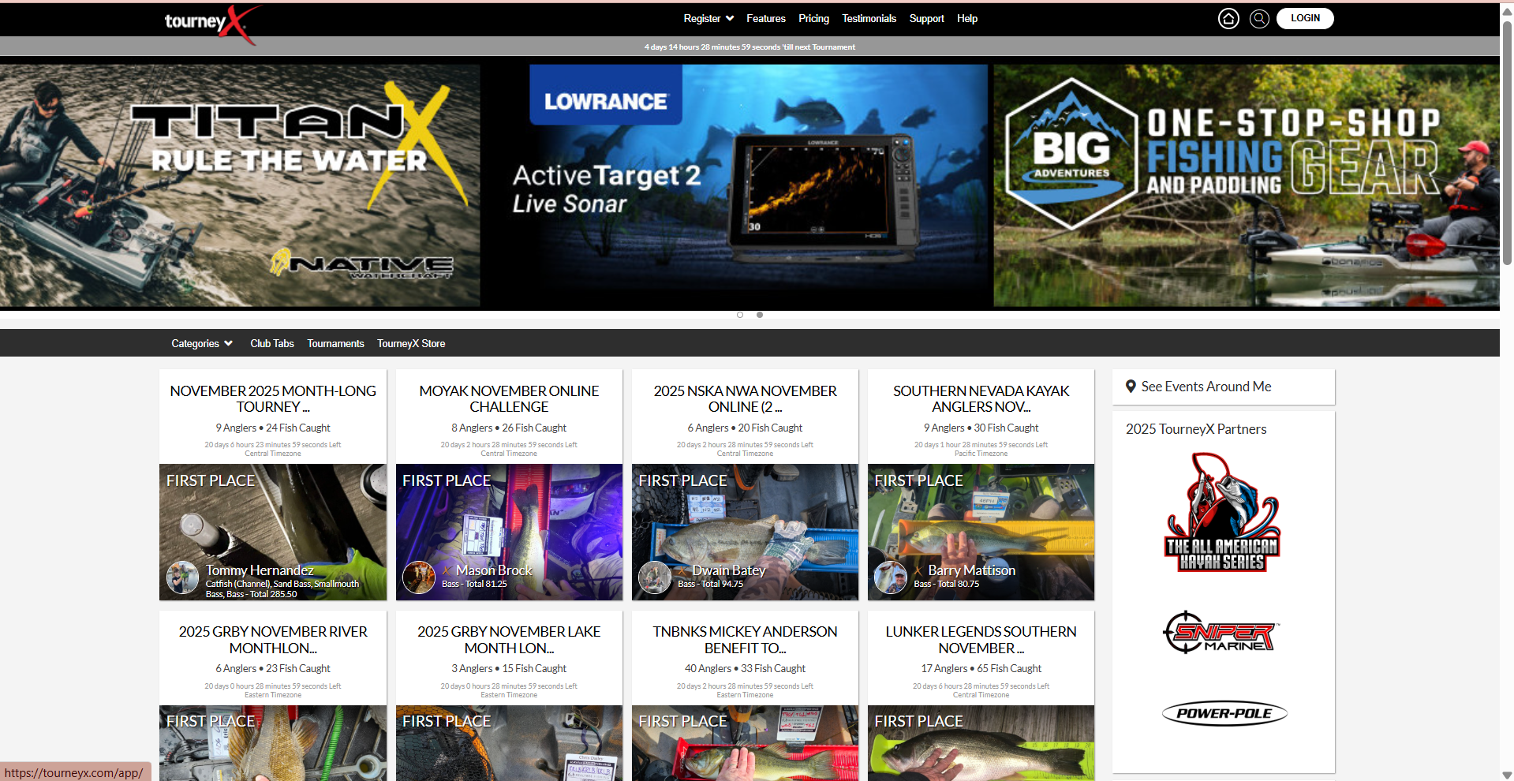

**Figure 2.1: TourneyX Tournament Advertisement**

Source: TourneyX, n.d.

1. **User Dashboard Management**

Anglers will be required to create an account before they can register for a tournament. As shown in Figure 2.2, users may select the event they interested in and can fill in the registration form and complete payment to register sucessfully.

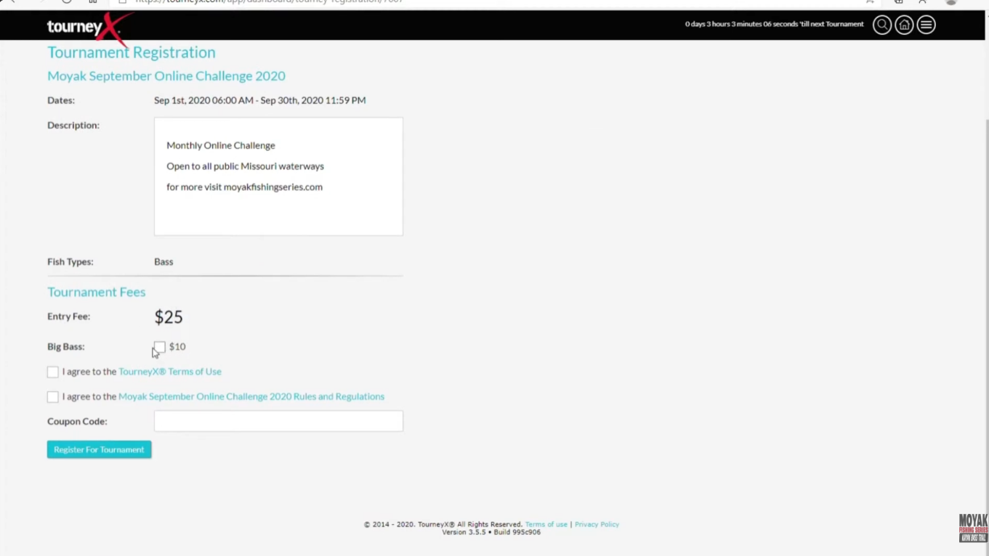

**Figure 2.2: TourneyX Angler Tournament Registration**

Upon registration, new members will get access to the personal dashboard (Figure 2.3) that features important features. The user dashboard is the main control panel for every participant throughout the tournament. Some of the main tasks that angler can perform through this dashboard include reporting fish catches, live ranking positions, team management, altering fishing days, check in as well as club details. This feature helps anglers in keeping track of everything they need and have all their tournament data in one easy place.

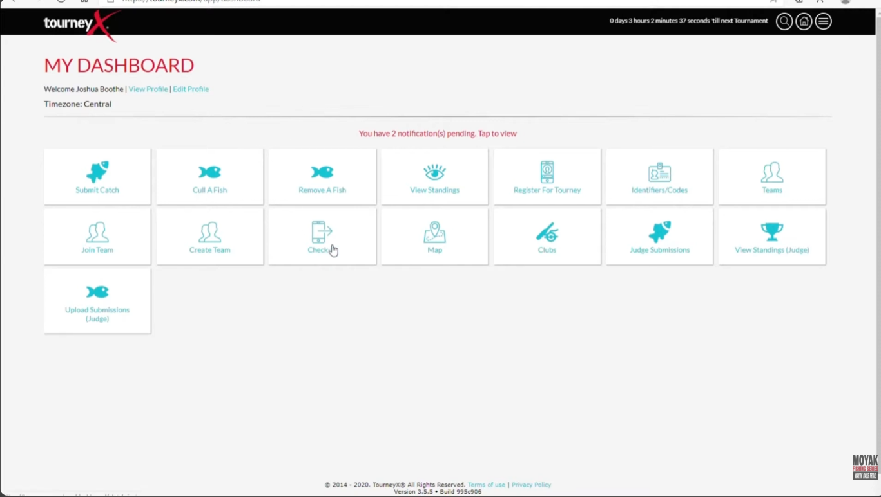

**Figure 2.3: TourneyX User Dashboard with Tournament Features**

1. **Fish Catch Submission**

The fish catch submission system is considered one of the most important functions in TourneyX system. The anglers are able to submit their catch directly via the submission form provided in Figure 2.4. The form allows anglers to upload a clear photo of their fish placed on a measuring board along with the fish species, length and date. The system also record the time, date and GPS location of the catch automatically to ensure fairness.

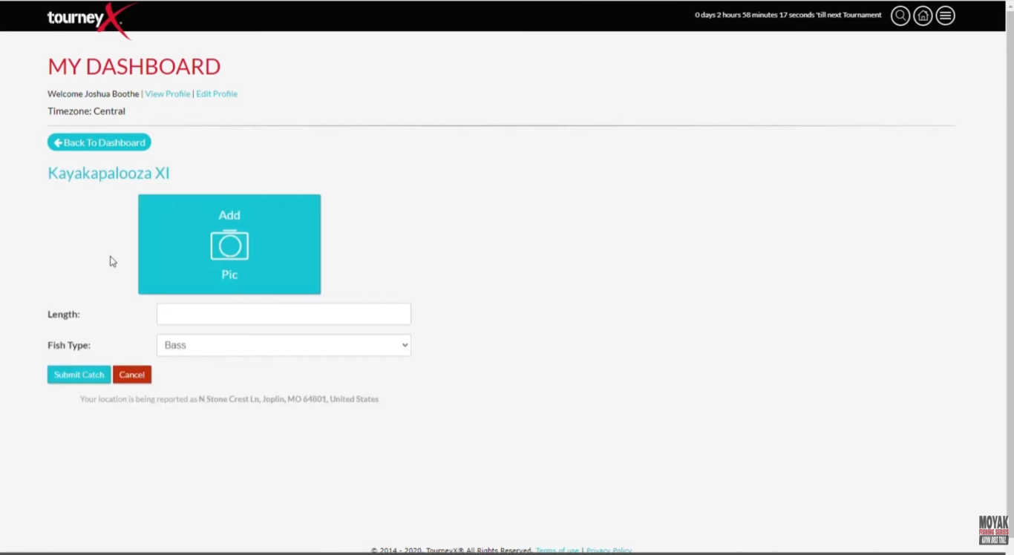

**Figure 2.4: TourneyX Angler Fish Catch Submission Form**

Once submitted all the catch records will be presented in a list format as in Figure 2.5 and both the angler and the organizer will be able to easily review and monitor all the entries.

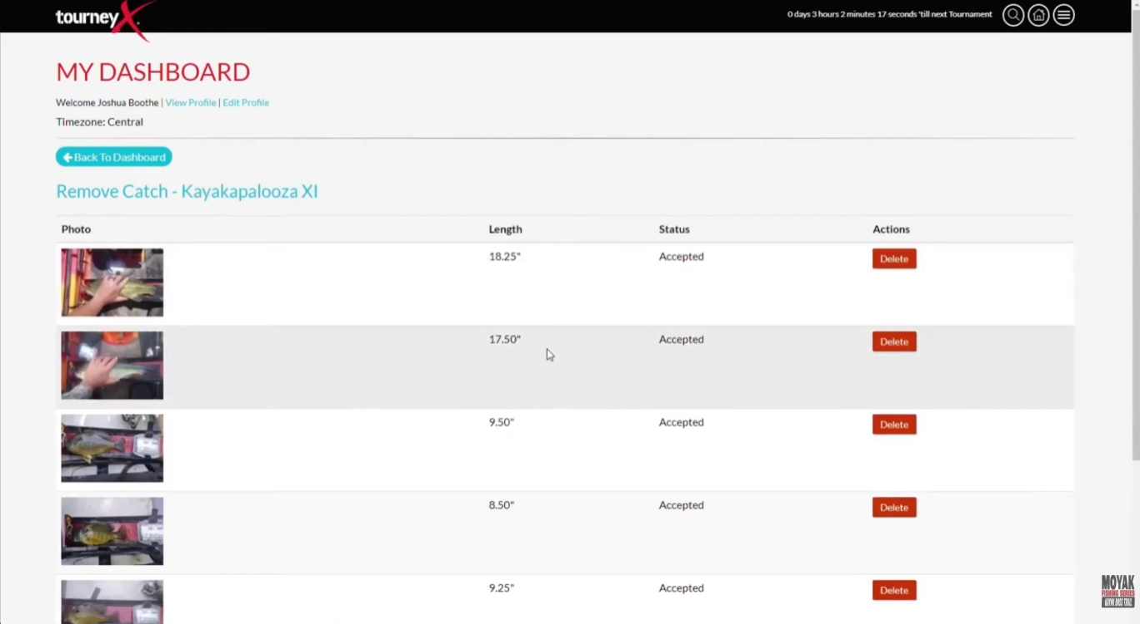

**Figure 2.5: TourneyX List of Catch Records**

The platform also includes a map feature (Figure 2.6) that displays the fishing spots where the catches were made. This makes the process transparent and easy to monitor.

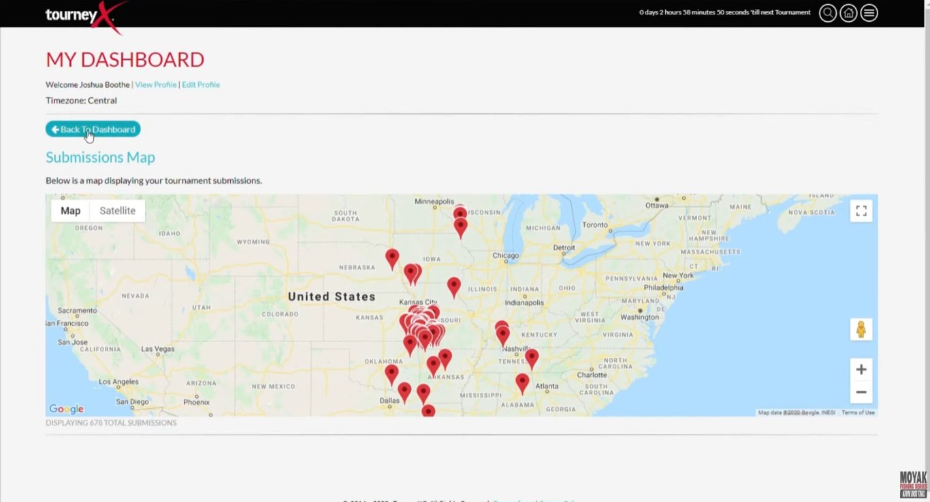

**Figure 2.6: TourneyX Fish Catch Submission Map**

This digital approach to fish submission has replaced the traditional weigh-in process that was once common in fishing tournaments. TourneyX facilitates a sustainable approach to catch, photo and release so that the fish population and the environment can be preserved by enabling the angler to take photos and release the fish immediately.

1. **Live Result Standing**

TourneyX also features a live results system that automatically update when new catches are submitted and verified. As shown in Figure 2.7, the live leaderboard displays each angler’s name, score and ranking in real time. This makes the competition transparent and allows both participants and administration to track the tournament progress in real time.

The live result feature helps to create a more interactive and engaging experience. Anglers can see how they are performing compared to others without waiting for manual result updates. It also gives the angler a sense of excitement as they can monitor who is leading the tournament any time.

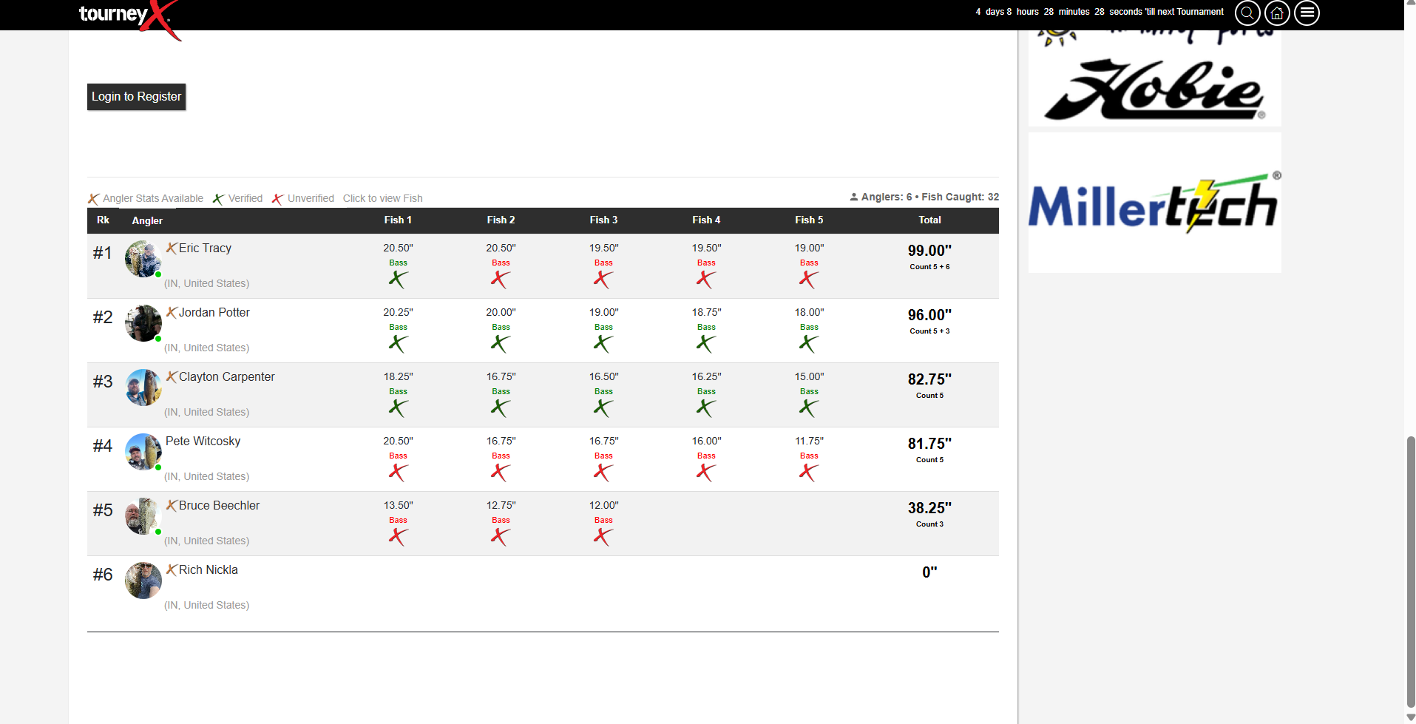

**Figure 2.7: TourneyX Tournament Live Result**

1. **Admin Management Dashboard**

For tournament organizers, TourneyX provides a complete admin management dashboard that simplifies the entire process of organizing a tournament. As shown in Figure 2.8, the admin dashboard includes several tools that allow organizers to create new tournaments, manage fish submissions, send notifications or emails to participants and also handle payments.

The dashboard is designed to give administrators full control over every aspect of the tournament. They can easily check on ongoing tournament, monitor angler activity, update tournament information and ensure everything runs smoothly. The system enables the organizers to save time and prevents confusion by centralizing all the management functions.

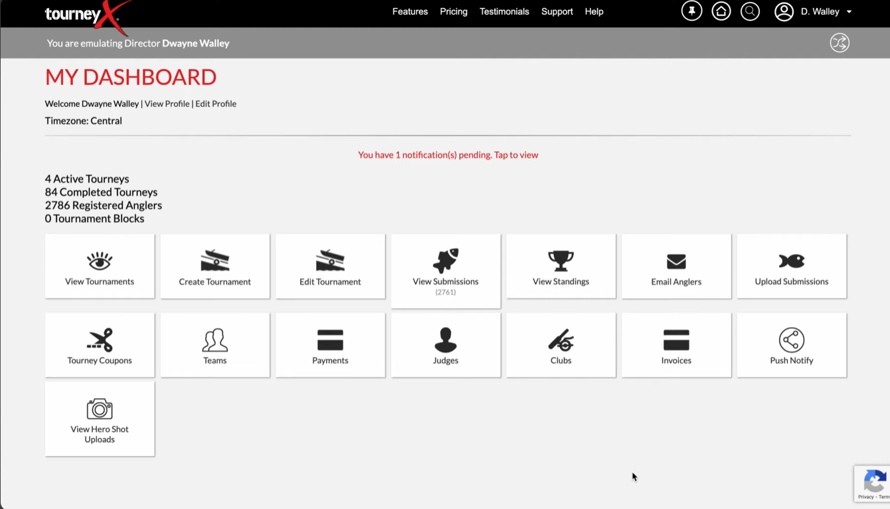

**Figure 2.8: TourneyX Admin Tournament Management Dasboard**

1. **Catch Fish Management and Verification**

The verification of catch fish is one of the most important steps in ensuring fairness and accuracy in fishing tournaments. The TourneyX platform has a specific area where administrators may check and approve fish submissions. As shown in Figure 2.9, all catches submitted by anglers are listed in one pages and this allow organizers to check each entry carefully before approving the catches.

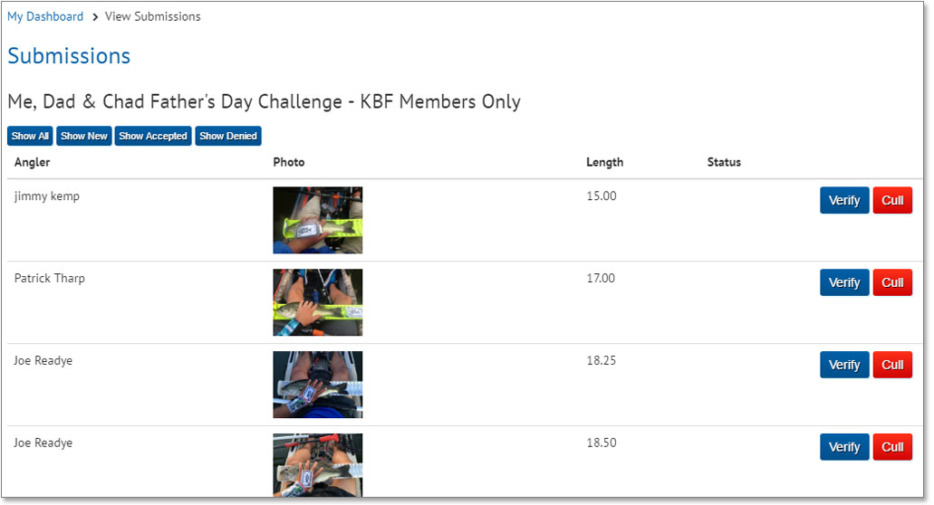

**Figure 2.9: TourneyX List of Catch Fish Submission**

Figure 2.10 depicts a verification interface where administrators would view the uploaded fish photos, validate the measurements and make sure that the submission is done according to tournament rules. The catch will only be displayed in the official leaderboard after having been validated. This verification process helps maintain trust and fairness throughout the tournament by preventing cheating or false reporting.

**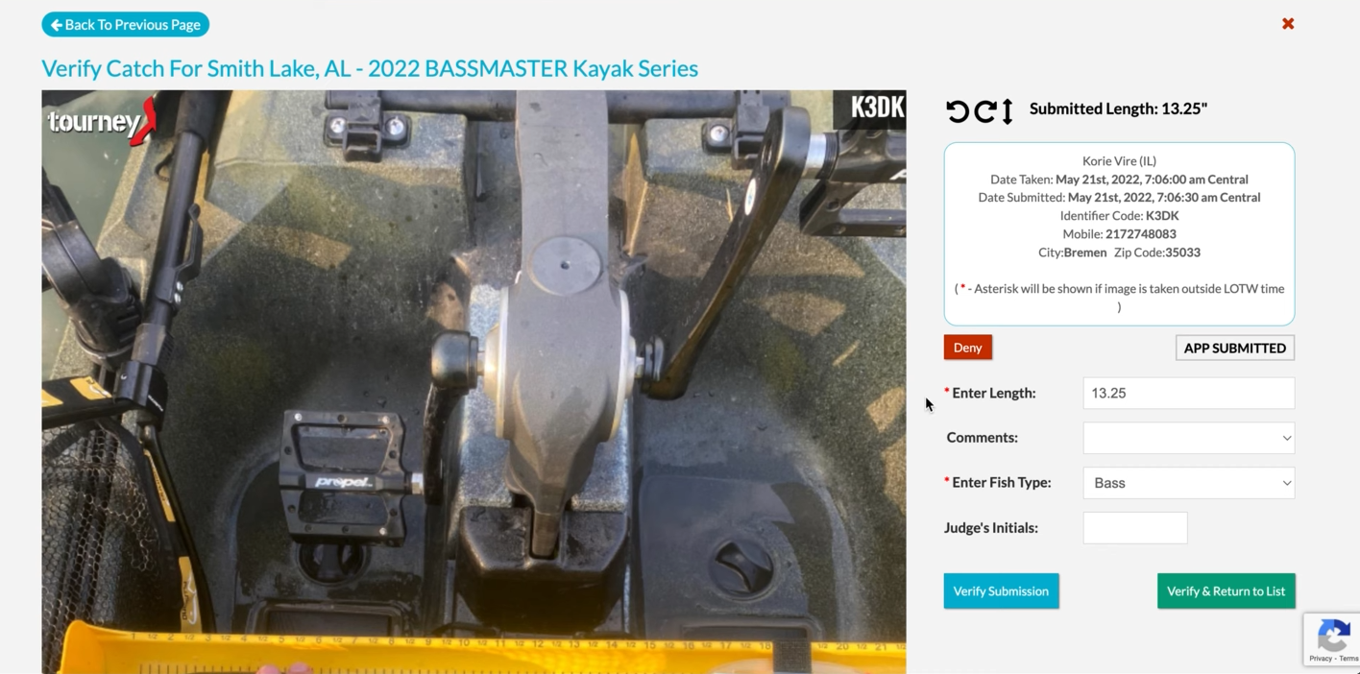  
Figure 2.10: TourneyX Admin Verification of Angler Catch Submission**

Overall, TourneyX demonstrates how digital technology can improve the management of fishing tournaments. The platform offers a convenient, transparent and fair platform to both the angler and the tournament organizers. TourneyX saves much time to both participants and administrators by automating most of its processes including registration, submission of fish catches, live scores and verifications, thereby minimizing the chances of human error. Moreover, the system is sustainable as it enhances a catch-photo-release technique whereby fish are recorded without being injured, as opposed to weigh-ins, which are stressful and injurious to fish.

Despite its strengths, TourneyX has several limitations that affect its usability in certain situations. One major limitation is that fish catches are submitted and recorded by the anglers themselves. This can sometimes lead to errors such as incorrect measurements, wrong species identification or even intentional misreporting. While the system includes photo verification and GPS tagging to reduce mistakes, human errors or dishonest submissions can still occur which affecting the accuracy and fairness of the tournament results.

Another important limitation is the platform’s interface which some users have found to be not very intuitive. Navigating through different features like catches, rankings or teams can be confusing to new users or those who are not so fluent in using the digital technologies. These factors can sometimes reduce the overall user experience and create barriers for efficient participation in tournaments.

Recognizing these limitations, SmartAngler aims to build upon the strengths of TourneyX while addressing its weaknesses. This system will also focus on creating a more user-friendly interface with simpler navigation, clear menus and step-by-step guidance to make it easy for all users regardless of their technical experience. In addition, SmartAngler will also offer advanced data analytics to both the angler and organizers, such as advanced performance analysis, history and statistics which can be used to plan strategically and enhance overall management of a tournament.

* + 1. **WeighBook**

WeighBook is another popular platform used for managing fishing tournaments, but it focuses more on traditional weigh-in systems where organizer will weigh the total fish the angler catches and record in the system. The platform provides tools for both anglers and tournament organizers in helping them manage tournaments, record catches and handle results efficiently. While it is not fully digital like some other platforms, it simplifies many manual processes that were once time-consuming and prone to errors.

1. **Tournament Advertisement List**

WeighBook allows anglers to search for tournaments easily using the advertisement list shown in Figure 2.11. Users can filter tournaments by city or zip code and also by entry fee range. This makes it simple for anglers to find the exact events that match their location and budget. This search and filtering feature makes browsing tournaments simple, saves time and ensures anglers can quickly find the right competitions for them.

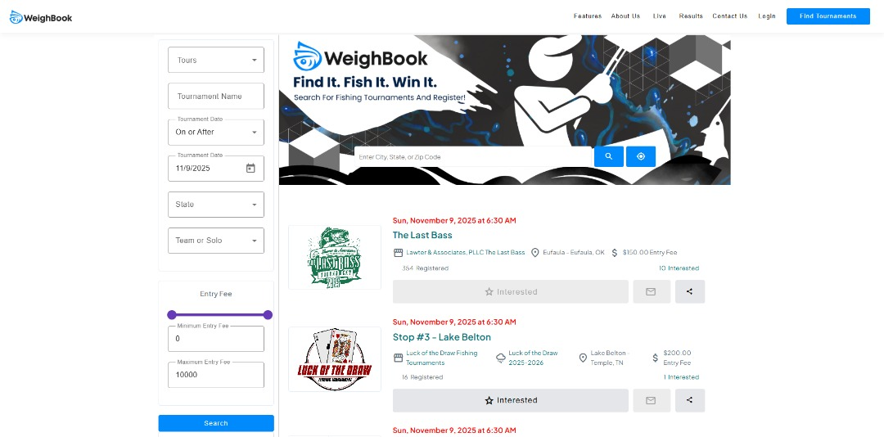

**Figure 2.11: WeighBook Tournament Advertisement List**

Source: WeighBook, n.d.

1. **Tournament Result**

The platform provides clear and organized tournament results. As seen in Figure 2.12, it lists each participant’s name, the total weight of fish they caught, the number of fish and their ranking. This allows anglers to easily see how they performed and enables organizers to monitor ranking standings in real time. Presenting results in a structured way also helps in maintaining transparency and fairness throughout the tournament.

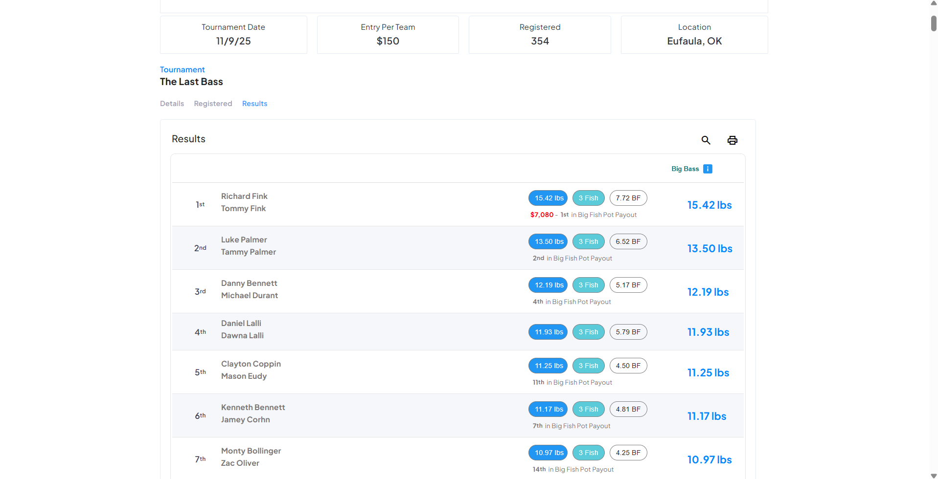

**Figure 2.12: WeighBook Tournament Result**

**iii. Administration Management**

WeighBook offers a comprehensive dashboard for tournament organizers. Figure 2.13 shows that the admin dashboard includes a sidebar with various functions such as managing tournaments, handling angler registrations, scheduling events on a calendar, sending messages, processing payments and more. This centralized system helps organizers manage multiple tasks in one place and reducing the chance of errors and confusion.

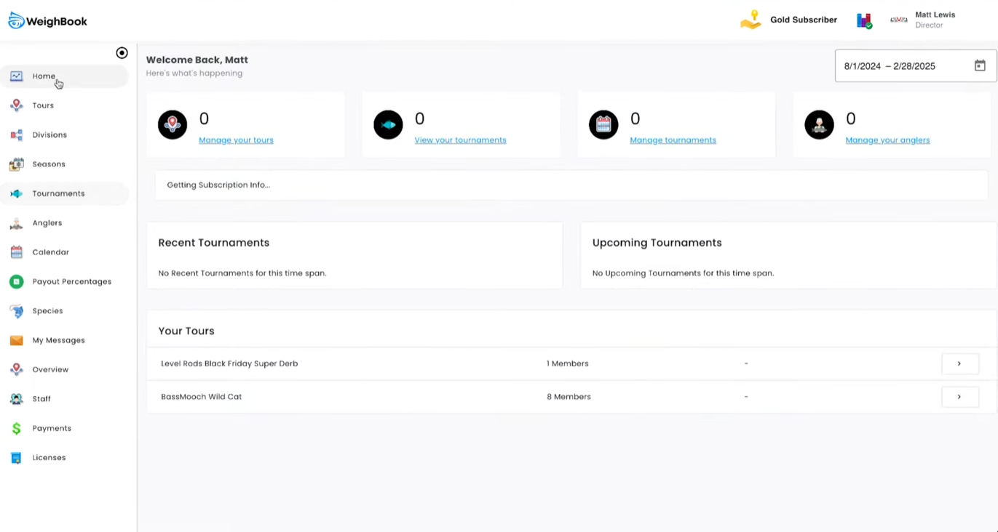

**Figure 2.13: WeighBook Administrator Dashboard**

Creating and managing tournaments on WeighBook is designed to be clear and organized for administrators. Administrators can fill in all the basic tournament details, rules, entry fees and payout structures through the form illustrated in Figure 2.14. This ensures that every tournament is properly prepared from the very beginning. It also helps participants understand exactly what to expect including the rules they need to follow, the fees they must pay to join and the prizes they could win. Having all this information clearly entered and displayed will reduces anglers’ confusion and prevents mistakes.

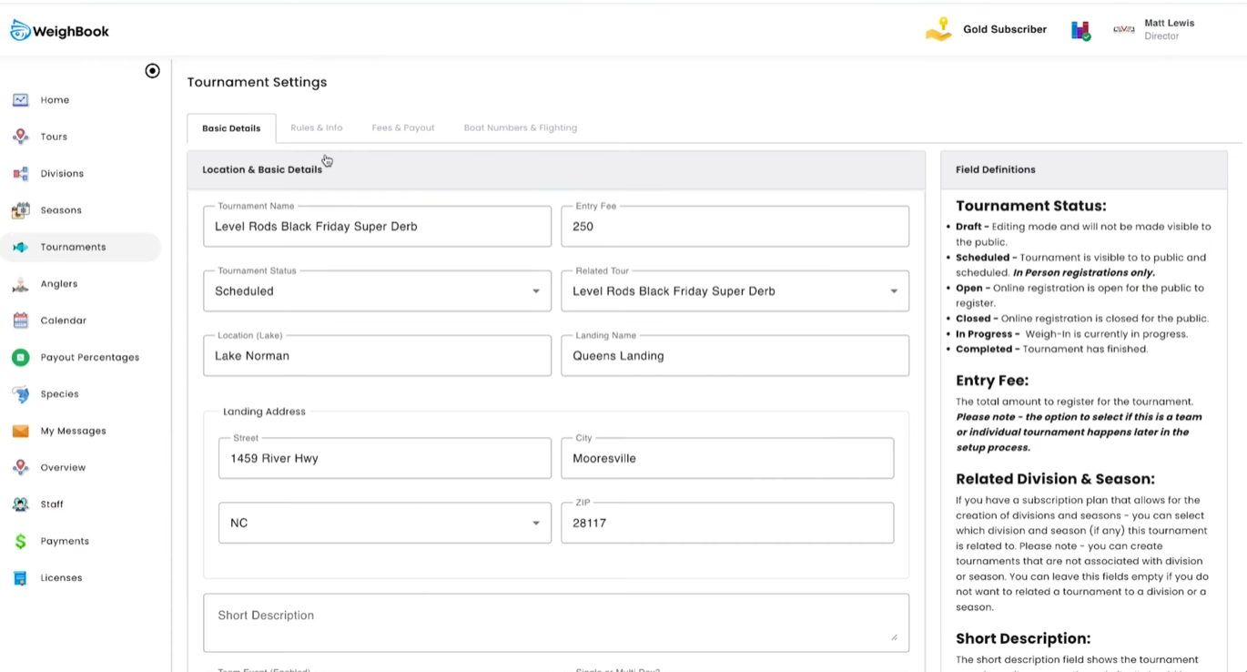

**Figure 2.14: WeighBook Tournament Creation and Management**

Fish catch logging is handled carefully through the system. Figure 2.15 shows that administrators can enter records directly into the system and the recors are printable. Each entry includes total fish caught, total weight and any penalties if applicable. Administrators can approve, remove or adjust entries as needed to ensure accuracy.

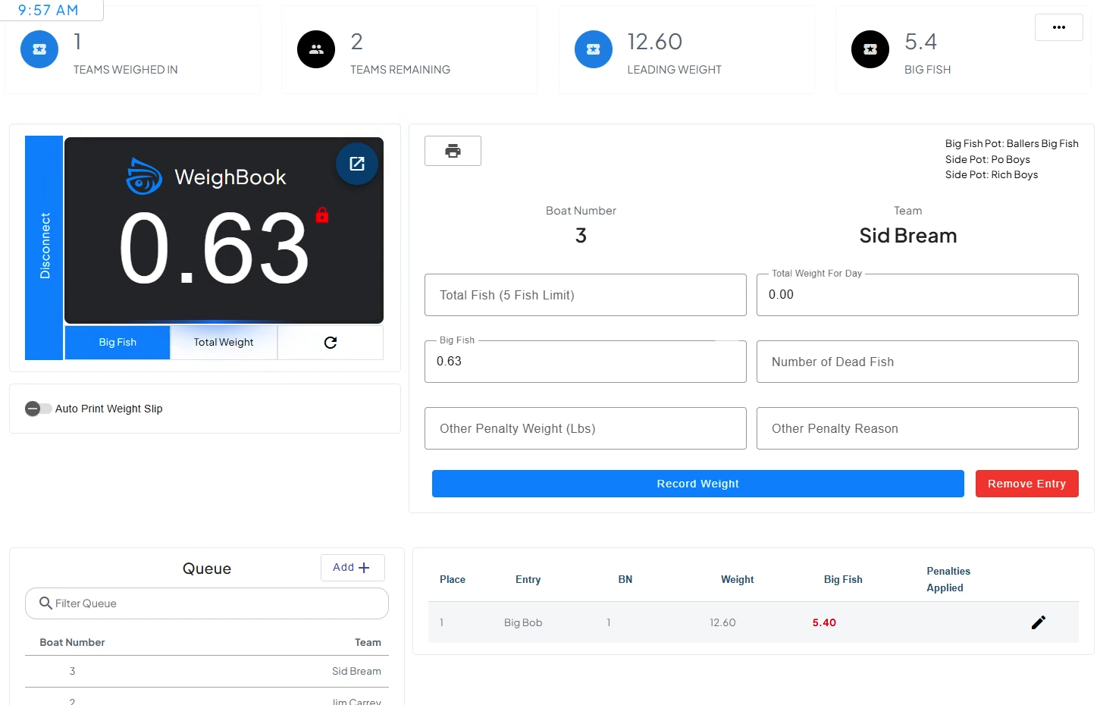

**Figure 2.15: WeighBook Fish Catch Logging**

Finally, the platform provides a tournament result management feature shown in Figure 2.16. This lists all winners, their results and the prizes they won. The results can also be shared easily, making it convenient for both organizers and participants to access the final outcomes.

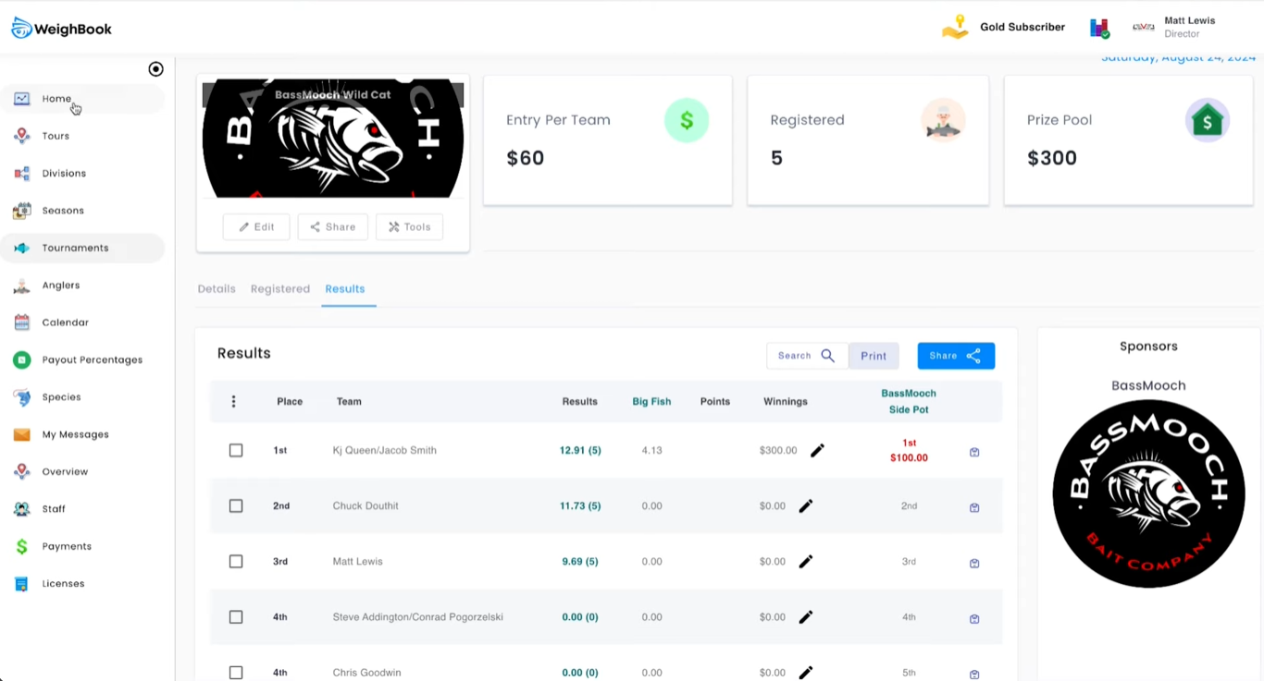

**Figure 2.16: WeighBook Tournament Result Management**

In conclusion, WeighBook is a reliable platform for managing traditional fishing tournaments that rely on physical weigh-ins and administrator-recorded data. It provides tools for searching tournaments, tracking results, logging fish catches and managing all aspects of event administration in one place. The system helps organizers keep tournaments organized, reduces paperwork and ensures that results are transparent and accurate.

* + 1. **FishPal**

FishPal is an online platform that simplifies booking fly fishing trips in the UK and Ireland by connecting fishery owners directly with anglers. It makes it easy for users to find fishing locations, check availability and make reservations online. By streamlining these tasks, the platform reduces organizer work for fishery owners while offering anglers a simple and reliable way to plan their trips.

The user-friendly interface, shown in Figure 2.17, allows anglers to quickly search for and reserve their fishing spots, making the entire process smooth and efficient. Overall, FishPal benefits both anglers and fishery owners by saving time, reducing workload and providing a convenient and organized way to manage fishing trips.

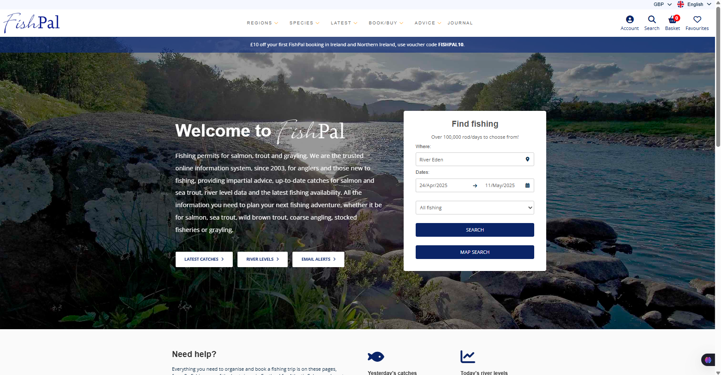

**Figure 2.17: FishPal Main Interface**

Source: FishPal, n.d.

1. **Booking System**

One of the main strengths of FishPal is its efficient booking system which allows anglers to quickly search for fishing spots, check available dates and make bookings with just a few clicks. This helps users plan trips faster without the need for phone calls or emails. In addition, the platform provides a list of available fishing spots as shown in Figure 2.18 which allowing anglers to view all opportunities at specific locations. This makes it easier to select spots that match their preferences, such as the type of fish, location convenience or accessibility. By having all options clearly displayed, anglers can make better decisions and enjoy a more organized trip planning experience.

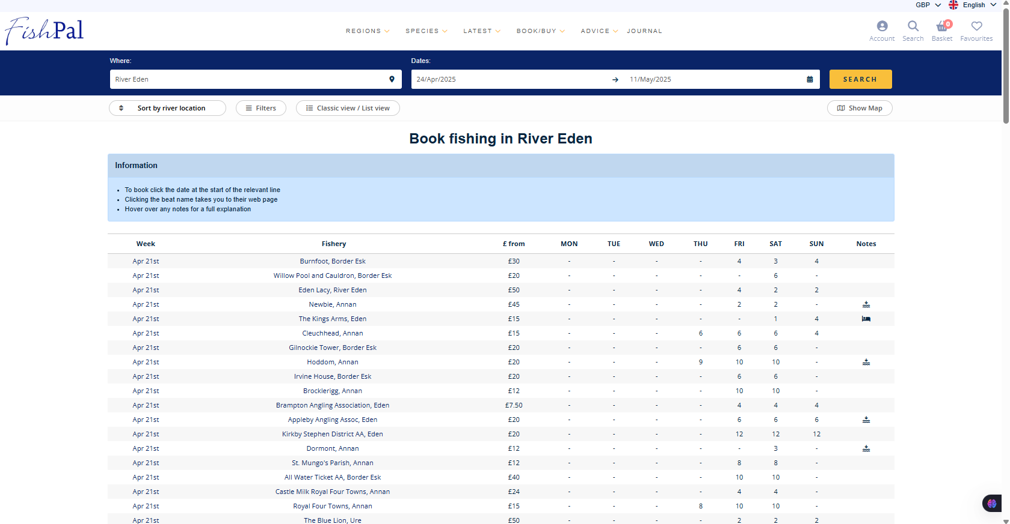

**Figure 2.18: Fishpal List of Available Book Fishing**

1. **Detailed Fishing Advertisement Information**

FishPal also provides detailed information about each fishing location, as seen in Figure 2.19. This includes the types of species available, fishing conditions, opening hours and other essential details. These information can help users make informed decision and make sure that anglers are prepared for the conditions they will encounter. By providing comprehensive details upfront, the platform minimizes uncertainty and enhances the overall user experience.

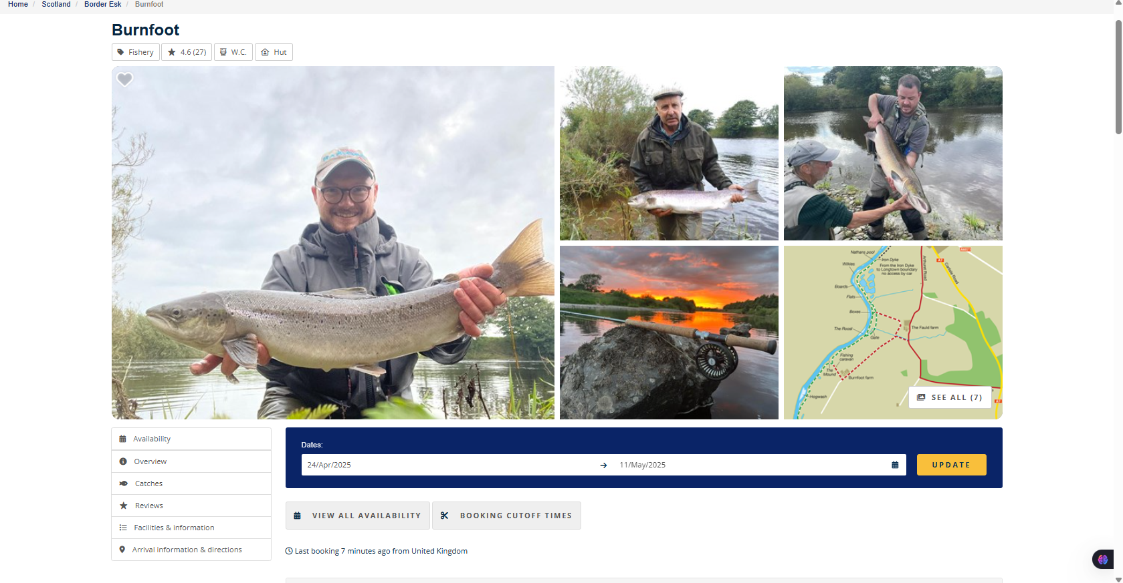

**Figure 2.19: FishPal Detailed Information of the Fishing Activities**

1. **Fish Catch Analysis**

Moreover, FishPal includes tools like fish catch analysis which were displayed in Figure 2.20. It gives insights into recent fishing trends and patterns. This allows anglers to plan their trips based on actual catch data and improves their chances of a successful fishing experience. By offering evidence-based insights, FishPal helps users make informed decisions rather than relying solely on guesswork or previous experience.

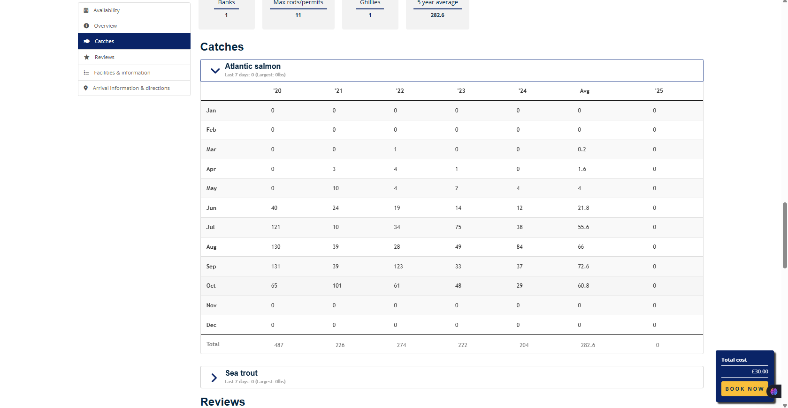

**Figure 2.20: FishPal Fish Catch Analysis**

1. **Angler Reviews**

The platform also includes reviews from other anglers as illustrated in Figure 2.21. These reviews allow new users to read feedback about different locations and learn from the experiences of others. By sharing personal experiences and ratings, this reviews help build trust in the platform and give users a better understanding of what to expect at each fishing spot. This feature also encourages transparency and helps anglers choose locations with confidence.

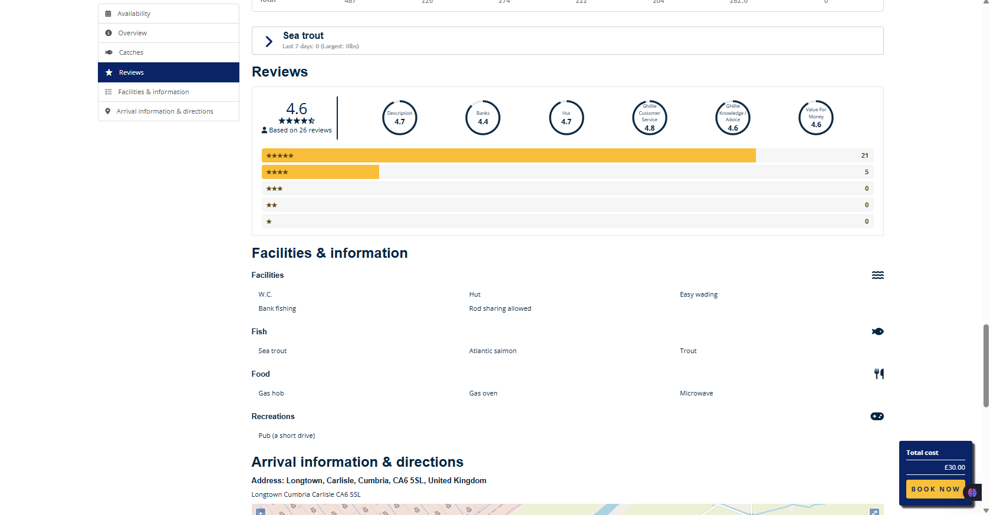

**Figure 2.21: FishPal Anglers’ Reviews**

However, this system only focusses on fly-fishing spots in the UK and Ireland. While it provides extensive coverage of fishing locations within these regions, it does not support fishing opportunities in other countries or areas outside the UK and Ireland. This means anglers looking to book trips abroad or explore different types of fishing will need to find another platform. As a result, FishPal is limited to a specific geographic area which may not meet the needs of anglers seeking broader or international fishing experiences.

* + 1. **KeepNet**

KeepNet is an online platform designed to simplify the process of organizing and participating in fishing tournaments. It provides features that help both tournament organizers and anglers by making event management easier and improving the overall participant experience. With its user-friendly interface, KeepNet allows organizers to promote their events, register participants and track the progress of tournaments.

For anglers, KeepNet provides a simple way to discover tournament ads, join competitions and compete in fishing tournaments across various locations. As illustrated in Figure 2.22, the competition list dashboard displays a wide selection of available tournaments, allowing users to browse through events easily and select those that best suit their interests.

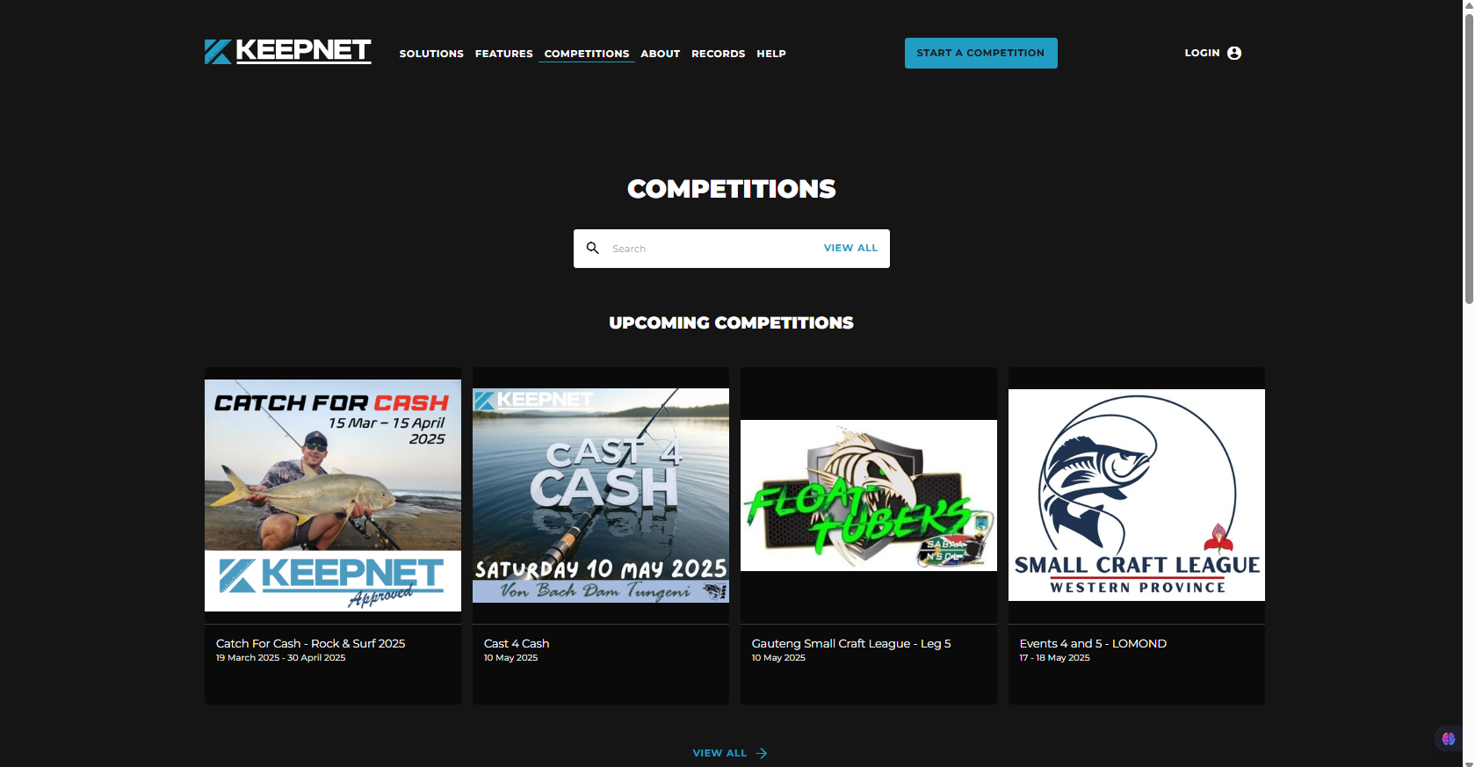

**Figure 2.22: KeepNet Competition List Dashboard**

Source: KeepNet, n.d.

1. **Tournament Advertisement and Promotion**

One of the key features of KeepNet is its ability to help organizers promote their fishing tournaments efficiently. The platform allows event organizers to post detailed advertisements for each tournament which including key information such as dates, locations, rules, registration requirements and entry fees.

This digital approach replaces traditional manual advertising and ensuring that events reach a wider audience of anglers. The listings are displayed directly on the platform and making it easy for users to discover and register for upcoming competitions. As shown in Figure 2.23, the tournament details page allows potential participants to view all event-related information in one place and proceed with registration seamlessly. This feature not only increases visibility for local and national tournaments but also encourages higher participation rates which helping organizers attract more anglers to their events.

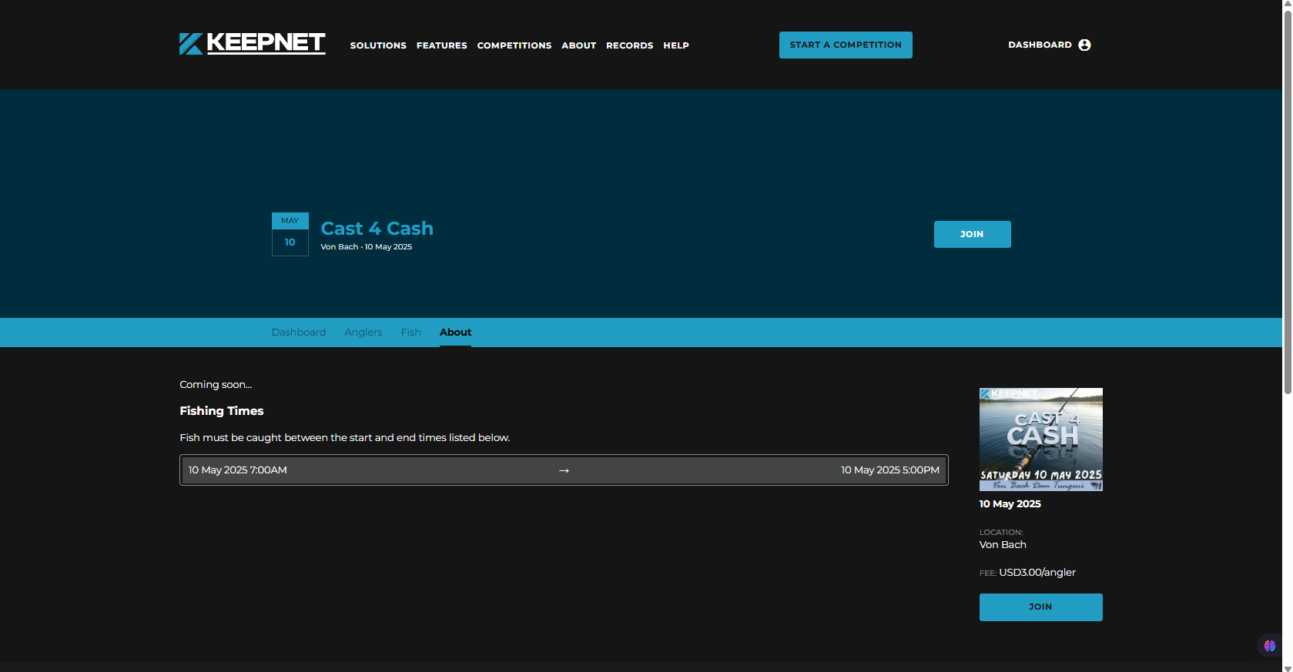

**Figure 2.23: KeepNet Fishing Tournament Details**

1. **Simplified Registration Process**

KeepNet also streamlines the registration process for anglers. It offer a simple and efficient way to join tournaments. Once a tournament is published, users can easily browse through the list of available events and explore details such as dates, locations, and rules and register directly through the platform. This eliminates the need for traditional paper forms or external registration systems which can often be time-consuming and prone to human error.

By digitalizing the entire registration workflow, KeepNet ensures a faster, more accurate and user-friendly experience for both organizers and participants. Anglers can complete their registration with just a few clicks, while organizers benefit from automated participant tracking and reduced administrative workload. This simple process encourages greater participation and helps maintain an organized and transparent tournament environment.

1. **Live Leaderboard and Real-Time Results**

Another important feature of KeepNet is its live leaderboard which allows participants to monitor their performance in real time throughout the tournament. As the event progresses, the leaderboard automatically updates with the latest results and showing each angler’s ranking, total catch and overall standing compared to others. This instant feedback keeps participants engaged and motivated to perform better as they can immediately see how their catches affect their position in the competition.

The live leaderboard also enhances the excitement of the event for both anglers and spectators by making it more dynamic and interactive. Anglers can follow the progress of their performance and stay updated on changing results. This feature not only improves the overall experience but also brings transparency and fairness to the tournament process, as shown in Figure 2.24, which displays the live results leaderboard.

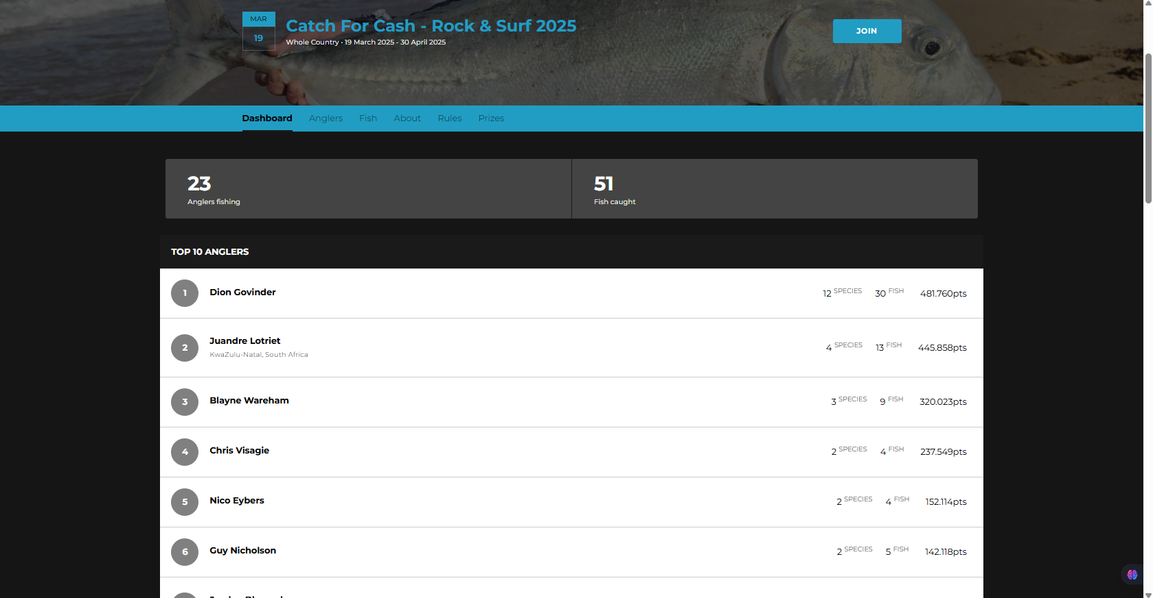

**Figure 2.24: KeepNet Live Results Leaderboard**

1. **Sponsorship and Community Engagement**

In addition, KeepNet also includes features for sponsorship promotion as illustrated in Figure 2.25. Organizers can showcase sponsors directly on the platform, providing visibility to partnering brands and creating opportunities for collaboration. This not only helps attract funding and support for tournaments but also strengthens the fishing community by connecting organizers, sponsors and participants through a shared digital ecosystem.

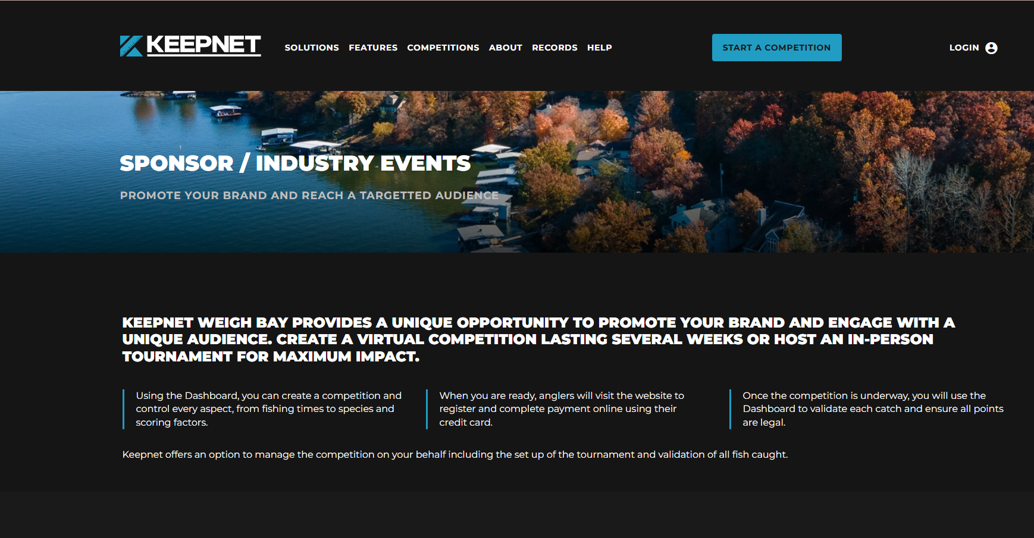

**Figure 2.25: KeepNet Sponsorship Page**

Overall, KeepNet shows how digital technology can greatly improve the way fishing tournaments are organized and experienced. By bringing together tools for event promotion, participant registration, live result tracking and sponsorship management, the platform makes the whole process more efficient and enjoyable for both organizers and anglers. Its easy-to-use interface and real-time updates help create a smoother and transparent tournament experience. KeepNet not only saves time and reduces manual work but also adds excitement and fairness to competitive fishing events.

* + 1. **Reel LiveWell**

Reel LiveWell is a fishing tournament app designed to simplify and improve the catch-record-release (CRR) process. Originally created in 2019 for the Classic Bass Champions Tour, the app has since been adopted by organizations like the Student Angler Tournament Organization (SATO) and the Minnesota Student Angler Tournament Trail (MNSATT). The app provides a complete solution for both tournament organizers and participants, focusing on sustainability, real-time tracking, and a user-friendly experience.

One of the standout features of Reel LiveWell is its customization options for tournament organizers. The app lets them set up events based on different factors, such as species, weight, length and the number of fish caught. This flexibility makes it ideal for both single-species and multi-species events. Organizers can also post tournament advertisements, which helps attract participants and increases the visibility of the events, as shown in Figure 2.26, where users can see a list of available fishing competitions.

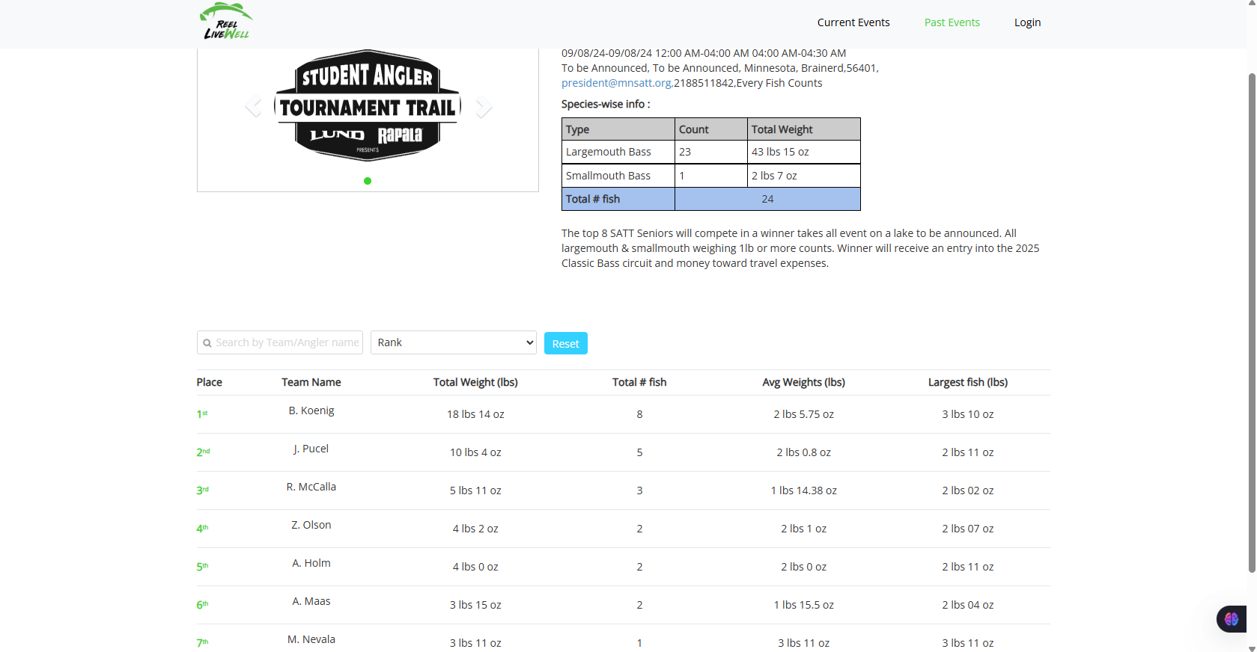

**Figure 2.26: Real-Time Leaderboard of Fishing Competition Results**

Source: Reel LiveWell, n.d.

Reel LiveWell also allows real-time updates, enabling participants to track catches and view live results during the event. This feature creates excitement and engagement, making the tournament more interactive for everyone. Figure 2.21 shows the real-time leaderboard, where participants can view their catches and their standing in the competition as it progresses.

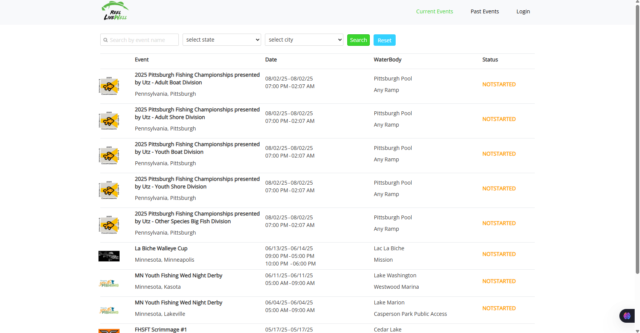

**Figure 2.27: List of Available Fishing Competitions**

**2.6 Comparison of Existing Fishing Tournament System**

The System Comparison Table provides an overview of various fishing tournament management systems, including iAngler, FishAngler, FishPal, KeepNet, Reel LiveWell, and the proposed SmartAngler system. It compares their key features like user authentication, tournament advertisement, participant registration, fishing spot booking, calendar, fish catch logging, live leaderboards, result management, and reviews. This comparison helps highlight the strengths and weaknesses of each system, offering insights into how they support tournament organizers and participants.

**Table 2.1: Comparison Between SmartAngler system with The Existing System**

|  |  |  |  |  |  |  |  |
| --- | --- | --- | --- | --- | --- | --- | --- |
| **No.** | **Features** | **SmartAngler** | **TourneyX** | **WeighBoook** | **FishPal** | **KeepNet** | **Reel LiveWell** |
| **1** | User Authentication | YES | YES | YES | YES | YES | YES |
| **2** | Tournament Advertisement | YES | YES | YES | YES | YES | YES |
| **3** | Participant Registration | YES | YES | YES | YES | YES | NO |
| **4** | Fishing Spot Booking | YES | NO | NO | YES | NO | NO |
| **5** | Notification and Announcement | YES | NO | YES | NO | NO | NO |
| **6** | Catch Fish Log | YES | YES | YES | NO | NO | NO |
| **7** | Sponsorship & Prize Management | YES | NO | YES | NO | YES | NO |
| **8** | Result Management | YES | YES | YES | YES | YES | YES |
| **9** | Review | YES | NO | NO | YES | NO | NO |

Based on the finding in Table 2.1, it shows that SmartAngler system is designed to bring together the best features from all these systems and add more advanced capabilities. It will provide features such as real-time tracking, automated fishing spot booking, live leaderboards, and participant reviews. SmartAngler aims to improve the tournament experience by addressing the gaps in current systems, making it a more complete and accessible option in the modern approach to the organization of the fishing tournament.

**2.7 Summary of Literature Review**

In summary, the literature review provides a thorough examination of fishing tournament management systems. It focuses on the evolution of the fishing tournament and the role of technology in modernizing this tournament processes. The review also highlights the impact of fishing tournaments such as boosting local economies, encouraging healthy outdoor activities and building stronger angler communities. The review also compared existing systems like TourneyX, WeighBook, FishPal, KeepNet and Reel LiveWell and identify their strengths and limitations. Overall, the review supports the development of SmartAngler as a modern solution to improve fishing tournament management for both organizers and participants.

**CHAPTER 3**

**METHODOLOGY**

* 1. **Introduction**

The project methodology explains the stages and steps that will be followed to develop the SmartAngler system. It outlines the Software Development Life Cycle (SDLC), which is the process that will guide the entire project. The SDLC includes key stages such as planning, analysis, design, implementation and testing. Each of these stages is important to ensure that the system is developed effectively and meets the goals of the project. This chapter provides a clear understanding of the process that will be used to develop SmartAngler and ensures the project is completed successfully within the defined timeline.

* 1. **Project Methodology for SmartAngler**

This project applied the Waterfall Development Model, a linear and sequential approach to system development. As shown in Figure 3, this model consists of six well defined phases which are Planning, Analysis, Design, Implementation, Testing and Project Closure. Each of these phases are clearly defined and must be completed before moving on to the next phase.

As highlighted in the study by Abdul *et al*. the Waterfall Model is particularly suitable for projects where the requirements are well-defined, stable and unlikely to change throughout the development cycle (Abdul *et al*., 2024). This model is sequential and linear whereby each phase is develop based on the previous one. Each phase must be completed before moving on to the next phase to ensure a thorough planning and analysis before any development begins. By doing this, the risk of changes and revisions during the later stages of development is minimized which making it ideal for projects with well-defined requirements.

In the context of SmartAngler, the project has clear and defined requirements, especially in terms of its core functionalities such as tournament advertisement, participant registration, fishing spot booking, fish logging and result management. These requirements are based on the needs of both the tournament organizers and participants, which were gathered through interviews and surveys. Since these core requirements are unlikely to change drastically throughout the development cycle, the Waterfall Model is a suitable choice for this project.

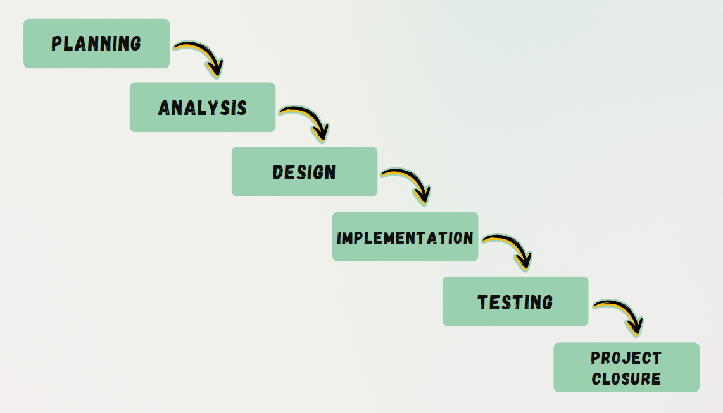

**Figure 3.1: Waterfall Model Phases for SmartAngler System Development**

* + 1. **Planning**

The Planning phase of the SmartAngler project begins by identifying the key problems faced by organizers and anglers in fishing tournaments. This involves studying and evaluating the existing fishing tournament systems to understand their limitations and challenges. By analysing these issues, a clear understanding of the current difficulties and define the scope for improvement can be defined.

Once the challenges are identified, the project’s objectives and scope are established. This includes determining the system’s functionality and ensuring that it addresses the specific needs of fishing tournament organizers and participants.

To support effective project management, a detailed Gantt chart is created, serving as a planning tool. This chart outlines tasks, deadlines and milestones while showing how each task depends on the others. The Gantt chart helps ensure that each phase of the development is properly planned and monitored, allowing for efficient allocation of resources and alignment with the project’s goals.

* + 1. **Analysis**

The Analysis phase focuses on gathering detailed requirements from the users regarding the required functions of the SmartAngler system to resolve the identified problems in the Planning phase. This stage involves direct interaction with key users to fully understand their operational requirements and expectations for the automated fishing tournament management system.

To gather insights, questionnaire are distributed to anglers to collect feedback about their experiences with current tournament processes and to identify their pain points. Additionally, interviews are conducted with tournament organizers to study administrative challenges that they faced.

Once all feedback is gathered, the requirements are categorized into functional and non-functional requirements. Functional requirements describe the core features and operations of the system. On the other hand, non-functional requirements define the system’s quality attributes, such as performance, usability, reliability, and data security. These well-defined requirements provide a solid foundation that guides the design phase, ensuring that the SmartAngler system meets user needs and expectations.

* + 1. **Design**

The Design phase of the SmartAngler system focuses on designing how the system will work and how it will look for users. This phase includes designing both the front-end and back-end of the system.

For the front-end, high-fidelity prototypes are created using Figma to visualize the design layout and functionality of the interface. This allows users to see how to navigate through the system. The goal is to ensure the design is intuitive, user-friendly and meets the requirements of both tournament organizers and participants.

For the back-end design, it focuses on how the system will process and manage data, ensuring smooth operations like storing participant information, logging fish catches, and generating results. It includes setting up the database structure and defining how the system will handle different types of data. Additionally, key diagrams are created which including use case diagrams, Data Flow Diagrams (DFD) and Entity Relationship Diagrams (ERD). These diagrams visually represent how the system’s components will interact with each other and how data will flow between them, providing a clear picture of the system’s architecture.

* + 1. **Implementation**

The Implementation phase is the actual development where the SmartAngler system is built based on the requirements defined in earlier phases. During this phase, the system's modules are coded and integrated to create a fully functional web-based application.

For the front-end development, the system will be developed using HTML (HyperText Markup Language) for structuring content, JavaScript for interactive elements and CSS (Cascading Style Sheets) for styling the user interface. These technologies will be used to create a clean and user-friendly interface that is easy to navigate for both organizers and participants.

For the back-end development, the system will be built using PHP (Hypertext Preprocessor), a server-side scripting language to handle the system's logic and interactions with the database. MySQL will be used for database management enabling efficient storage, retrieval and update of data related to participants, tournament details, fish logs and results.

* + 1. **Testing**

During this phase, the functionality of the SmartAngler system will be thoroughly tested to ensure it meets the defined requirements and performs as expected. Unit testing will be conducted on each module to verify that every component of the system works independently and integrates smoothly with the others. These tests are done to catch early-stage bugs, logical errors and misconfigurations in the system's basic components.

Following unit testing, the system’s usability and user satisfaction are evaluated using the System Usability Scale (SUS). The SUS is a standardized questionnaire that evaluates users' perceptions of the system’s usability, including aspects such as ease of use, efficiency and overall satisfaction. Feedback will be collected from key users, including tournament organizers and participants to measure the clarity of the interface and the overall user experience. The SUS data are analysed to identify strengths and areas that need to improve.

* + 1. **Project Closure**

The project closure phase is the final step of SmartAngler system development, with a focus on finalizing complete documentation. After the system has been fully created and tested, this phase involves creating a thorough final report that explains every part of the project, from problem identification to requirement analysis, design, implementation and testing. This phase ensures that the whole project is properly documented and ready for submission, thereby concluding the SmartAngler Final Year Project.

* 1. **Conclusion**

To conclude, this chapter has provided a insightful overview of the methodology used in the development of the SmartAngler system. The Waterfall Model was selected as the most suitable approach for this project because it offers a structured and step-by-step process that will ensures each phase including planning, analysis, design, implementation, testing and project closure is completed in systematic order. This methodology allows for clear progress tracking, minimizes risks and ensures that all requirements are met, which will eventually help the successful development of a user-friendly and efficient system for managing fishing tournaments.

**CHAPTER 4**

**SYSTEM DESIGN**

* 1. **Introduction**

In this chapter, the analysis and design of the SmartAngler system are thoroughly discussed. It begins with an analysis of the data collected through surveys from anglers (fishing tournament participants) and interviews with fishing tournament organizers. The insights gained from these interactions help guide the system’s design that will ensure it meets the users’ needs and addresses the challenges identified earlier in the project. The chapter further explores the architectural and technical design of the system which including key diagrams such as use case diagrams, Data Flow Diagrams (DFD), Entity Relationship Diagrams (ERD) and user interface designs using high-fidelity prototype. These diagrams and prototype will help to illustrate how the system will function, how data will flow and how users will interact with the SmartAngler system.

* 1. **Interview Findings**

An interview was conducted with Mr. Alphonsus Raymond Ongkudon, the owner and fishing tournament organizer of Kolam Rekreasi Pupuluton Valley (KRPV), located in Tambunan, Sabah. With over 12 years of experience in organizing fishing tournaments, Mr. Alphonsus had shared valuable insights into the challenges and current methods used for managing the fishing tournament.

During the interview with Mr. Alphonsus, he explained that the main tasks involved in organizing fishing tournaments still managed using a manual process. The registration of participants is made manually in paper forms that leads to the long queues and possible errors in the information input. Additionally, fishing spot bookings are also handled manually, either by phone or in person and recorded on paper (shown on Figure 4.1) which sometimes leads to double bookings or confusion about available spots. He mentioned that these manual processes are manageable for small events but become overwhelming when the number of participants increases.

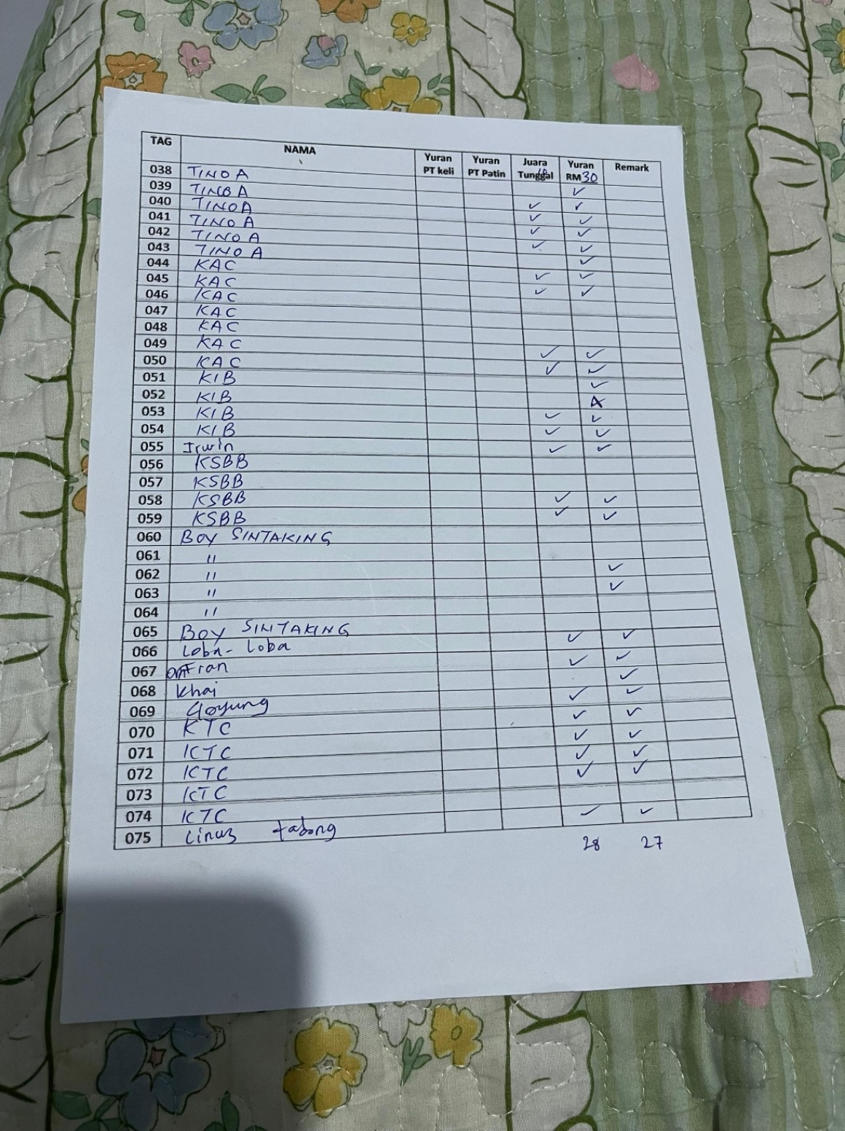

**Figure 4.1: Booking and Registration Record on Paper**

Mr. Alphonsus also discussed the difficulties in advertising tournaments. They primarily use social media platforms like Facebook and WhatsApp to advertise fishing tournament flyers and share updates. He however recognized the shortfalls of using these platforms since not everyone makes regular checks on them hence leading to missed information or confusion about event details.

Regarding tracking fish catches and results, Mr. Alphonsus stated that the process was done manually using paper logs (shown in Figure 4.2) which are later inserted into Excel spreadsheets. This process is time-consuming and prone to errors especially when there are large numbers of fish caught during the tournament. He also highlighted the delays in generating and announcing results as they are manually generated and often updated late which leading to participant frustration.

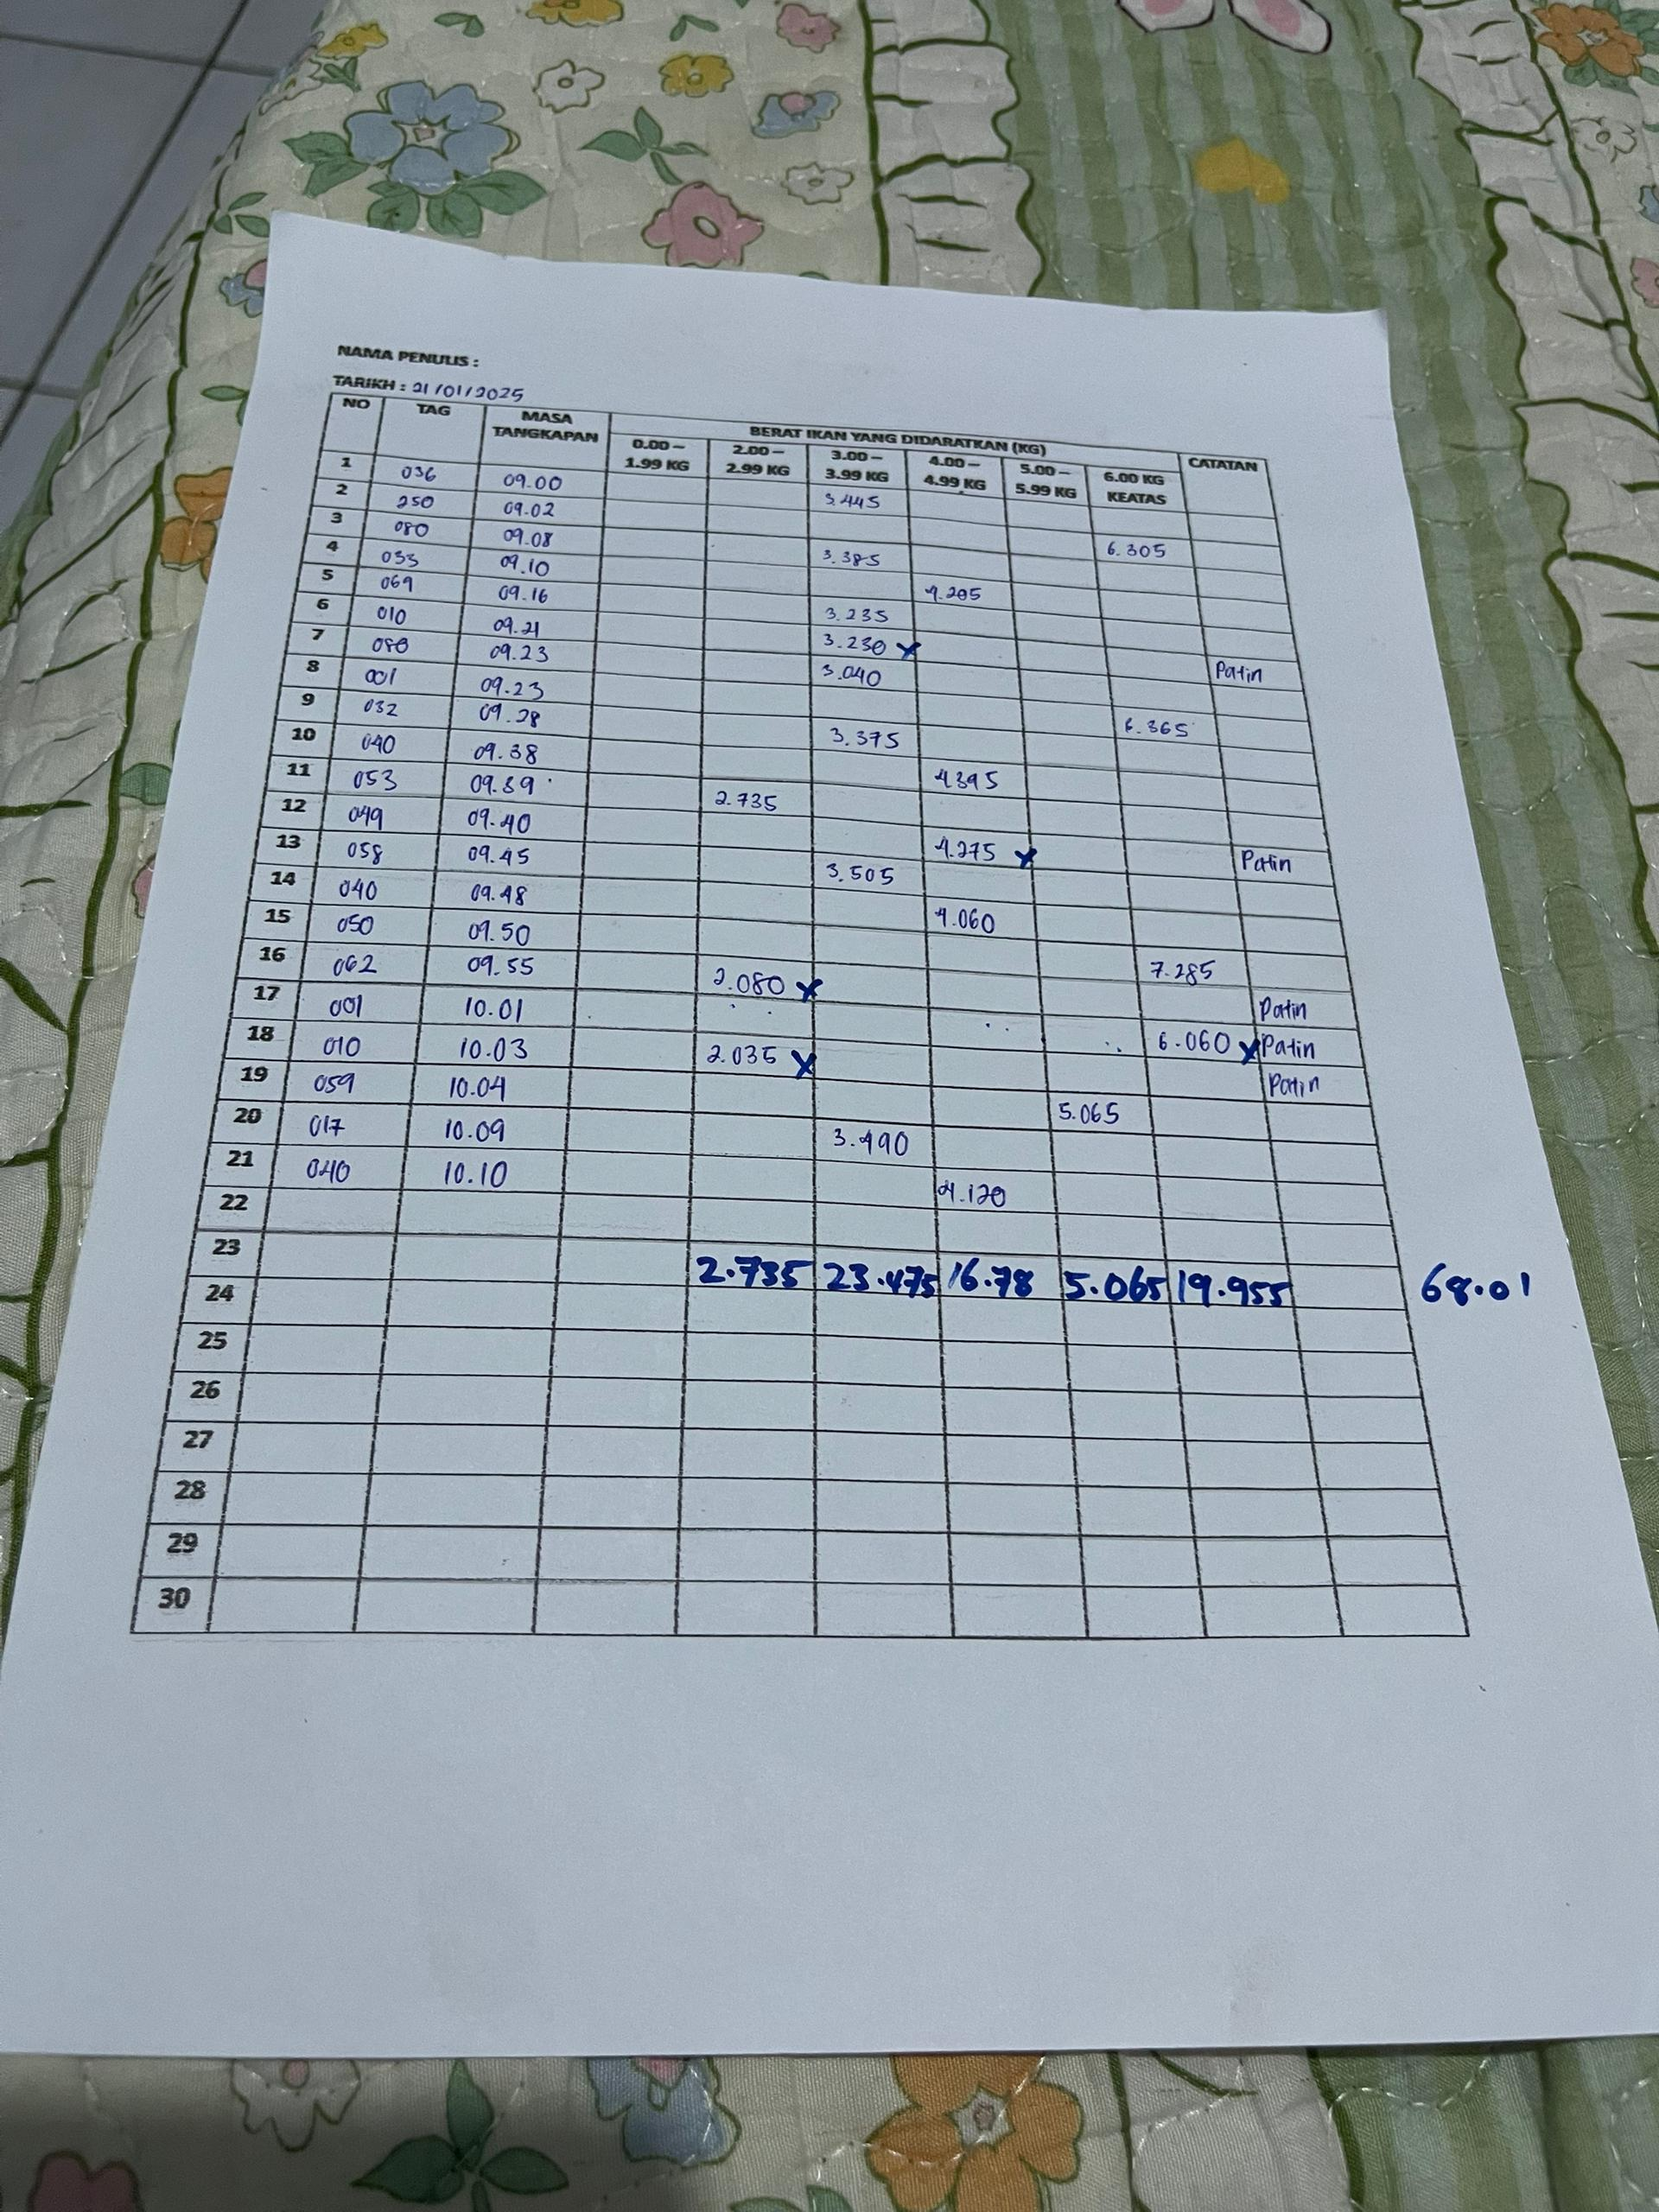

**Figure 4.2: Paper Based Fish Catch Logging Record**

He stated that an ideal fishing tournament system should have features that can automate registration, real-time fishing spot booking, live leaderboard updates and allow for easy advertising of the tournaments. He highlights that automation would help reduce the workload of organizers, minimize errors and speed up processes such as participant registration and result generation, hence improving the overall experience for both organizers and participants.

The interview revealed that the current manual processes are not efficient enough to handle the growing number of angler participants and the complexity of the tournaments. An automated system like SmartAngler would address these challenges by streamlining registration, spot booking, fish logging and result management, making the tournament experience more organized and efficient for both organizers and participants.

* 1. **Survey Questionnaire Analysis**

The SmartAngler system survey was conducted on the angler community specifically the angler from around Tambunan, Keningau and nearby participants to gain information on 50 respondents. To reach a broader audience, the survey was distributed through fishing club WhatsApp group chats and status updates to ensure accessibility and engagement within the angler community. The survey was conducted between June 14 until June 18, 2025, and ended up with a total of 53 responses which is more than the initial target.

The aim of the survey was to collect the feedback on the current fishing tournament, identify pain points and evaluate the possible need in the automatized the management of fishing tournament system. The responses collected provided valuable insights into the preferences, challenges and expectations of the angler community regarding the fishing tournament management. This analysis is important in shaping the design and functionality of the system hence making it possible to design a system that meets the actual needs of the system users and their expectations. The following section gives the main findings of the questionnaire analysis which highlights the insights and responses gathered from the anglers.

1. **Demographic Information of Respondents.**

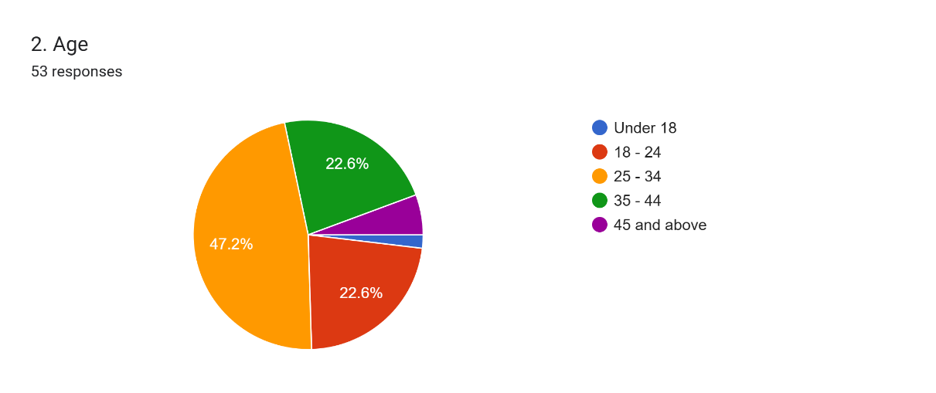

**Figure 4.3: Percentage of Angler Age Group**

The findings of the survey data on the age distribution indicates that most respondents were between the ages of 25 and 34 years representing 45.5%, 12 persons (22.6%) were aged between 18-24 years, and 12 respondents (22.6%) aged between 35-44. A total of 3 respondents (5.7%) were 45 and older and only 1 respondent (1.9%) is below 18 years old. This age distribution indicates that SmartAngler is likely to target a tech-savvy users with the majority of participants ranging between the ages of 25 and 34. Hence, the design of the system must focus on user-friendliness and compatibility in the mobile format because these generations are more prone to the use of the digital platform to participate in tournaments

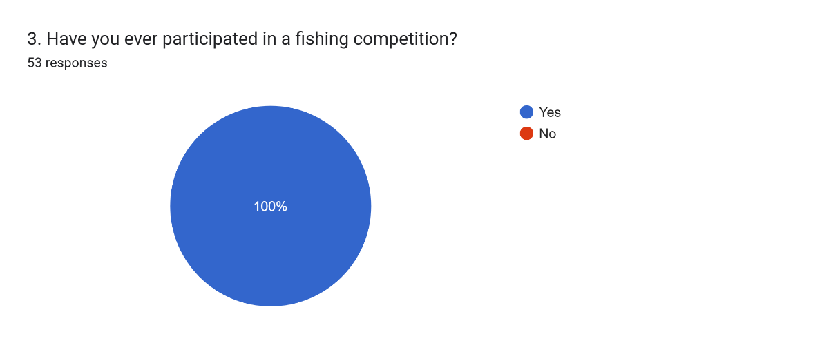

**Figure 4.4: Angler Participation in Fishing Tournament**

According to the results of the survey in Figure 4.4, all the respondents have participated in a fishing competition before, which means that they are familiar with the current processes involved in fishing tournament. This is important for the development of SmartAngler, as it suggests that the users have a clear understanding of the challenges and frustrations that can arise during tournament. Through this understanding, the development of SmartAngler can focus in solving these problems by providing such features such as easy registration, real-time results updates, fish-logging and more features which aim at enhancing the entire tournament experience regardless of whether the user is already familiar with current tournament processes.

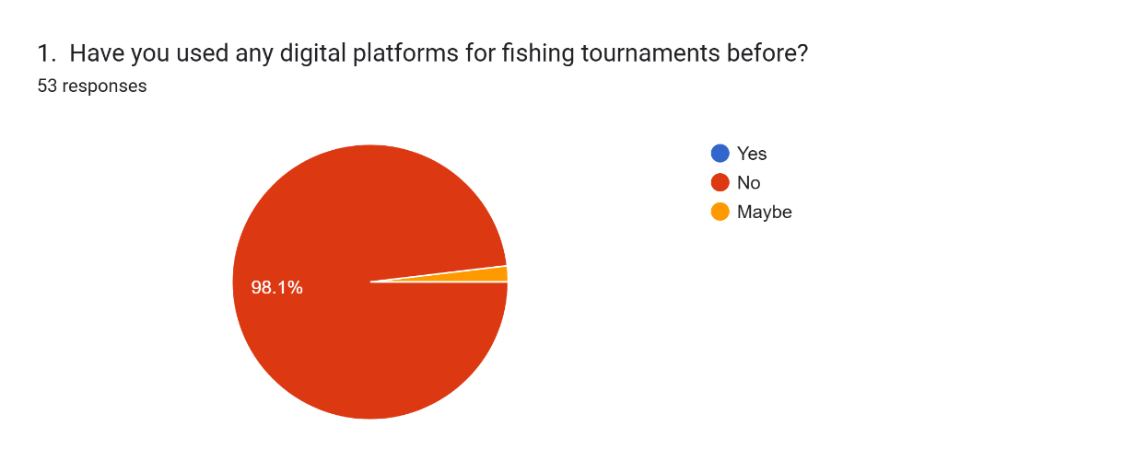

**Figure 4.5: Percentage of Digital Platform Usage for Fishing Tournaments**

The survey results in Figure 4.5 indicate that out of the 53 people that filled in the survey, none had used a digital platform for fishing tournaments previously, with 52 of the respondents (98.1%) stating that they have not used such a platform and 1 of the respondents (1.9%) expressing uncertainty. This implies that SmartAngler will be presenting a new idea to the fishing community and this the angler’s opportunity to enhance management of the tournaments by the use of technology. Since most participants are not used to using digital platform in the processes of tournaments, SmartAngler will need to focus on user-friendly features and simple tournament processes to ensure a smooth transition and encourage adoption among users.

1. **Challenges Faced by Anglers in The Current Fishing Tournament Process.**

Based upon the insights gained from the respondents’ familiarity of the current tournament process, the survey also revealed a major challenge regarding tournaments and their dissatisfaction with the current processes of tournaments management.

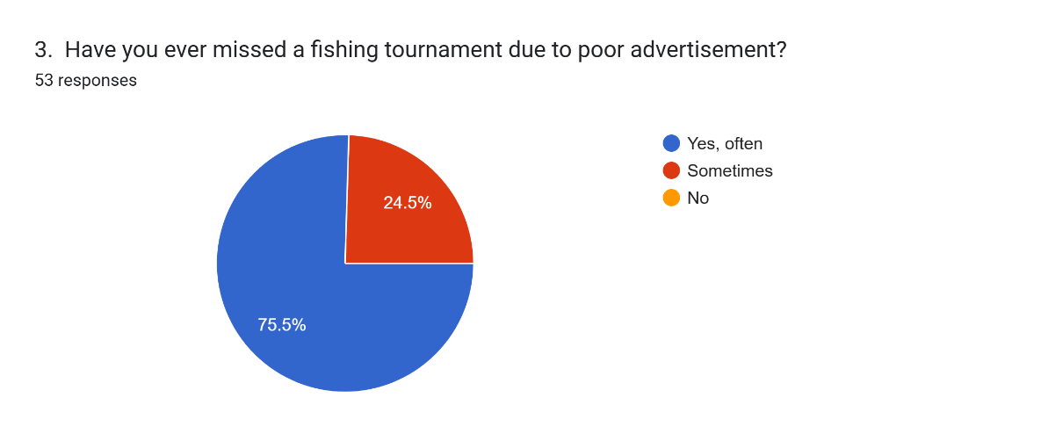

**Figure 4.6: Participants Who Missed Tournaments Due Poor Advertisement**

The survey results in Figure 4.6 indicate that 40 of the 53 respondents have often missed a fishing tournament due to poor tournament advertisement, whereas 13 responds have sometimes missed tournaments. This shows a major problem that can be solved by SmartAngler in offering a more centralized platform on effective advertisement of tournaments. By using this system, organizers can easily post and update tournament information and ensuring that anglers can get updated information of the tournament details effectively. This can reduce the likelihood of missed tournaments due to poor promotion.

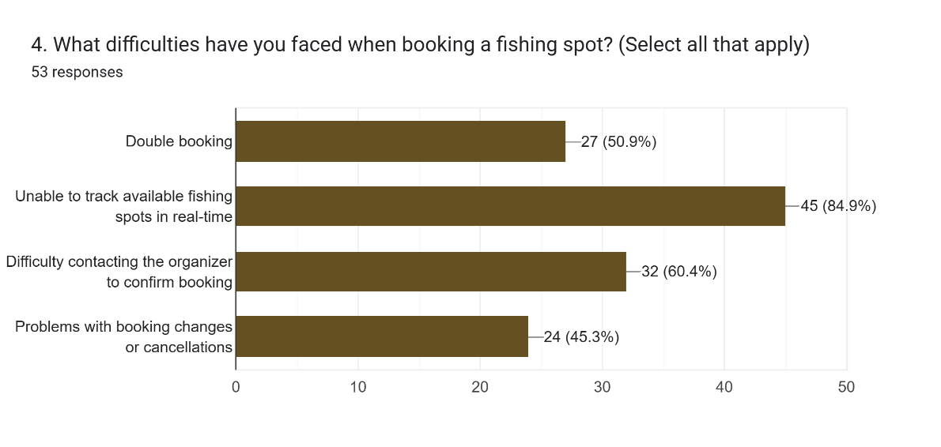

**Figure 4.7: Issues Faced When Booking a Fishing Spot**

Figure 4.7 shows the survey results on several issues participants face when booking fishing spots. The most common problem faced by the angler is the inability to view available spots in real-time which leading to confusion and missed opportunities to book spots. Additionally, 32 respondents had trouble contacting the organizer to confirm bookings. Another concern in spot booking is double bookings which causes confusion in the tournament. Finally, 24 respondents faced issues with booking changes or cancellations. These findings highlight the need for SmartAngler to provide a more efficient system that allows real-time tracking and easier management of spots bookings.

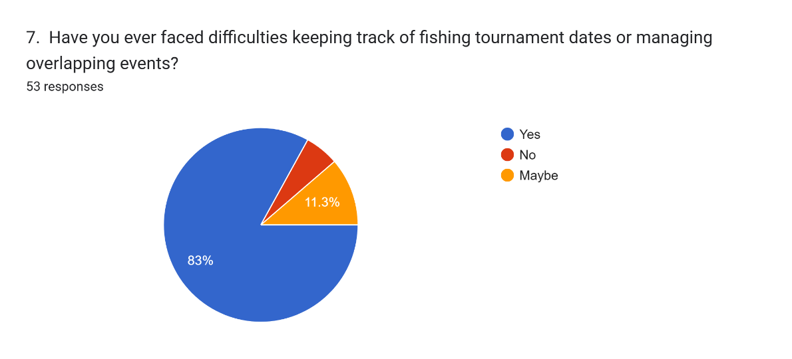

**Figure 4.8: Percentage of Angler Facing Issue in Tracking Tournament Dates**

As illustrated in Figure 4.8, the results of the survey revealed that 44 survey respondents have faced difficulties in keeping track of fishing tournament dates. Only 3 respondents (5.7%) reported not experiencing any issues, while 6 respondents (11.3%) were uncertain about this issue. This suggests that keeping track of multiple tournaments can be a challenge for participants. Hence, this highlights the need for SmartAngler to include a centralized tournament calendar feature in the system. This feature could help users to easily track upcoming fishing tournament and avoid tournament dates confusion.

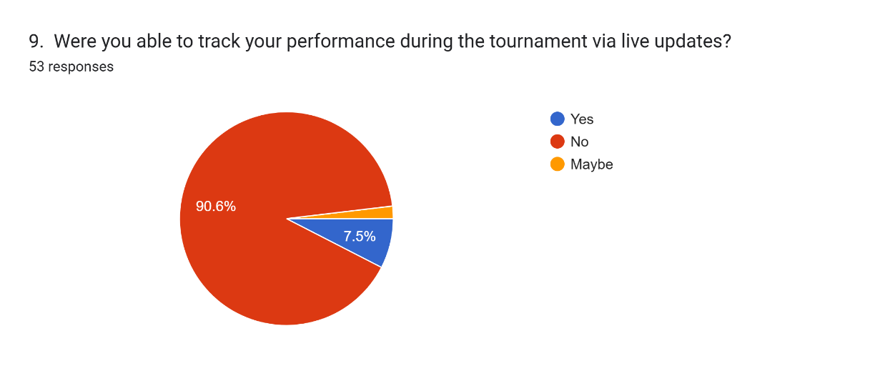

**Figure 4.9: Number of Angler Able to Track Performance via Live Updates**

The survey results shown in Figure 4.9 showing that the majority of respondents which is 48 out of 53 (90.6%) were unable to track their current ranking during the ongoing tournament via live updates. Only 4 respondents (7.5%) reported being able to do so, while 1 respondent (1.9%) was uncertain. This shows an evident lack in real-time monitoring of current ranking used in existing tournament systems. To solve this problem, SmartAngler will implement a live leaderboard feature which allowing participants to monitor their standings ranking and progress throughout the tournament. This might enhance engagement and improving the overall experience for users.

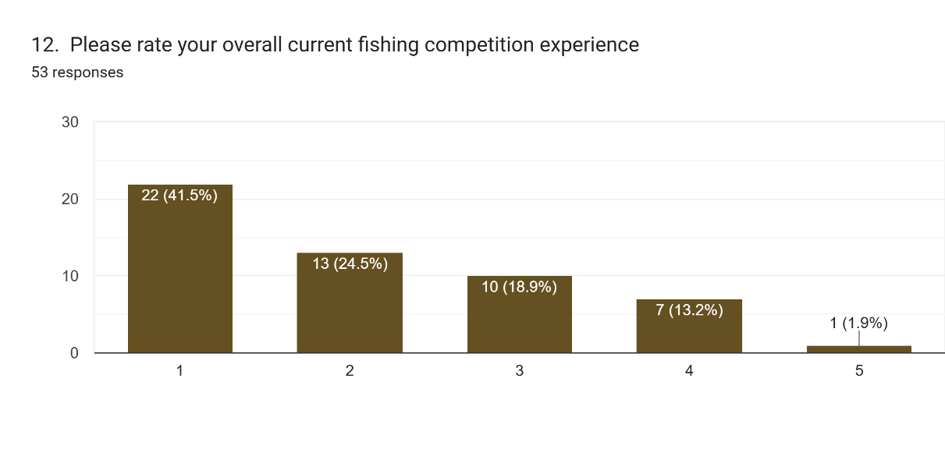

**Figure 4.10: Overall Satisfaction with Current Fishing Competition Experience**

The results of the survey presented in Figure 4.10 showing that the overall experience of participants in fishing competitions is rated quite low with an average rating of 2.09 out of 5 stars. Specifically, 22 respondents (41.5%) gave a rating of 1 star, 13 respondents (24.5%) rated it 2 stars and 10 respondents (18.9%) rated it 3 stars. Only 7 respondents (13.2%) gave a rating of 4 stars and just 1 respondent (1.9%) rated the experience 5 stars. These low ratings highlight a strong dissatisfaction of anglers with the current fishing tournament experience. To resolve this, SmartAngler can introduce features that streamline processes such as registration, spot booking, fish catch logging and result generation. This can improve the overall participant experience and improve angler satisfaction regarding the tournament.

1. **Angler Preferences for SmartAngler Features and User Requirements**

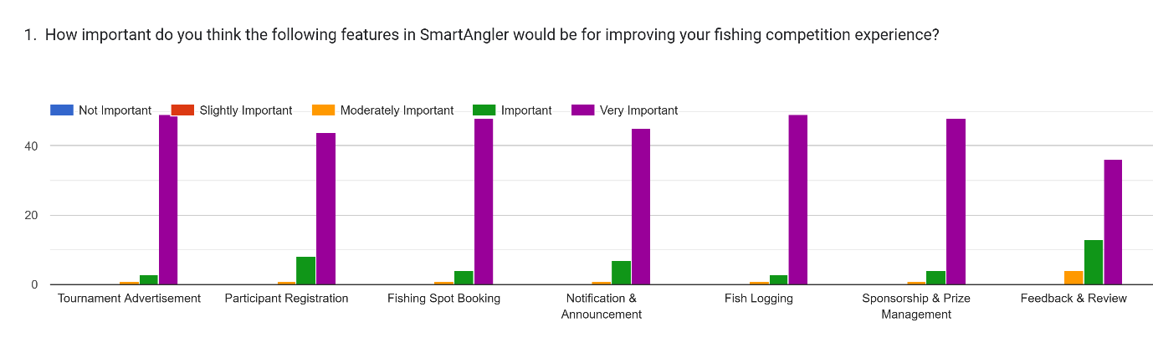

**Figure 4.11 Anglers’ Perceived Importance of SmartAngler Features for Enhancing Fishing Competition Experience.**

According to the survey results represented in the Figure 4.11, all suggested SmartAngler features are highly valued by anglers to improve their experience of fishing competition. A majority percentage of people rated every feature like Tournament Advertisement, Participant Registration, Fishing Spot Booking, Calendar, Fish Logging, Live Leaderboard and Review as "Very Important". This highlights a strong demand for comprehensive digital support in organizing and participating in fishing tournament. Particularly, such functions as Tournament Advertisement, Fish Logging, and Live Leaderboard have been rated extremely high which indicates that users are extremely focused on real-time updates and exposure during the competitions. Overall, the data highlight the need for SmartAngler to include efficient and user-friendly functionalities that support both preparation and live tournament management.

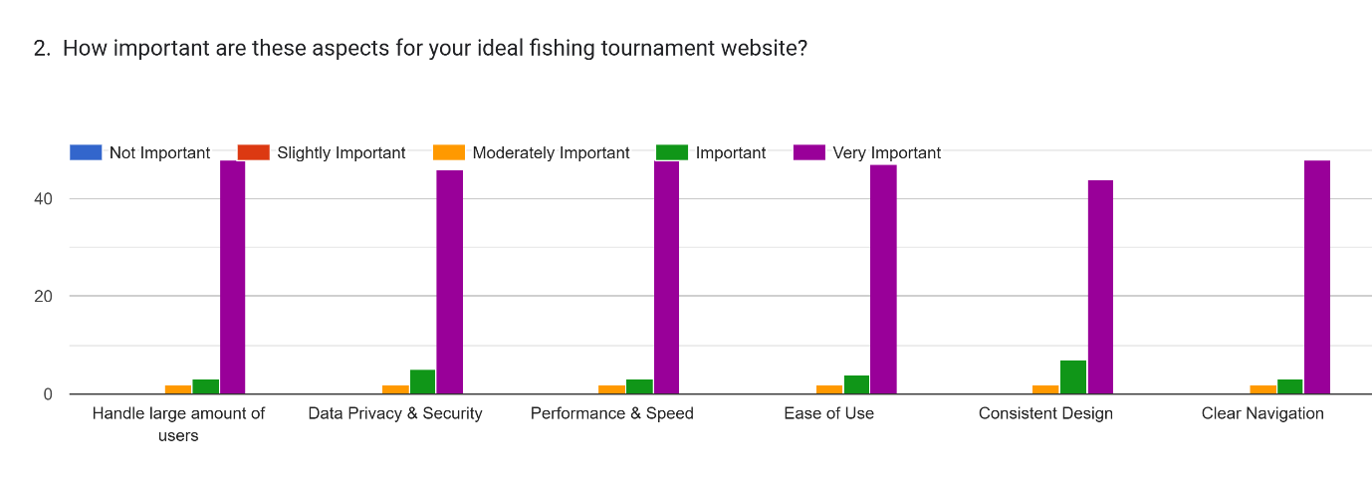

**Figure 4.12 Aspects Rated by Anglers for an Ideal Fishing Tournament Website**

The survey findings in Figure 4.12 shows the non-functional requirement of the users. It shows that anglers place high importance on core technical and design aspects when considering their ideal fishing tournament website. Most respondents rated all included aspects like the ability to support a high number of users, data privacy and security, performance and speed, ease of use, consistency of design and clear navigation in the range of Very Important. This indicates that users expect a platform that is not only secure and fast but also intuitive and visually consistent. Clear navigation and ease of use were particularly emphasized which reflecting a strong preference for a seamless and user-friendly experience during tournament.

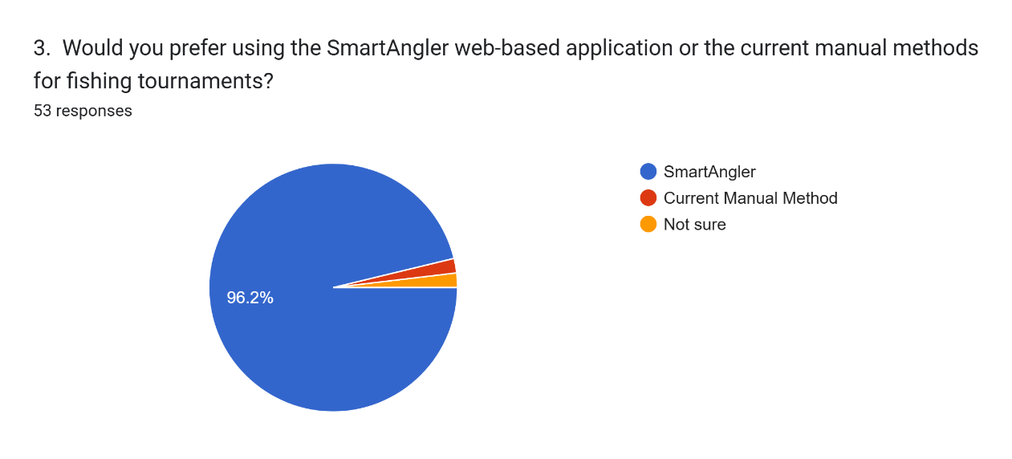

**Figure 4.13: Anglers’ Preference Between SmartAngler Web-Based Application and Current Manual Methods for Fishing Tournaments**

The survey in Figure 4.13 results show a strong preference for using the SmartAngler web-based application, with 51 out of 53 respondents (96.2%) choosing it over the current manual methods. Only 1 respondent (1.9%) preferred the traditional manual method, and 1 respondent (1.9%) was unsure. This overwhelming support indicates that participants are eager for a more efficient and automated solution like SmartAngler, suggesting that the system will be well-received and likely improve the overall tournament experience by reducing the complexities of manual processes.

* 1. **System Design**

The System Design phase of the SmartAngler project focuses on planning how the system will work and how users will interact with it. During this stage based on the data within the previous stage of analysis, the structure of both front-end and back-end part of the system will be developed. The key diagrams such as Data Flow Diagrams (DFD) and Entity Relationship Diagrams (ERD) will be created to map out how data will flow and how different parts of the system will connect. Additionally, user interface prototypes are designed to make sure the system is easy to use for both tournament organizers and participants. This phase sets the groundwork for the actual development of the SmartAngler system.

* + 1. **System Architecture**

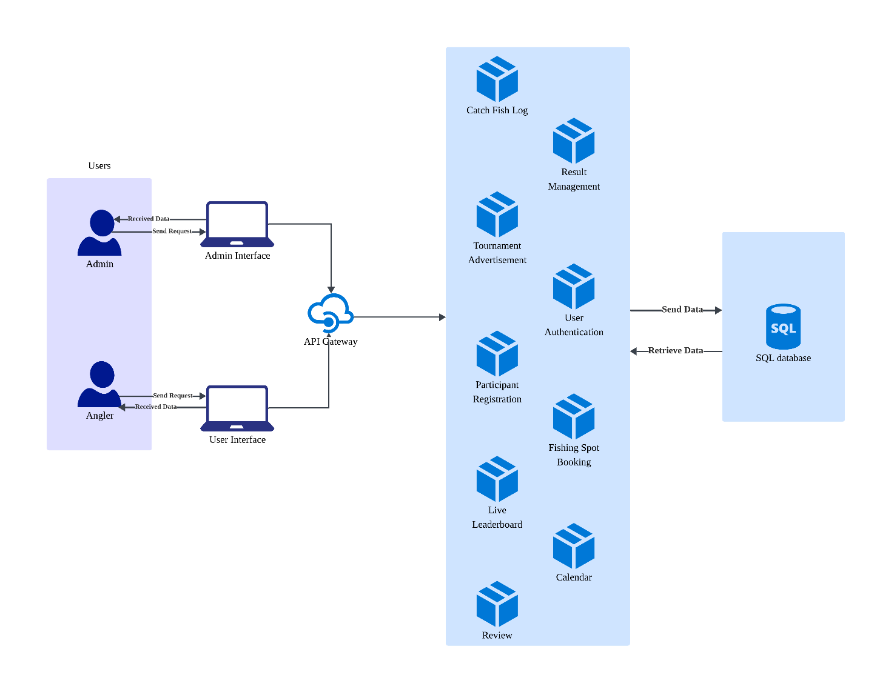

**Figure 4.14 System Architecture of SmartAngler**

SmartAngler system architecture is aimed at organizing fishing tournaments in the most efficient way by connecting users, features, and data storage in an organized form. There are two main types of users which is the Admin, who manages the tournament and the Angler, who participates in tournaments. Both users access the system through their devices, sending and receiving data via the internet. All such user requests are directed to a cloud server which connects to various functional modules.

Cloud server is the centre of the communication flow between the system and the users in the context of different modules of the system. These incorporate important functions like User Authentication, Participants Registration, Fishing Spot Booking, Catch Fish Logging, Tournament advertising, Live Leaderboard, Result Management, Calendar and review. Each module is designed to handle specific tasks to ensure smooth tournament process and enhance user experience.

Each of the modules is also linked via a centralized SQL database which securely stores, manages and retrieves data as needed including user credentials, registration records, tournament scores, booking details and feedback. This architecture not only allows for seamless data flow and interaction but also supports scalability which ensuring that the system can handle multiple tournaments and users simultaneously. Overall, SmartAngler offers an effective, real-time system to organize fishing tournament in a more organized, transparent and user-friendly manner.

* + 1. **Data Flow Diagram (DFD) Level 0**

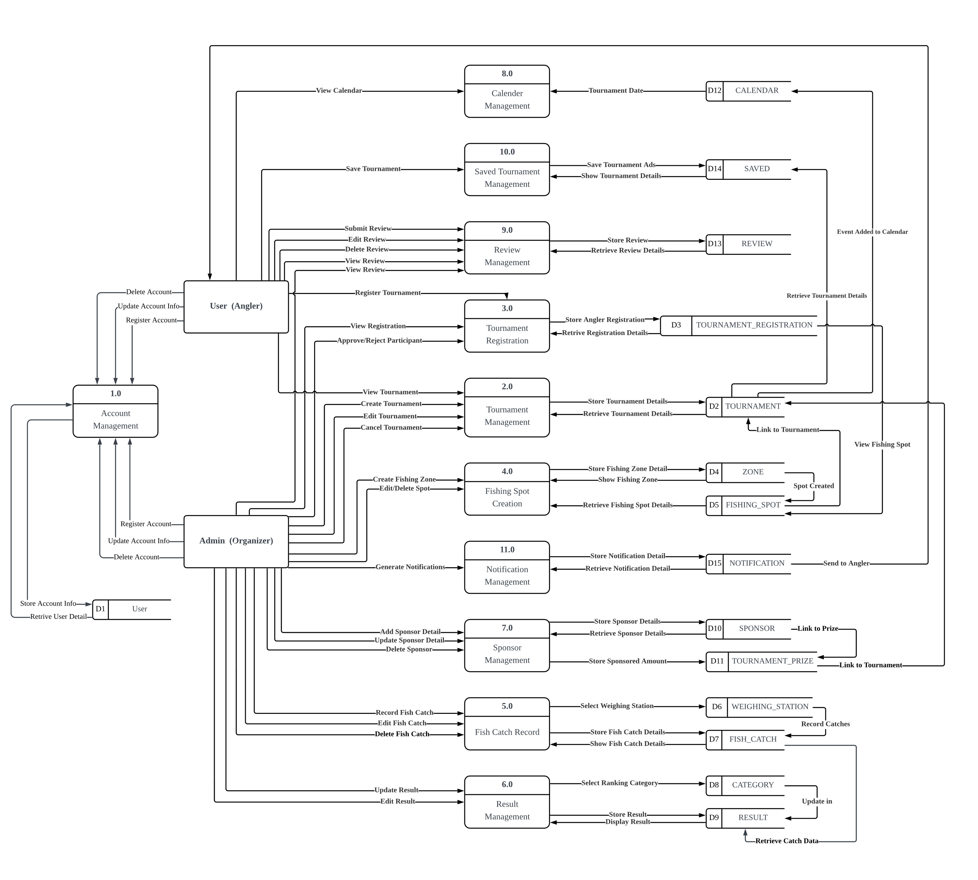

**Figure 4.15: Data Flow Diagram (DFD) Level 0 of SmartAngler Automated Fishing Tournament System.**

Figure 5.15 above shows the overall data flow diagram (DFD) for the SmartAngler Automated Fishing Tournament System, which includes ten main processes such as account management, tournament advertisement, fishing spot creation and booking, participant registration, fish catch recording, result management, live leaderboard, calendar and review management. The system consists of ten data stores to keep important data like user accounts, tournament details, bookings, participant data, results and feedback. There are two main users in the system which are Anglers who participate in tournaments and submit data, and Admins who manage events, approve participants, and update results. This DFD helps explain how data flow through the system.

* + 1. **Data Flow Diagram (DFD) Level 1**

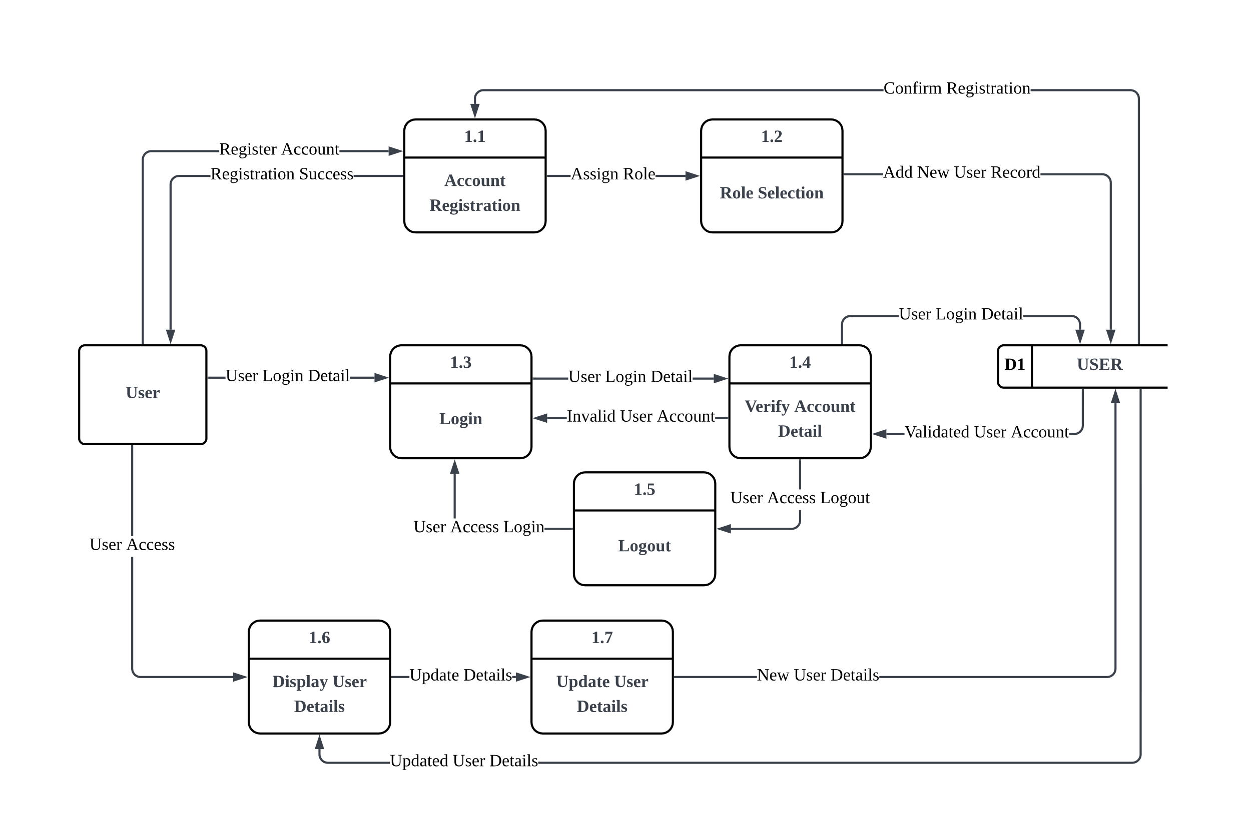

**Figure 4.16: DFD Level 1 for Account Management**

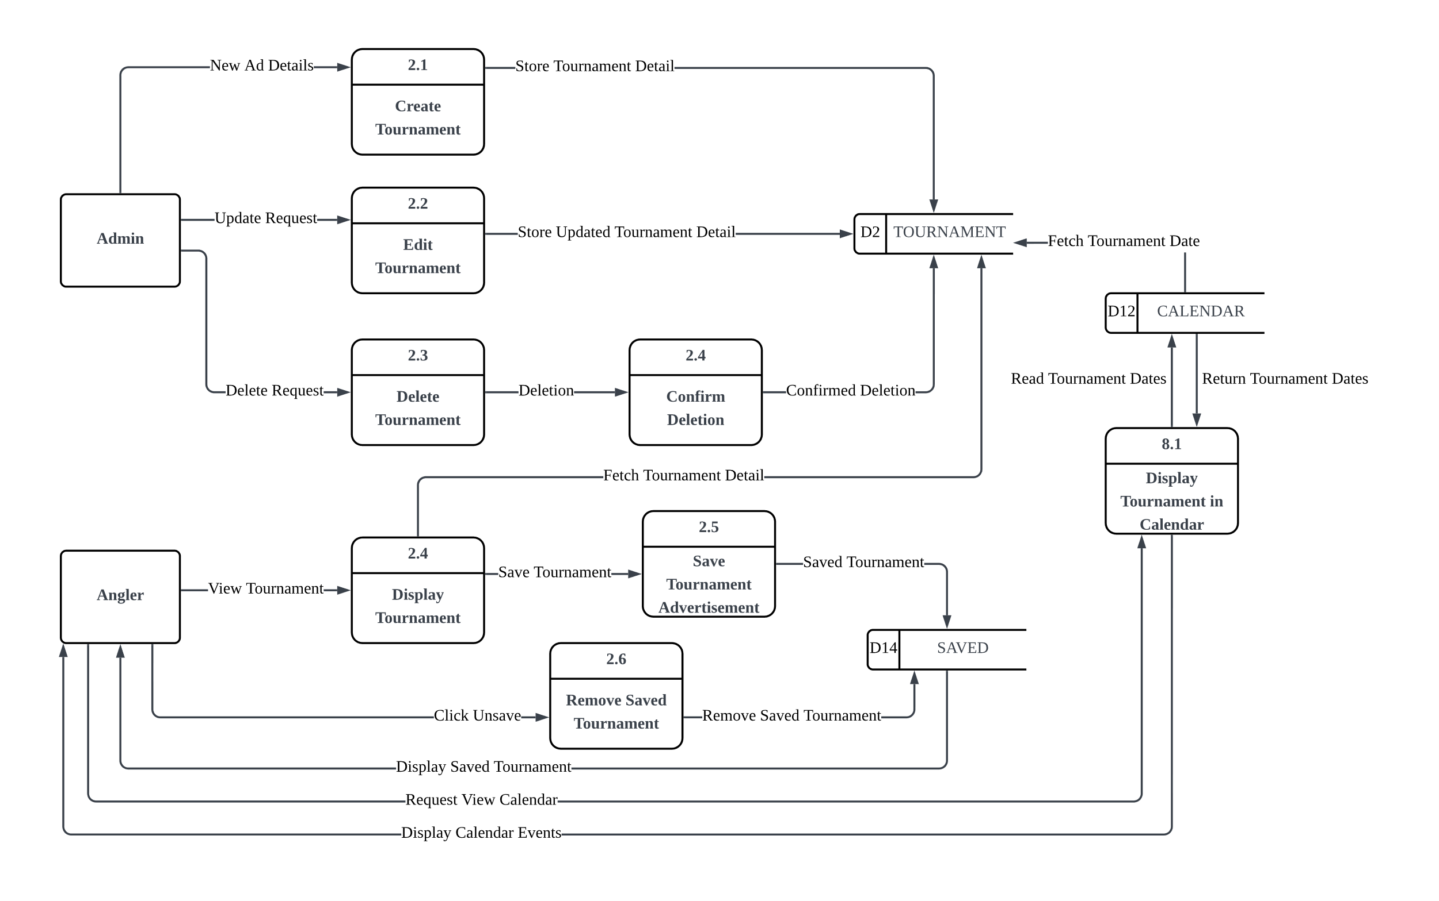

**Figure 4.17: DFD Level 1 for Tournament Management**

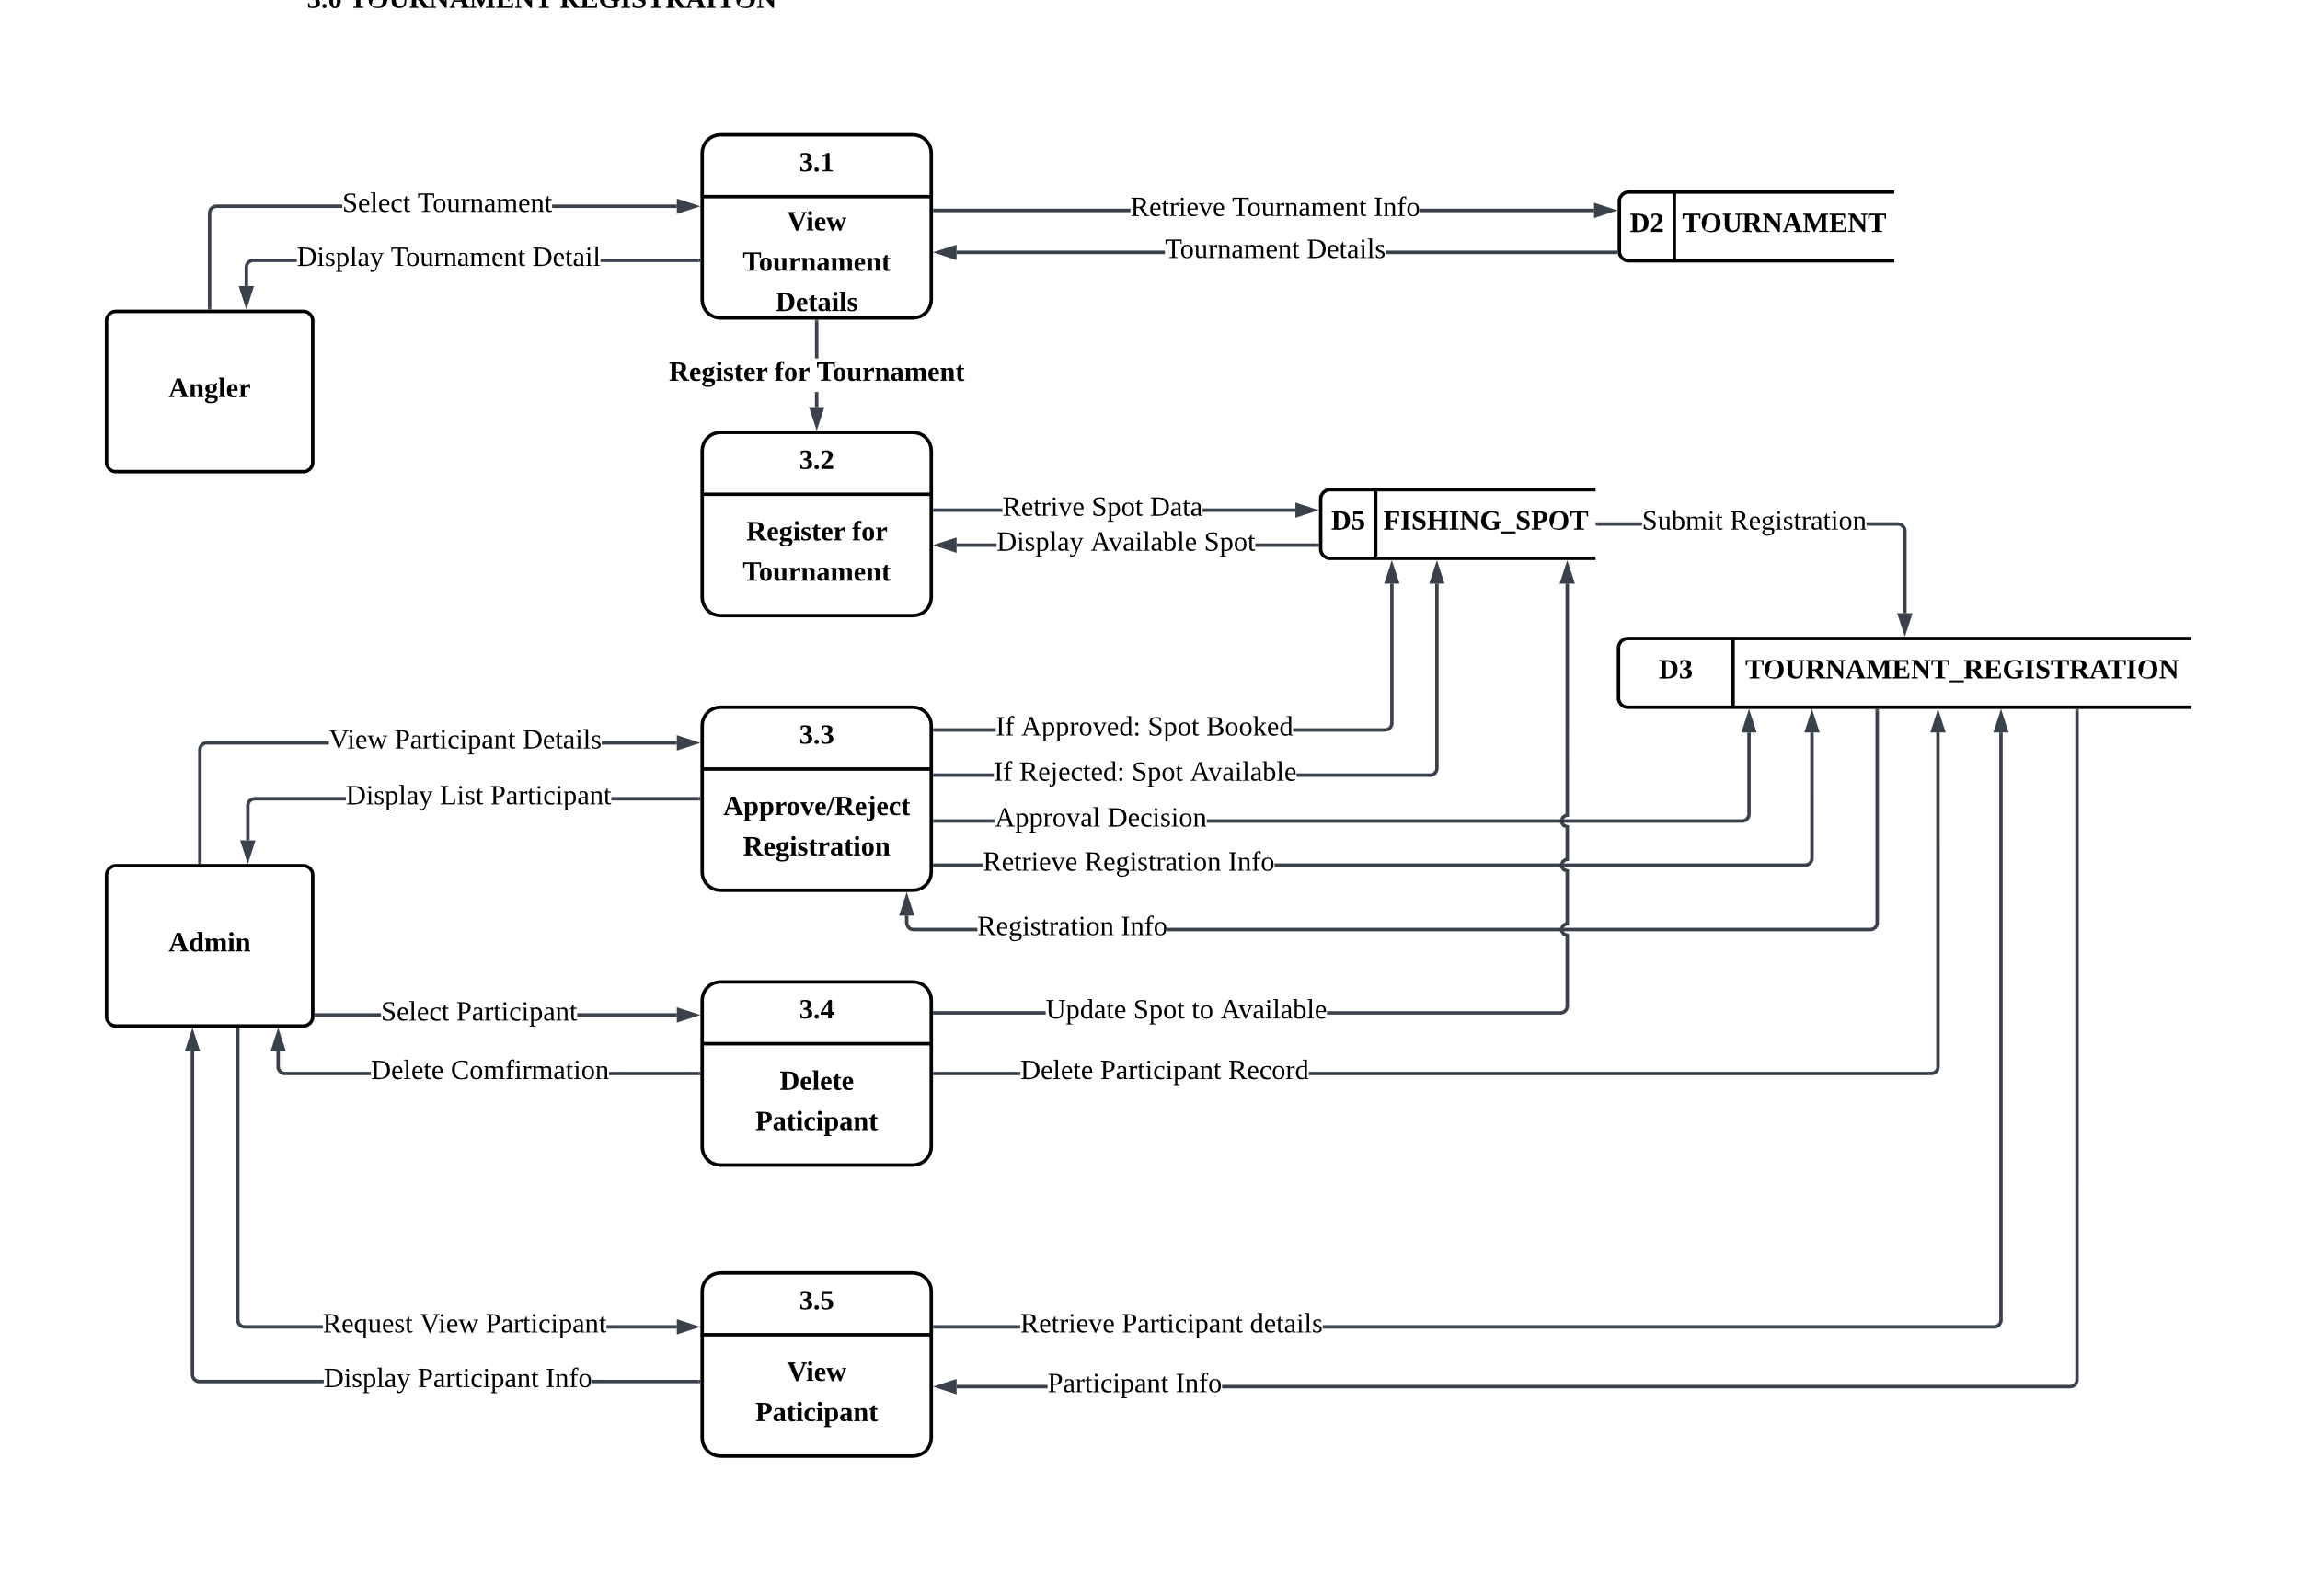

**Figure 4.18: DFD Level 1 for Participant Registration**

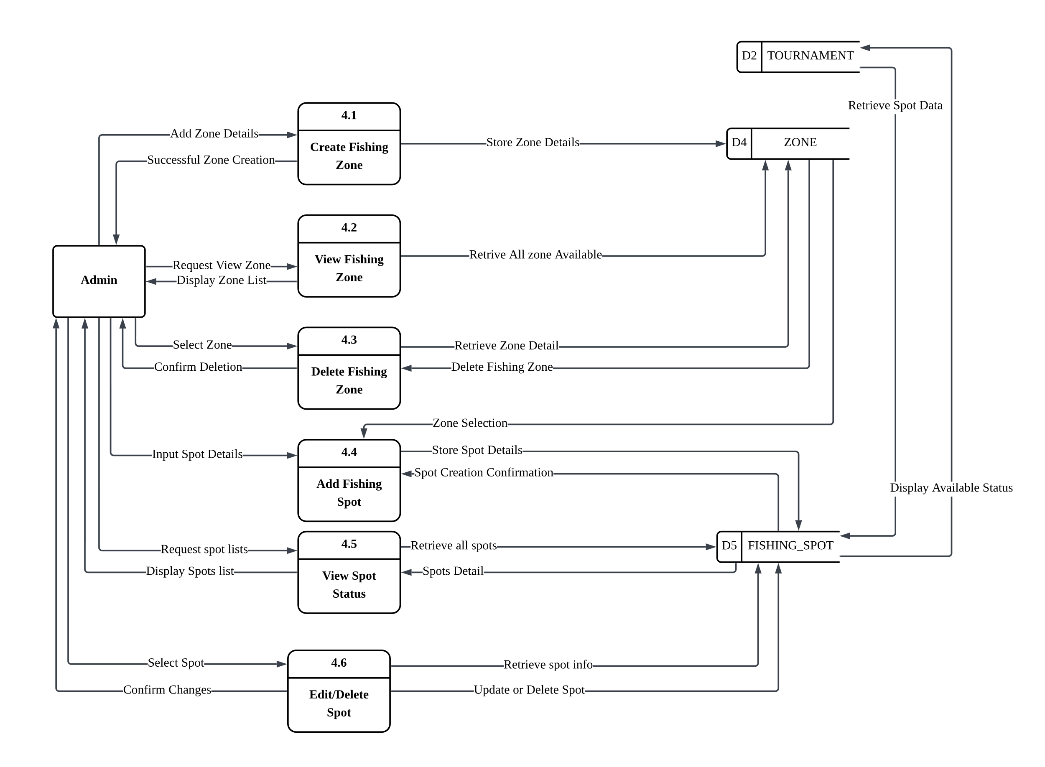

**Figure 4.19: DFD Level 1 for Fishing Spot Management**

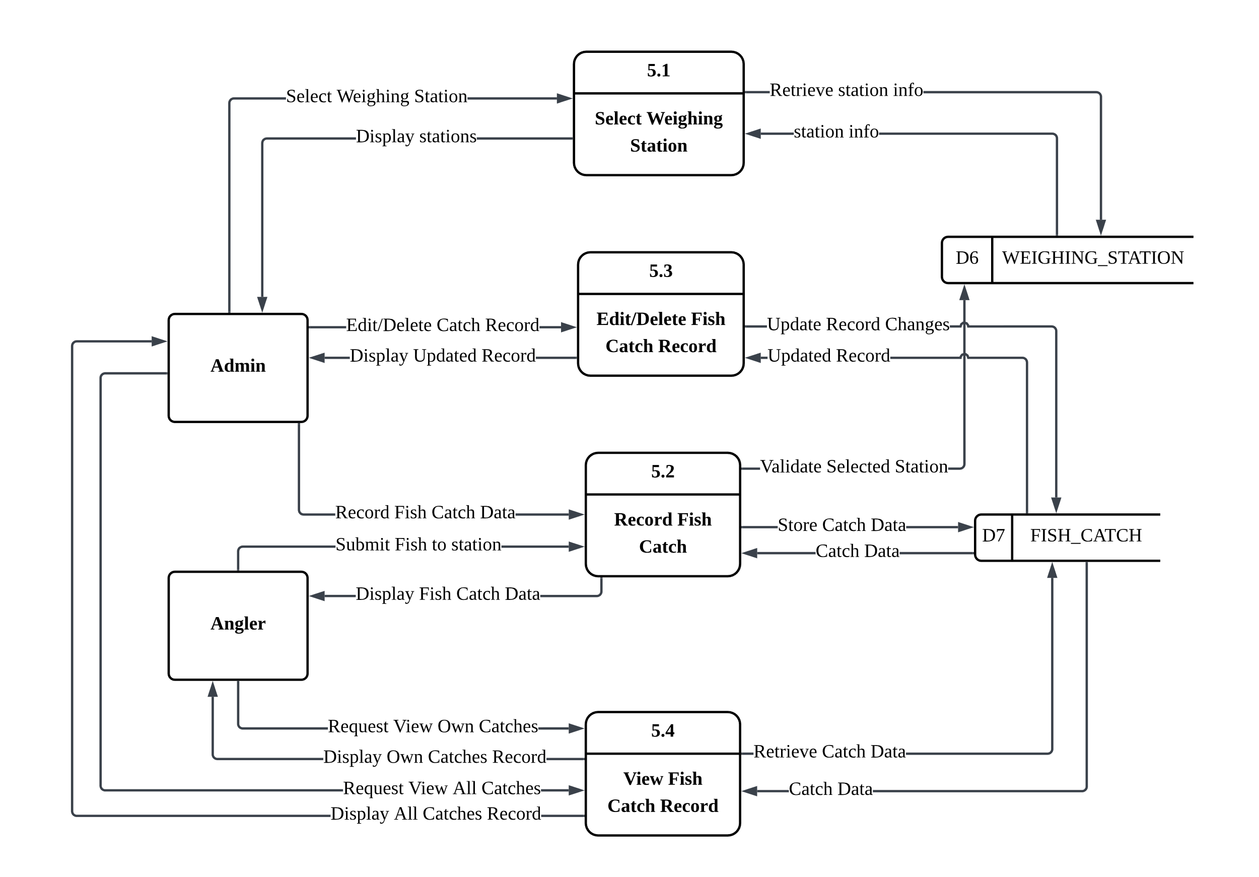

**Figure 4.20: DFD Level 1 for Fish Catch Record**

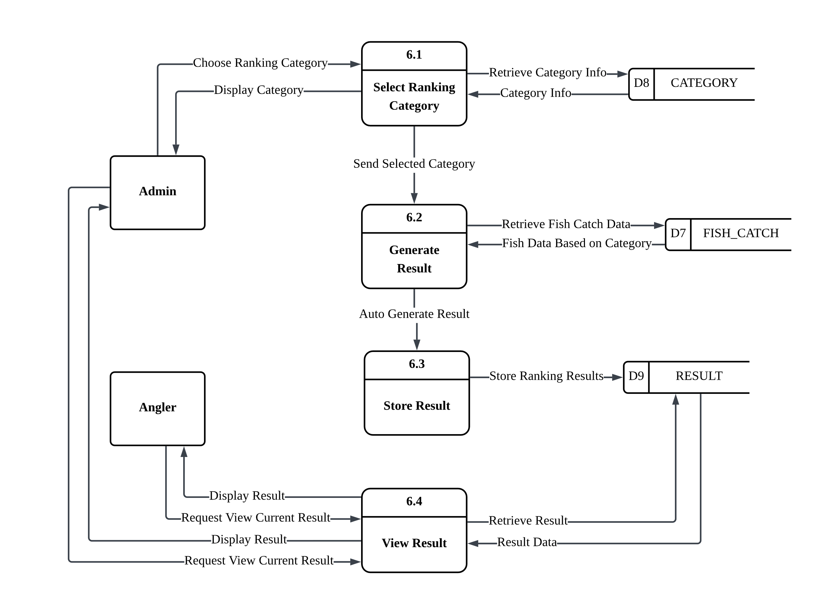

**Figure 4.21: DFD Level 1 for Result Management**

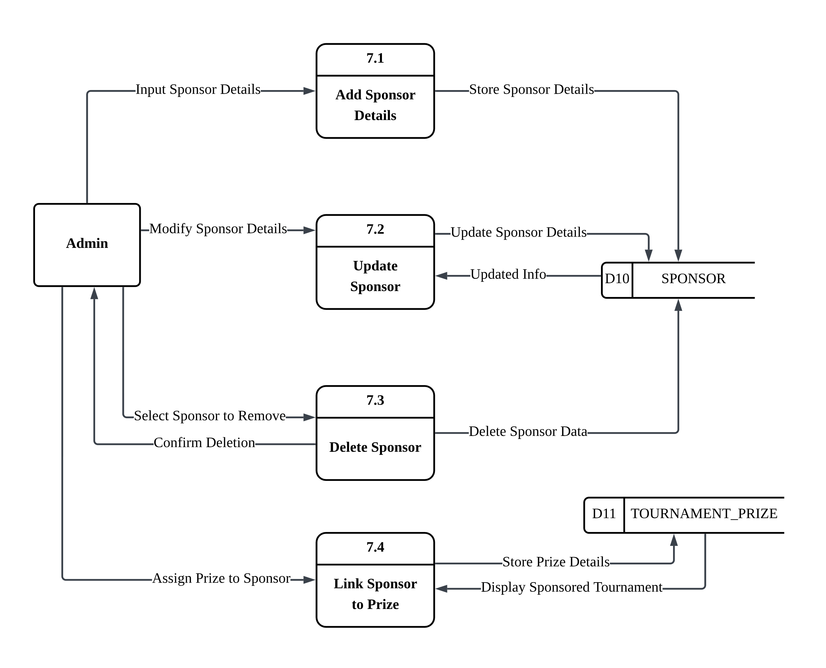

**Figure 4.22: DFD Level 1 for Review Management**

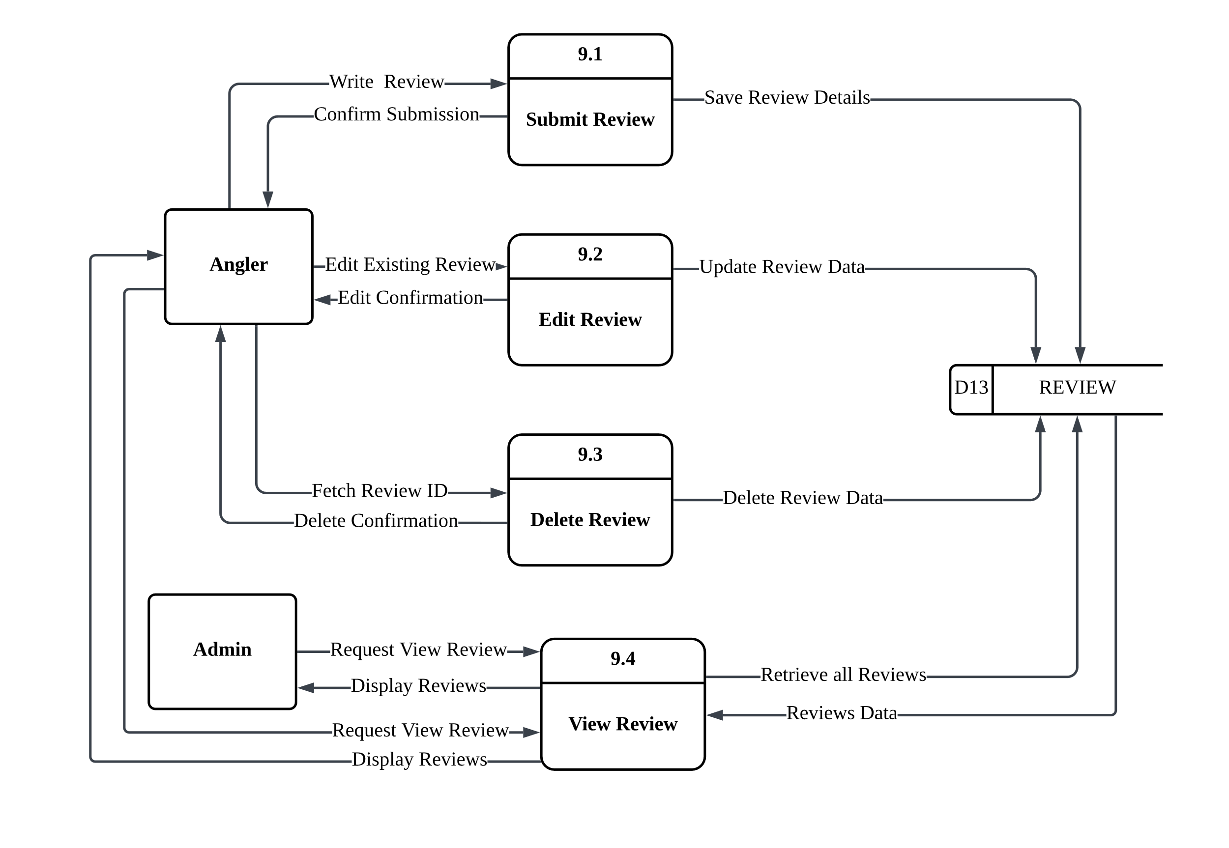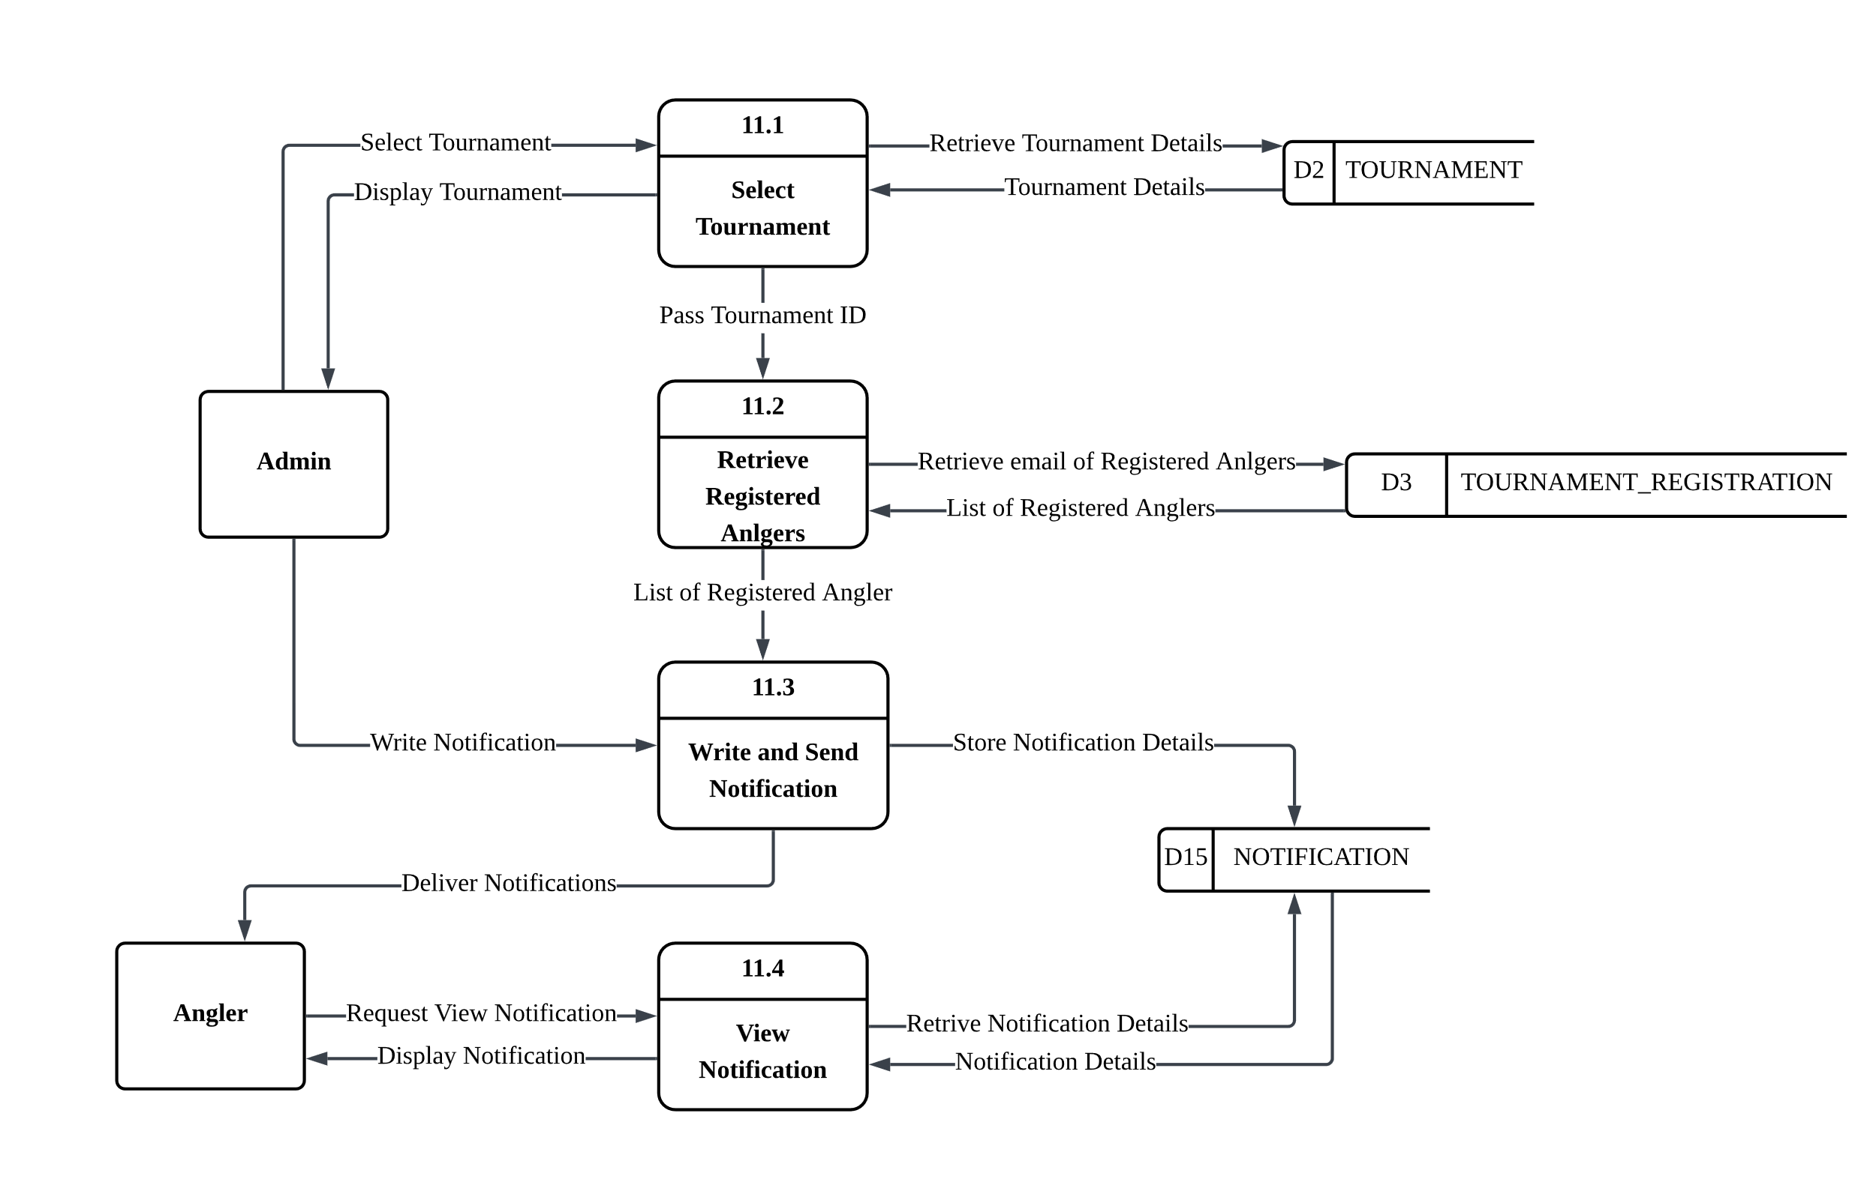

* + 1. **Entity Relationship Diagram (ERD)**

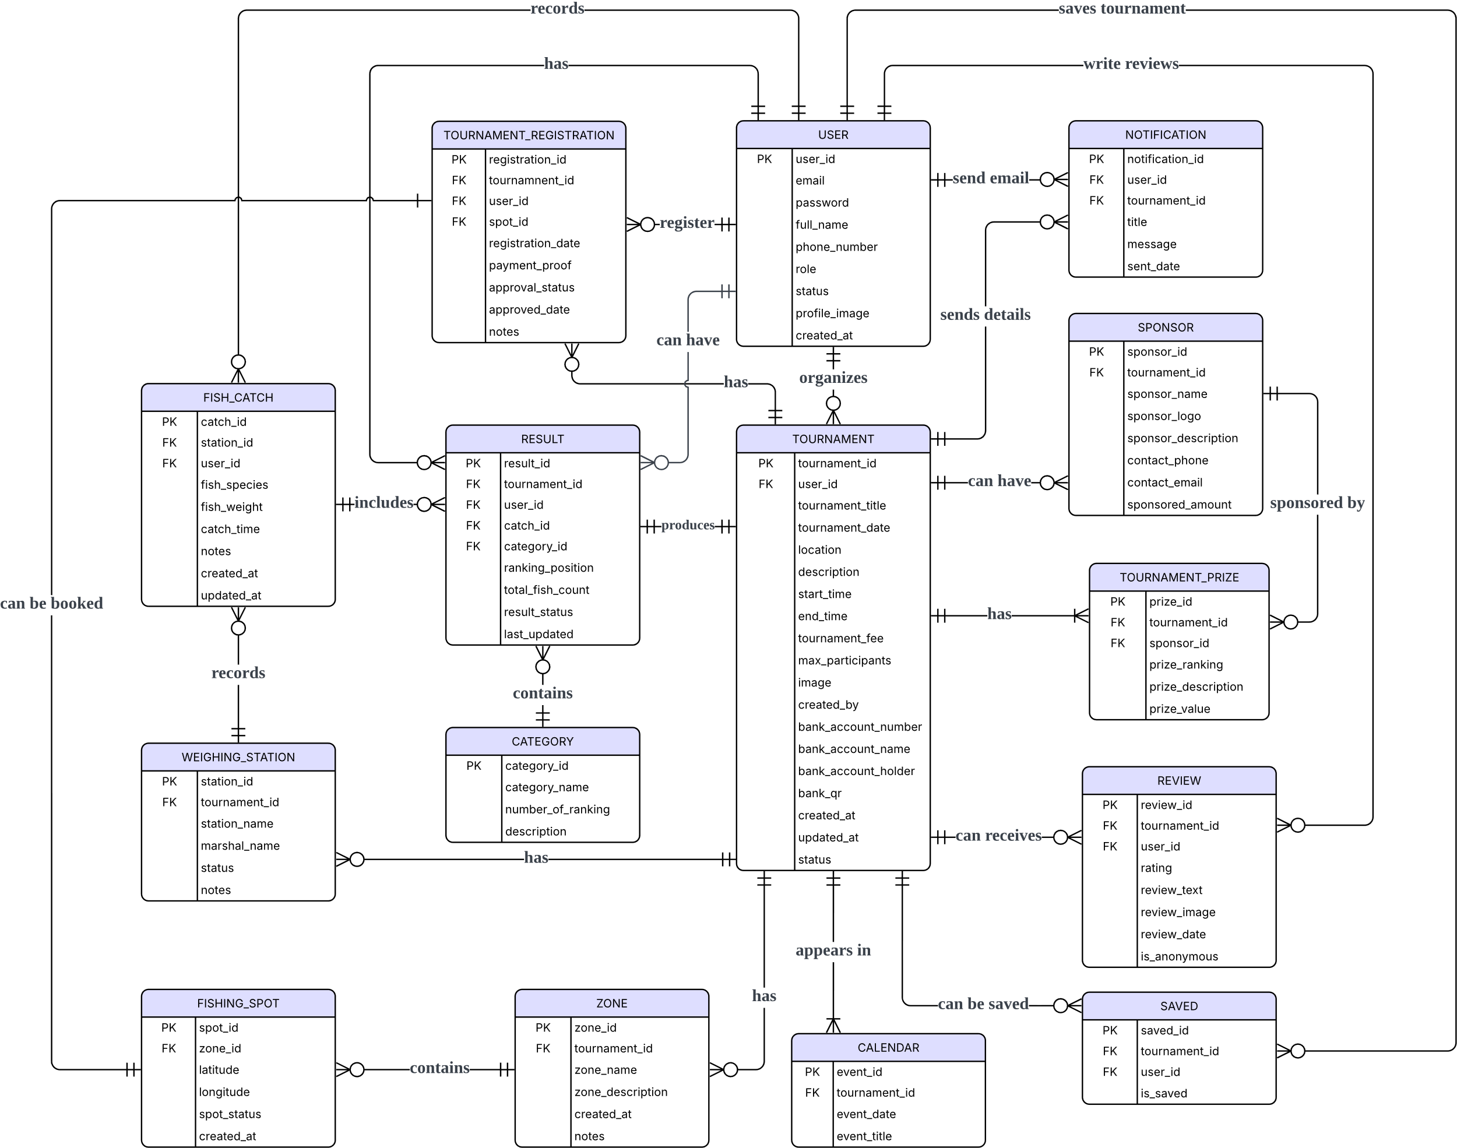

**Figure 4.23: Entity Relationship Diagram (ERD) of SmartAngler Automated Fishing Tournament System.**

Figure 4.23 shows the Entity Relationship Diagram (ERD) for the SmartAngler Automated Fishing Tournament System. It shows an inter-relation between various data tables (entities) within the system. Each entity represents a major part of the system. All of these entities are connected through relationships which show how the data is linked. The ERD also defines the attributes stored in each table and how they are uniquely identified using primary keys. It can assist for the future development of SmartAngler by guiding how to build the database and show the flow of the database between different parts of the system to ensure everything is well-organized and connected.

* + 1. **Data Dictionary**

The data dictionary provides a clear and detailed explanation of each table within the SmartAngler database. It contains important information such as the table name, attribute name, data type, constraints and a brief description of each attribute. This dictionary helps to explain the structure and characteristics of the data and the relationships between different tables. By using this data dictionary, SmartAngler can ensure that all data elements are clearly defined, consistently used and well-organized throughout the system. This makes it easier for the development of SmartAngler to build, manage and update the database accurately.

**Table 4.1: USER Table**

|  |  |  |  |  |
| --- | --- | --- | --- | --- |
| **No.** | **Attribute Name** | **Data Type** | **Constraint** | **Description** |
| **1** | user_id | INT | Primary Key | Unique identifier for each user |
| **2** | email | VARCHAR | UNIQUE, NOT NULL | User's email address |
| **3** | password | VARCHAR | NOT NULL | User's account password |
| **4** | full_name | VARCHAR |  | User's full name |
| **5** | phone_number | VARCHAR |  | User's phone number |
| **6** | role | ENUM | Default 'angler' | Role of the user:  1- admin or 2-angler |
| **7** | status | ENUM | Default 'active' | Account status:  active or inactive |
| **8** | profile_image | VARCHAR |  | User's profile image |
| **9** | created_at | DATETIME | Default CURRENT_TIMESTAMP | Date and time the user account was created |

**Table 4.2: TOURNAMENT Table**

|  |  |  |  |  |
| --- | --- | --- | --- | --- |
| **No.** | **Attribute Name** | **Data Type** | **Constraint** | **Description** |
| **1** | tournament_id | INT | Primary Key | Unique identifier for the tournament |
| **2** | user_id | INT | Foreign Key | Reference to admin user who created tournament |
| **3** | tournament_title | VARCHAR | NOT NULL | Name/title of the tournament |
| **4** | tournament_date | DATE | NOT NULL | Date of the tournament |
| **5** | location | VARCHAR |  | Location of the tournament |
| **6** | description | TEXT |  | Description of the tournament including prizes and rules. |
| **7** | start_time | TIME |  | Start time of the tournament |
| **8** | end_time | TIME |  | End time of the tournament |
| **9** | tournament_fee | DECIMAL | Default 0.00 | Entry fee for participation |
| **10** | max_participants | INT |  | Maximum number of participants allowed |
| **11** | image | VARCHAR |  | Image representing the tournament |
| **12** | created_by | INT |  | Admin who created the tournament |
| **13** | bank_account_number | VARCHAR |  | Bank account number for payments |
| **14** | bank_account_name | VARCHAR |  | Name of the bank |
| **15** | bank_account_holder | VARCHAR |  | Account holder’s name |
| **16** | bank_qr | VARCHAR |  | QR image for faster payment |
| **17** | created_at | DATETIME | Default CURRENT_TIMESTAMP | Date of tournament creation |
| **18** | updated_at | DATETIME | ON UPDATE CURRENT_TIMESTAMP | Last updated date |
| **19** | status | ENUM |  | Tournament status: upcoming, ongoing, completed, cancelled |

**Table 4.3: WEIGHING_STATION Table**

|  |  |  |  |  |
| --- | --- | --- | --- | --- |
| **No.** | **Attribute Name** | **Data Type** | **Constraint** | **Description** |
| **1** | station_id | INT | Primary Key | Unique identifier for each weighing station |
| **2** | tournament_id | INT | Foreign Key | Associated tournament that using the weighing station |
| **3** | station_name | VARCHAR | NOT NULL | Station label or name |
| **4** | marshal_name | VARCHAR |  | Name of the marshal that working at this station |
| **5** | status | ENUM | Default 'active' | Status of the station: active or inactive |
| **6** | notes | TEXT |  | Additional remarks about the station |

**Table 4.4: ZONE Table**

|  |  |  |  |  |
| --- | --- | --- | --- | --- |
| **No.** | **Attribute Name** | **Data Type** | **Constraint** | **Description** |
| **1** | zone_id | INT | Primary Key | Unique identifier for each zone |
| **2** | tournament_id | INT | Foreign Key | Tournament associated with the zone |
| **3** | zone_name | VARCHAR | NOT NULL | Name of the fishing zone |
| **4** | zone_description | TEXT |  | Description or notes about the zone |
| **5** | created_at | DATETIME | Default CURRENT_TIMESTAMP | Creation date of the zone record |

**Table 4.5: FISHING_SPOT Table**

|  |  |  |  |  |
| --- | --- | --- | --- | --- |
| **No.** | **Attribute Name** | **Data Type** | **Constraint** | **Description** |
| **1** | spot_id | INT | Primary Key | Unique identifier for each fishing spot |
| **2** | Zone_id | INT | Foreign Key | Reference to tournament this spot belongs to |
| **3** | latitude | DECIMAL (10,8) |  | GPS latitude |
| **4** | longitude | DECIMAL (11,8) |  | GPS longitude |
| **5** | spot_status | ENUM |  | Spot availability: available, booked, cancelled or under maintenance |
| **6** | Created_at | DATETIME | Default CURRENT_TIMESTAMP | Date spot was added |

**Table 4.6: TOURNAMENT_REGISTRATION Table**

|  |  |  |  |  |
| --- | --- | --- | --- | --- |
| **No.** | **Attribute Name** | **Data Type** | **Constraint** | **Description** |
| **1** | registration_id | INT | Primary Key | Unique identifier for the registration of angler in a tournament |
| **2** | tournament_id | INT | Foreign Key | Reference to tournament being registered for |
| **3** | user_id | INT | Foreign Key | User who registered |
| **4** | spot_id | INT | Foreign Key | Reference to assigned fishing spot |
| **5** | registration_date | DATETIME |  | Date and time of registration |
| **7** | payment_proof | VARCHAR |  | File path or link to uploaded proof of payment |
| **8** | approval_status | ENUM |  | Registration status: pending, approved, rejected, cancelled |
| **9** | approved_date | DATETIME |  | Date and time when registration was approved |
|  | notes | TEXT |  | Remarks or admin notes |

**Table 4.7: FISH_CATCH Table**

|  |  |  |  |  |
| --- | --- | --- | --- | --- |
| **No.** | **Attribute Name** | **Data Type** | **Constraint** | **Description** |
| **1** | catch_id | INT | Primary Key | Unique identifier for each fish catch |
| **2** | station_id | INT | Foreign Key | Station where the fish was weighed |
| **3** | user_id | INT | Foreign Key | Reference to angler who caught the fish |
| **4** | fish_species | VARCHAR | NOT NULL | Species of fish caught |
| **5** | fish_weight | DECIMAL | NOT NULL | Weight of the fish in specified unit |
| **6** | catch_time | TIME | NOT NULL | Time when fish was caught |
| **7** | notes | TEXT |  | Additional notes about the catch |
| **8** | created_at | DATETIME | Default CURRENT_TIMESTAMP | Record creation date and time |
| **9** | updated_at | DATETIME | ON UPDATE CURRENT_TIMESTAMP | Last modification date and time |

**Table 4.8: CATEGORY Table**

|  |  |  |  |  |
| --- | --- | --- | --- | --- |
| **No.** | **Attribute Name** | **Data Type** | **Constraint** | **Description** |
| **1** | category_id | INT | Primary Key | Unique identifier for each category |
| **2** | category_name | VARCHAR | NOT NULL | Name of competition category |
| **3** | number_of_ranking | INT |  | Number of ranking positions in the category |
| **4** | description | TEXT |  | Description of how category is judged |

**Table 4.9: RESULT Table**

|  |  |  |  |  |
| --- | --- | --- | --- | --- |
| **No.** | **Attribute Name** | **Data Type** | **Constraint** | **Description** |
| **1** | result_id | INT | Primary Key | Unique identifier for each result entry |
| **2** | tournament_id | INT | Foreign Key | Reference to tournament |
| **3** | user_id | INT | Foreign Key | Reference to angler’s result |
| **4** | catch_id | INT | Foreign Key | Reference to catch fish data |
| **5** | category_id | INT | Foreign Key | Category under which ranking applies |
| **6** | ranking_position | INT |  | Current ranking position of the angler |
| **7** | total_fish_count | INT | Default 0 | Total number of fish caught in the tournament |
| **8** | result_status | ENUM | Default 'ongoing' | Result status: ongoing or final |
| **9** | last_updated | DATETIME | ON UPDATE CURRENT_TIMESTAMP | Last update timestamp |

**Table 4.10: REVIEW Table**

|  |  |  |  |  |
| --- | --- | --- | --- | --- |
| **No.** | **Attribute Name** | **Data Type** | **Constraint** | **Description** |
| **1** | review_id | INT | Primary Key | Unique identifier for each review |
| **2** | tournament_id | INT | Foreign Key | Reference to tournament being reviewed |
| **3** | user_id | INT | Foreign Key | Reference to angler writing review |
| **4** | rating | INT | CHECK (1–5) | Rating from 1 to 5 stars |
| **5** | review_text | TEXT |  | Written review content |
| **6** | review_image | VARCHAR |  | Uploaded image related to the review (catch photo or event image) |
| **7** | review_date | DATETIME | Default CURRENT_TIMESTAMP | Date and time when review was submitted |
| **8** | is_anonymous | BOOLEAN |  | Indicates if the reviewer is anonymous |

**Table 4.11: CALENDAR Table**

|  |  |  |  |  |
| --- | --- | --- | --- | --- |
| **No.** | **Attribute Name** | **Data Type** | **Constraint** | **Description** |
| **1** | event_id | INT | Primary Key | Unique identifier for each calendar event |
| **2** | tournament_id | INT | Foreign Key | Reference to tournament |
| **3** | event_date | DATE |  | Date of the event |
| **4** | event_title | VARCHAR |  | Title of the event |

**Table 4.12: SAVED Table**

|  |  |  |  |  |
| --- | --- | --- | --- | --- |
| **No.** | **Attribute Name** | **Data Type** | **Constraint** | **Description** |
| **1** | saved_id | INT | Primary Key | Unique identifier for each saved advertisement |
| **2** | tournament_id | INT | Foreign Key | Reference to tournament being saved |
| **3** | user_id | INT | Foreign Key | Reference to user saving tournament |
| **4** | is_saved | BOOLEAN |  | Indicates whether the tournament is saved |

**Table 4.13: NOTIFICATION Table**

|  |  |  |  |  |
| --- | --- | --- | --- | --- |
| **No.** | **Attribute Name** | **Data Type** | **Constraint** | **Description** |
| **1** | notification_id | INT | Primary Key | Unique identifier for each notification |
| **2** | user_id | INT | Foreign Key | Reference to user receiving the notification |
| **3** | tournament_id | INT | Foreign Key | Selected tournament |
| **4** | title | VARCHAR |  | Notification title or subject |
| **5** | message | TEXT |  | Full notification message content |
| **6** | sent_date | DATETIME | Default CURRENT_TIMESTAMP | Date and time notification was sent |

**Table 4.14: SPONSOR Table**

|  |  |  |  |  |
| --- | --- | --- | --- | --- |
| **No.** | **Attribute Name** | **Data Type** | **Constraint** | **Description** |
| **1** | sponsor_id | INT | Primary Key | Unique identifier for each sponsor |
| **2** | tournament_id | INT | Foreign Key | Sponsored tournament |
| **3** | sponsor_name | VARCHAR |  | Sponsor or company name |
| **4** | sponsor_logo | VARCHAR |  | File path or URL of sponsor logo |
| **5** | sponsor_description | TEXT |  | Short sponsor information |
| **6** | contact_phone | VARCHAR |  | Phone number for sponsor |
| **7** | contact_email | VARCHAR |  | Email contact for sponsor |
| **8** | sponsored_amount | DECIMAL |  | Amount contributed by sponsor |

**Table 4.15: TOURNAMENT_PRIZE Table**

|  |  |  |  |  |
| --- | --- | --- | --- | --- |
| **No.** | **Attribute Name** | **Data Type** | **Constraint** | **Description** |
| **1** | prize_id | INT | Primary Key | Unique identifier for each prize |
| **2** | tournament_id | INT | Foreign Key | Tournament associated with the prize |
| **3** | sponsor_id | INT | Foreign Key | Sponsor providing the prize |
| **4** | prize_ranking | VARCHAR |  | Ranking placement for the prize |
| **5** | prize_description | TEXT |  | Description of prize |
| **6** | prize_value | DECIMAL |  | Monetary value or equivalent of the prize |

* 1. **User Interface**

The user interface design for the SmartAngler Fishing Tournament Management System was developed using Figma which is a collaborative interface design tool. These high-fidelity prototypes designs represent the actual visual appearance of the system including detailed layout, colour schemes, typography, icons and interactive components. The designs aim to provide a clean, modern and intuitive experience for both anglers and administrators to ensure ease of use and smooth navigation.

For anglers, the interface allows users to easily register and log in, view and register for tournaments, book fishing spots, track scores through a live leaderboard, view event calendars and submit reviews. Meanwhile, the admin interface is designed to streamline backend tasks such as managing tournaments, approving participants, handling bookings, updating fishing spots, processing catch records, generating results and monitoring overall system activity.

These designs serve not only as visual guides but also as functional blueprints that help to develop the front-end more accurately and efficiently. By clearly defining the user flow, visual hierarchy and interaction elements, the high-fidelity prototypes play a crucial role in ensuring that the final system meets user expectations.

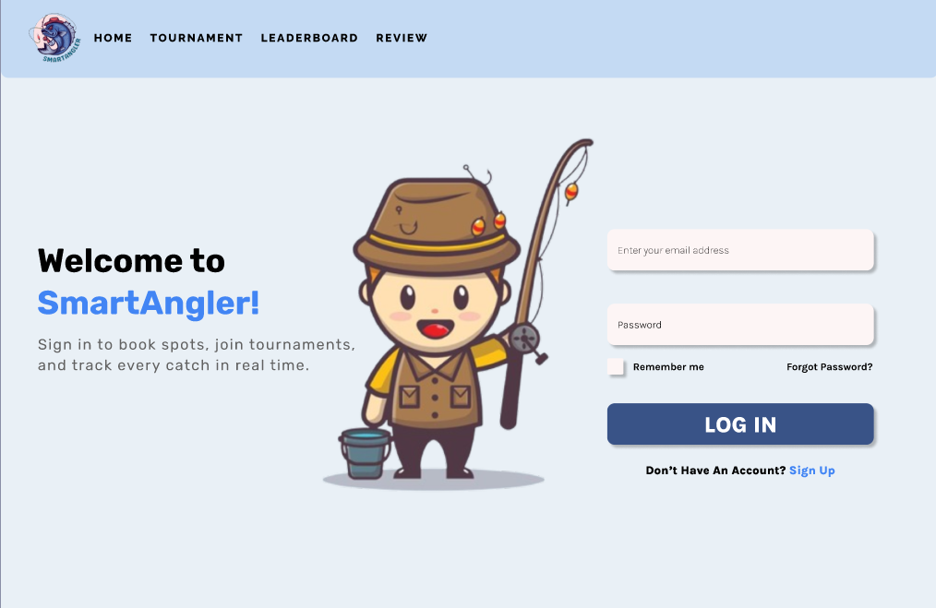

**Figure 4.24: User Login Page**

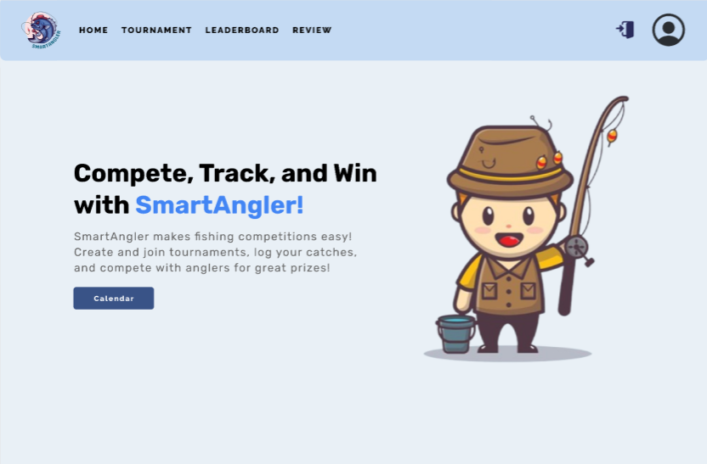

**Figure 4.25: Homepage**

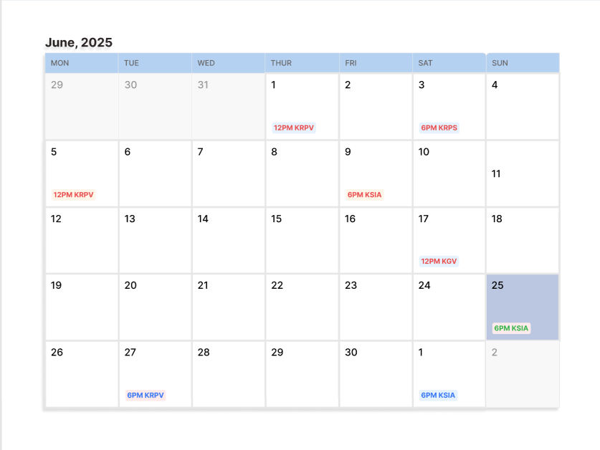

**Figure 4.26: Calendar**

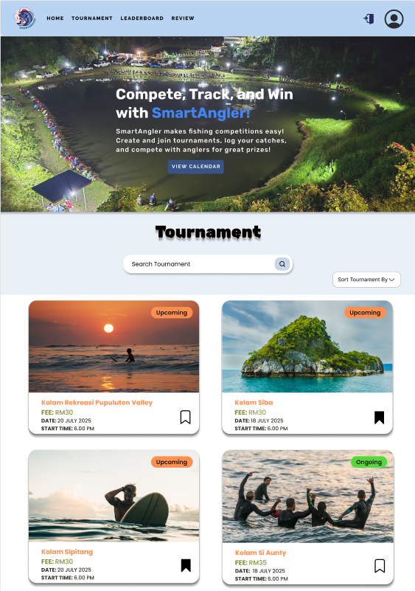

**Figure 4.27: Tournament Advertisement Page**

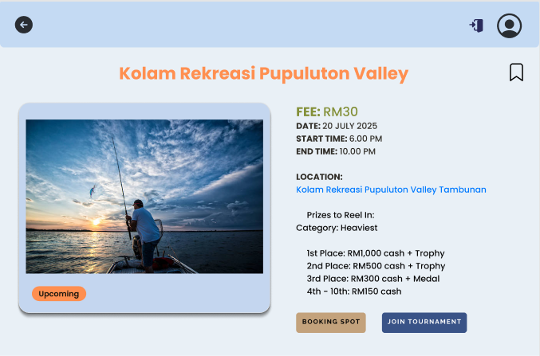

**Figure 4.28: Tournament Details Page**

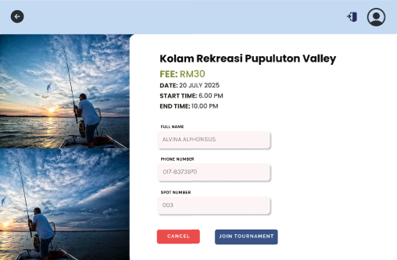

**Figure 4.29: Participant Registration to Join Tournament Page**

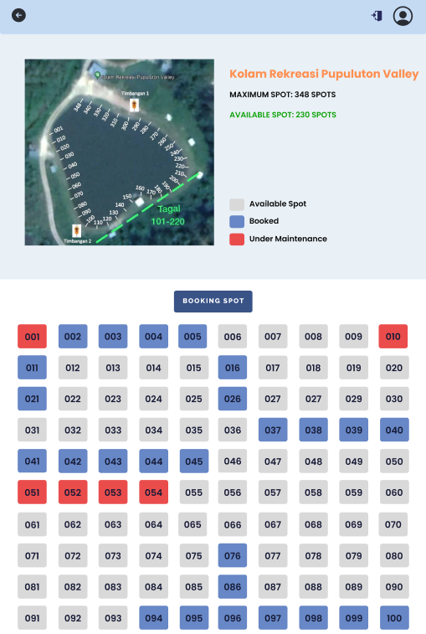

**Figure 4.30: Fishing Spot Booking Page**

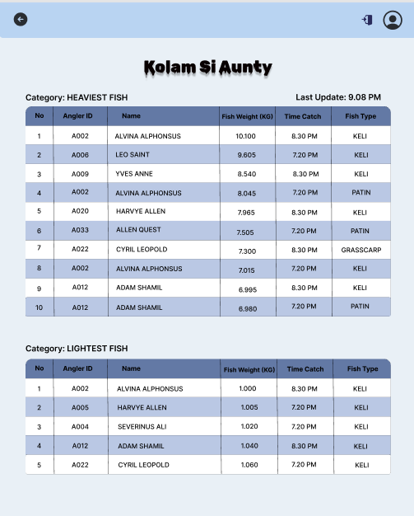

**Figure 4.31: Live Leaderboard Page**

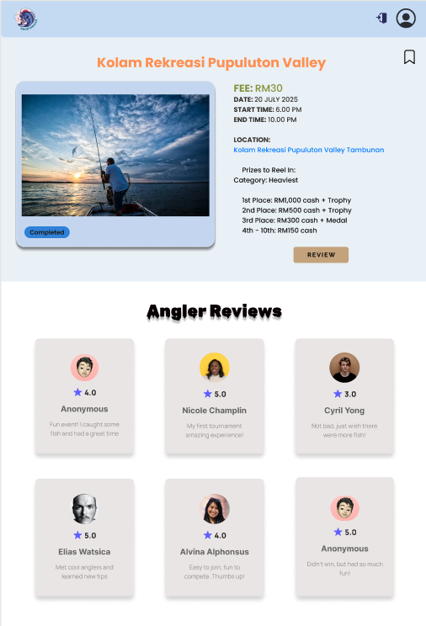

**Figure 4.32: Review Page for Tournament**

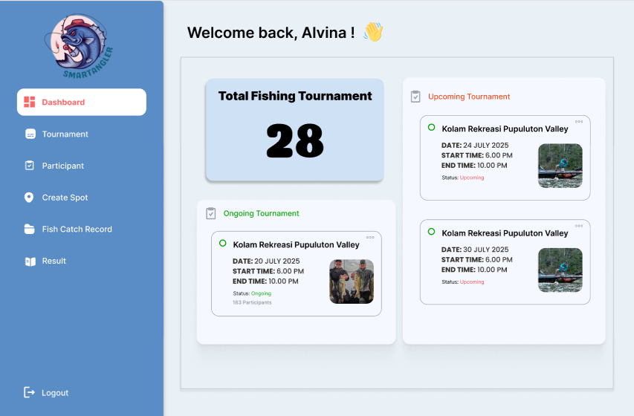

**Figure 4.33: Admin Dashboard**

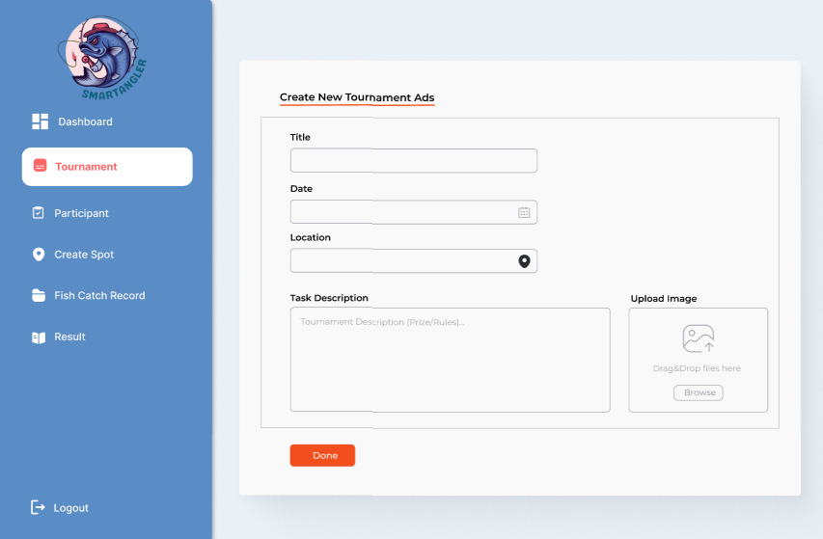

**Figure 4.34: Admin Create Tournament Advertisement Page**

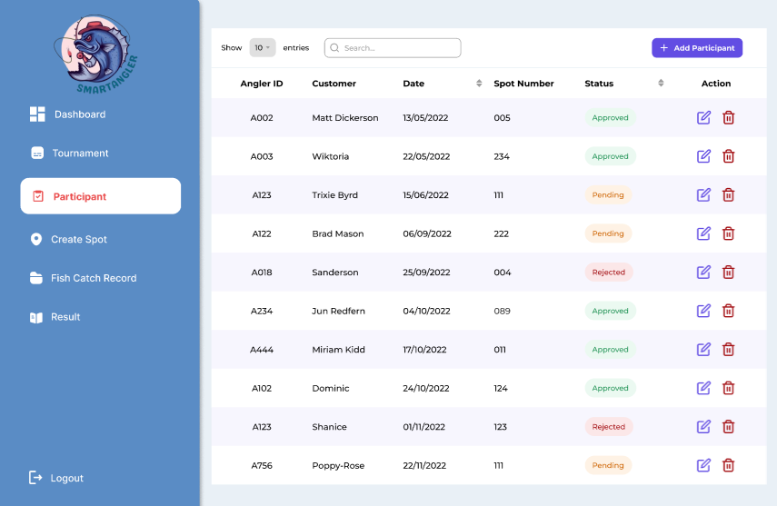

**Figure 4.35: Tournament Participant List Page**

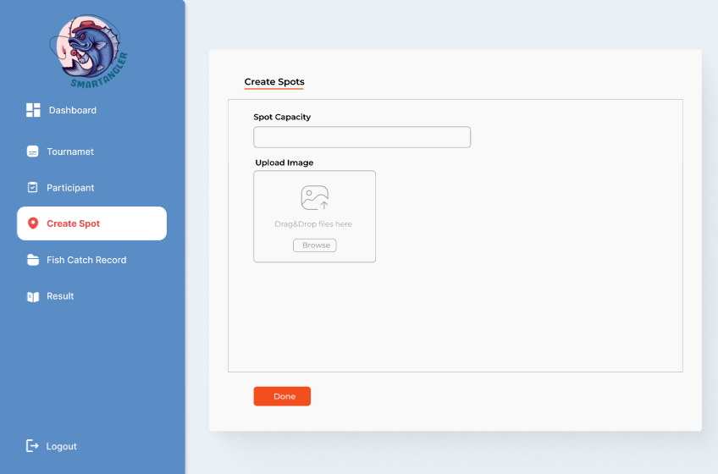

**Figure 4.36: Create Fishing Spot Page**

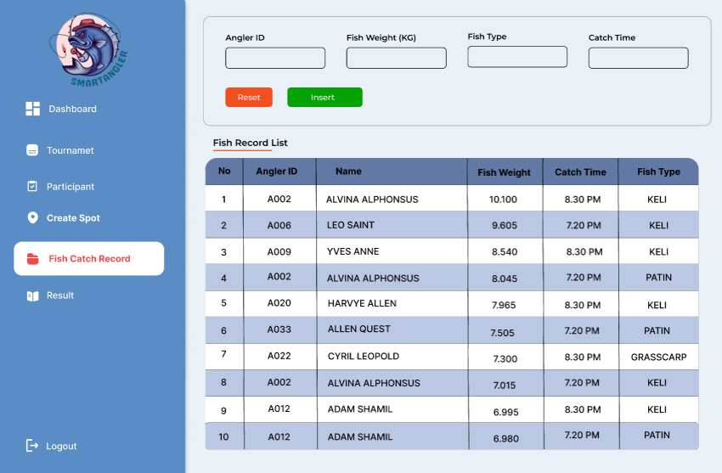

**Figure 4.37: Fish Catch Log Page**

* 1. **Prototype**

The design and the user requirements were used in developing the prototype of the SmartAngler Fishing Tournament Management System. The prototype is a working model that demonstrate how the system functions, including the main features and user interface. It allows users and developers to visualize the system flow, test the interface and provide feedback before the final version is developed. This helps ensure the system meets user needs and expectation and works as expected.

**Prototype Link:** <https://www.figma.com/proto/yEmPgAwKYAboHdAwZglBnJ/SmartAngler-Prototype?node-id=90-534&p=f&t=FDc1pkEIXfahTMpK-1&scaling=min-zoom&content-scaling=fixed&page-id=0%3A1&starting-point-node-id=1%3A7>

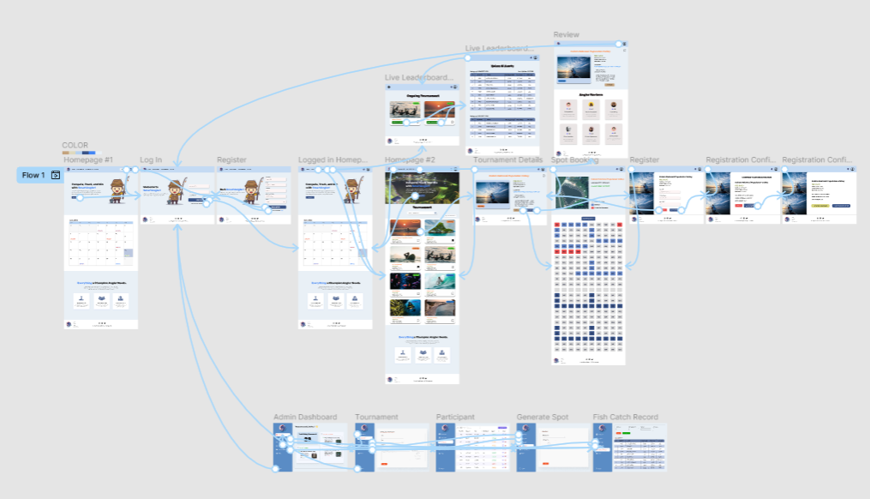

**Figure 4.38: Prototype User Flow for SmartAngler**

* 1. **Conclusion**

In conclusion, this chapter focused on the design phase of the SmartAngler Fishing Tournament Management System. Upon completion of the requirement analysis process, the system design was developed using several important components such as the system architecture, context diagram, data flow diagrams (DFD), and entity relationship diagram (ERD). The data dictionary was also included in the form of defining how each piece of data would be structured and its meaning within the system. Additionally, a high-fidelity prototype was developed using Figma to show how the system will look and function for both anglers and admins. These design elements serve as a solid foundation for the next stage, which is the implementation of the system.

**REFERENCES**

Abdul, R., Khan, H., Gopal, P., Yogesh, P., Nitin, P., Sahebrao, K., Sharad, P., & Santosh, P. (2024). The Waterfall Model-Software Engineering. *International Journal of Research Publication and Reviews Journal Homepage: Www.ijrpr.com*, *5*(4). <https://ijrpr.com/uploads/V5ISSUE4/IJRPR25788.pdf>

Aftco Social. (2024). *History of Sportfishing*. AFTCO. Accessed on May 15, 2025, from https://www.aftco.com/blogs/news/history-of-sportfishing

ASA Fishing. (2020). *Sportfishing in America: A Reliable Economic Force. Produced for the American Sportfishing Association by Southwick Associates via Multistate Grant #F20AP00183 awarded by the Wildlife and Sport Fish Restoration Programs of the U.S. Fish and Wildlife Service.* Accessed on May 20, 2025, from <https://asafishing.org/wp-content/uploads/2021/03/Sportfishing-in-America-economics-report.pdf>

Cabo, B. S. (2025). *IGFA Offshore World Championship Cabo - Blue Sky Cabo*. Accessed on May 15, 2025, from https://cabofishings.com/igfa-offshore-world-championship-cabo/

Combs, K., (2024). *New technologies make tournament fishing more efficient - Bassmaster*. (2024, June 20). Bassmaster. Accessed on May 20, 2025, from https://www.bassmaster.com/column/keith-combs/new-technologies-make-tournament-fishing-more-efficient/

Hamid, A. (2023). The Transformative Role of Artificial Intelligence in the Event Management Industry. *Journal of International Business Economics and Entrepreneurship*, *8*(2), 98–106. <https://doi.org/10.24191/jibe.v8i2.24045>

FishAngler. (n.d.). *Social Sport Fishing mobile APP - Connect, Catch, Compete*. Accessed on April 24, 2025, from <https://www.fishangler.com/>

FishPal. (n.d.). B*ookings for Everyone*. Fishpal.com. Accessed on April 24, 2025, from https://www.fishpal.com/

Harris, G. (2025). *Has the “Sport” Been Taken Out of Sportfishing?* Triton. Accessed on June 20, 2025, from https://www.the-triton.com/2025/05/has-the-sport-been-taken-out-of-sportfishing/

IGFA. (n.d.). International Game Fish Association Tournament Guide. Accessed on May 15, 2025, from <https://igfa.org/wp-content/uploads/2024/06/Tournament-Rules-Booklet-ENGLISHud2024.pdf>

Keepnet. (n.d.). *Catch & Release / Weigh Bay Solutions / Social Fishing*. Keepnet.co. Accessed on April 24, 2025, from https://www.keepnet.co/

Land, T. (2024,). *Fishing Tournaments Land Economic Boost For The Lake Champlain Region*. Regional Office of Sustainable Tourism. Accessed on May 20, 2025, from https://www.roostadk.com/fishing-tournaments-land-economic-boost-for-the-lake-champlain-region

Reel LiveWell. (n.d.). *The #1 Fish Scoring App for Fishing Tournaments - Reel LiveWell*.  Accessed on April 24, 2025, from https://www.reellivewell.com/

Sabah News. (2025). *Angler wins RM50k in fishing event*. Dailyexpress.com.my; Sabah Publishing House Sdn Bhd. Accessed on April 16, 2025, from https://www.dailyexpress.com.my/news/253059/angler-wins-rm50k-in-fishing-event/

SportFishing. (2024a). *When did people start sport fishing?* The History of Sportfishing. Accessed on April 16, 2025, from  <https://thehistoryofsportfishing.com/when-did-people-start-sport-fishing/>

SportFishing. (2024b). *Evolution of Sport Fishing Gear and Tackle - The History of Sportfishing*. Accessed on May 15, 2025, from  <https://thehistoryofsportfishing.com/evolution-of-sport-fishing-gear-and-tackle/>

*TourneyX*. (n.d.). *TourneyX.com. Homepage*. Accessed on June 20, 2025, from <https://tourneyx.com/app/>

WeighBook (n.d.). *WeighBook Tournament Management System*. Accessed on June 20, 2025, from https://weighbook.com/home

Zainuddin, Z. (2025). *Royal Pahang Billfish International Challenge (RPBIC) 2025 kembali ke Kuala Rompin*. Accessed on June 16, 2025, from https://malaysiagazette.com/2025/09/14/royal-pahang-billfish-international-challenge-rpbic-2025-kembali-ke-kuala-rompin/

**APPENDICES**

1. Turnitin Report

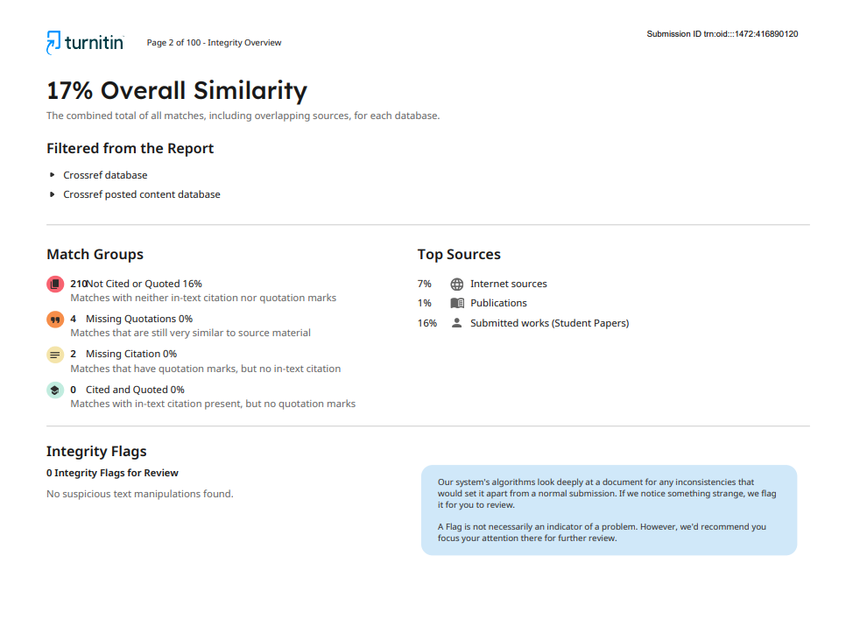

1. FYP Meeting Log

